Research Best Practices
Instrumental Language and ICT Resources

Content and Language Integrated Learning

Research Best Practices

Instrumental Language and ICT Resources
for
Content and Integrated Language Learning

An Educational Proposal by Maria Teresa Escrivà Llidó
Content: Mathematics and English
Level: 6th grade of Primary School

Research Best Practices
CLIL and ICT Group
http://www.uv.es/clil
University of Valencia

Copyleft, 2016 – Maria Teresa Escrivà Llidó

LET’S COOK
BASIC DESCRIPTORS i
UNIT DESCRIPTORS i
LESSON DESCRIPTORS ii
LESSON 1 ii
LESSON 2 ii
LESSON 3 ii
LESSON 4 ii
LESSON 5 ii
ABSTRACT ii
CONTENTS 1
GLOSSARY (A – Z) 6
INDEX 8
List of Figures 8
APPENDIXES 2
PLAY ROLES 2
FRACTION BOTTLE 3
SELF-ASSESSMENT 4
DOUBLE BLIND PEER REVIEW 5
FIRST REVIEWER 5
SECOND REVIEWER 5

BASIC DESCRIPTORS

UNIT DESCRIPTORS

Educational Level(s) |  |  |  |  | 6th grade of Primary School
Area(s) |  |  |  | 1 | Mathematics and English
Unit(s) |  |  |  | 1 | Let’s cook
Number of Lesson(s) |  |  |  | 5 | - What about cooking?  - Use our daily products  - How many…?  - Let’s go to the supermarket  - Being a chef
Student Learning Outcomes (4Cs Framework)
Content |  |  | - Recipe  - Decimals and fractions  - Equivalent fractions  - Units conversion  - Use money  - Operate with decimals to count money  - Estimations  - Calculate measurements  - Be motivated to the topic of the unit
Cognition |  |  | - Use resources such as the dictionary, the Internet, etc.  - Communicate and compare information  - Participate in group works  - Ask questions  - Solve problems  - Get information and communicate it  - Express their questions and doubts about the unit  - Acquire new vocabulary
Culture |  |  | - Different cultural meals  - Cooperative group  - Be able to convert the ingredients of a recipe into different units.  - Find the product that we need  - Money buying  - Make a purchase in the supermarket  - Know if the cashier will give back the correct money  - Follow a recipe and cook it.
Communication |  |  | Language for the Topic AND for Interaction
Content  Of (What) |  |  | - Nouns: Different kinds of food, ingredients, measurements, and words related to the kitchen and cook.  - Verbs: related with our recipe and the actions needed: bake, mix, flavour, divide…  - Adjectives: spicy, sweet, cheap, expensive…
Meta-cognition &  Grammar System  For (How to) |  |  | - Learner-learner: they will work in group for asking questions, looking for ingredients in the supermarket, etc.  - Learner-computer: they are looking for recipes.  - Team-Team: they will communicate making their dramatization or telling their best purchase.  - Learners-teacher: when they have a question or doubt about the activity.
Cognition  Through (Why) |  |  | - Imperative  - Present simple and continuous  - Future simple and be going to  - Express their opinion: I think…/In my opinion…  - Comparative and superlatives  - How many…? /How much…?
Key competences (Knowledge, Skills and Attitudes) for Lifelong Learning (EU Act)
01 | ✔ | Communication in the mother tongue
02 | ✔ | Communication in foreign languages
03 | ✔ | Mathematical competence and basic competences in science and technology
04 | ✔ | Digital competence
05 | ✔ | Learning to learn
06 | ✔ | Social and civic competences
07 | ✔ | Sense of initiative and entrepreneurship
08 | ✔ | Cultural awareness and expression
Teaching Objectives
- Learn the structure of a recipe
- Know the common measurement units
- Use decimals and fractions in a familiar context
- Make units conversion
- Express their ideas using vocabulary of food.
- Pay with money
- Improve their oral and writing skills.
- Be able of working in teams.
Assessment Criteria
Hetero |  |  | The teacher will take into account the following criteria:  - Children look for a recipe, understand it and follow the steps to cook it.  - Students are able to interpret a recipe to buy the ingredients.  - They use vocabulary of food.  - They can express their ideas and opinions in English.  - They make the correct units conversion.  - They are able to use decimals and fractions in the correct way.  - They solve a real problem (buy the real ingredients to make their recipe).  - They can use real and fictional money to buy products.  - They participate in group activities actively.
Initial |  |  | In the first lesson the teacher is going to know the student’s prior knowledge.
Continuous |  |  | During the unit, the teacher is going to focus on how the students are improving and learning. It will be based on the development of activities, by the observation of the class and the questions asked to the children, their activities in big group, in small group, in pairs and individual.
Final |  |  | At the end of the unit, they should show what they have learnt during the unit.
Self-Assessment |  |  | During the unit, learners will assess themselves to measure their own progress.
Materials
Primary |  |  | - Real supermarket, the ingredients for making the recipe and a bake or a fridge.  - Recipe, books of recipes, different products to make the supermarket in class, some bars of chocolate, water, glass of water, bottles, electronic scale and different kinds of spoons.  - Computers, Internet, video and projector
Secondary |  |  | - Paper, pen, dictionary and post-it.
Others |  |  | - They can use or not a mobile phone.
Resources
Primary |  |  | Youtube | It’s a useful tool to watch videos.
Secondary |  |  | Padlet | It’s a tool that students can use to express their opinion.
 |  |  | Power point | It is used to answer a questionnaire in the first and the last lesson.
 |  |  | Twitter | To make discussions
Others |  |  | nrich | There are a lot of the exercises of maths in this page, so we’re going to use it.
 |  |  | Oxford learners | Learners will use it to know the meaning of some words.
Final Task(s)
- Buy the ingredients and cook a recipe.

LESSON DESCRIPTORS

LESSON 1

Unit | 1 | Let’s cook
Lesson | 1 | What about cooking?
Learning Outcomes (4Cs Framework)
Content | - Know the prior knowledge about recipe, decimals, fractions and units conversion.
Communication | - Oral expression  - Watch a video and talk about it.  - Learn vocabulary about the topic.
Cognition | - Express their prior knowledge.  - Use resources such as the dictionary, the Internet...
Culture | - Different cultural meals.  - Cooperative group
Introduction | - Watch the video about different kinds of meals in some cities.  - After watching the video, students should guess the topic of the unit, and which contents they are going to learn in it.
Activities
Revision
Warm up Activities | - Debate or discussion about typical food, their favourite food, etc. in Twitter.
Main Activities | - In groups of 4, they are going to play a game of questions, to know their prior knowledge about the contents of the unit. They will write their answers down in the gap.
Want to Know | - Each group is going to look for a recipe in a book or in the computer. Also, each member of the group should manage one part of the search, depending on different roles (Scribe, Time keeper, Leader and Speaker). After finding their recipe, they will write it down in a paper.  There is only one restriction to the recipe that they find: “the recipe could be easy to cook and each student of the class could cook one, for example, a cookie.”
Reinforcement
Assessment
Hetero | - Teacher will know what their students have known about this topic, so this is essential to know how the teacher has to adapt the following lessons.  - Moreover, teacher needs to focus on the participation of each member of the group in group activities.
Initial | Children will think about “what they know of the topic” and “what I would like to learn in this unit” and then, they will write it in Padlet.
Continuous | Not Needed (NN) or Not Good (NG)
Final
Self-Assessment
Reflections
Materials
Primary | Computers, Internet, video and projector.
Secondary | Paper, book of recipes and dictionary.
Others
Resources
Primary | Padlet | To express their thoughts.
Primary | Youtube | To watch the video.
Primary | Twitter | To make a discussion
Secondary | Power point | To ask the questionnaire.
Secondary | Oxford learners | Learners will use it to know the meaning of some words.
Secondary | Google drive | To create a shared document
Others
Cross Curricular Learning
Unit(s)
Observations | - They are learning language.

LESSON 2

Unit | 1 | Let’s cook
Lesson | 2 | Use our daily products
Learning Outcomes (4Cs Framework)
Content | - Decimals  - Equivalent fractions  - Units conversion
Communication | - Dramatization  - Learn vocabulary about the topic
Cognition | - Compare and share information  - Use resources such as the dictionary, the Internet...
Culture | - Be able to convert the quantity of the recipe’s ingredients into different units.  - Cooperative group
Introduction | - In groups, they will dramatize the recipe found in the lesson 1.
Activities
Revision
Warm up Activities | - They are going to look for the quantity of each ingredient in their recipe, so they are going to find decimals, fractions or quantity of spoons and circle it.
Main Activities | -In groups of 4, they are going to discuss about the structure of the recipe and find the main parts of it. They are going to complete the document and to order a recipe.  -They are going to play with chocolate (each group will have one real bar of chocolate)  - What would you like $\frac{1}{4}$ or $\frac{1}{5}$ of a chocolate bar?  - Put the fractions in order from smallest to largest ( $\frac{1}{7}$, $\frac{1}{5}$, $\frac{1}{16}$, $\frac{1}{8}$, $\frac{1}{20}$, $\frac{1}{3}$, $\frac{1}{11}$, $\frac{1}{6}$, $\frac{1}{15}$, $\frac{1}{12}$ ) and ( $\frac{8}{12}$, $\frac{3}{8}$, $\frac{1}{6}$, $\frac{5}{6}$, $\frac{3}{4}$, $\frac{5}{8}$ ).  - https://nrich.maths.org/34  -They are going to play with water (each group will have some glasses of water and one plastic bottle)  - Fraction bottle (photocopy)  - Marta has 3 ½ bottles of water in her refrigerator. She used $\frac{3}{5}$ bottle in the morning and $\frac{1}{4}$ bottle in the afternoon. How many bottles of water does she have left over?  - In a water bottling plant there are two kinds of water, one is normal and the other is special, are mixed up to make the water have different properties. Each fraction shows the amount of special water that is in the bottle. Make pairs with the bottles that have the same properties. $\frac{2}{3}$, $\frac{3}{4}$, $\frac{3}{5}$, $\frac{15}{20}$, $\frac{6}{24}$, $\frac{6}{8}$, $\frac{12}{20}$, $\frac{16}{24}$, $\frac{1}{4}$, $\frac{4}{6}$.  - http://nrich.maths.org/2420  -1. Order different kinds of spoons and to do it, they will weight out different food or liquid and compare it; 2. After that, they are going to convert into other unit.
Want to Know | - Watch a video about how to do a recipe to see the unit conversions of the ingredients depending on the servants.
Reinforcement | - Students are going to do this exercise: http://nrich.maths.org/1026
Assessment
Hetero | Not Needed (NN)
Initial
Continuous | Teacher will observe children how they are doing these activities to adapt their learning. Teacher will assess their motivation, collaboration in group tasks and demonstrate a good understanding of the contents.
Final | Not Needed (NN)
Self-Assessment
Reflections | - The big spoon and the scales have disappeared, so each group has to convert the units of their recipe into small spoons.
Materials
Primary | Some bars of chocolate, water, glass of water, bottles, electronic scale, spoons, computer, projector and Internet.
Secondary | Paper and pen.
Others | Photocopy
Resources
Primary | Youtube | To watch the video
Primary | Padlet | To express their thoughts.
Secondary | nrich | To do activities
Others
Cross Curricular Learning
Unit(s)
Observations | - They are learning language and drama.

LESSON 3

Unit | 1 | Let’s cook
Lesson | 3 | How many…?
Learning Outcomes (4Cs Framework)
Content | - Recipe  - Fractions and decimals  - Units conversion  - Money
Communication | - Write a recipe  - Democratic choice
Cognition | - Use resources such as the dictionary, the Internet,etc.  - Participate in group works.
Culture | - Find the product that we need  - Save money buying  - Cooperative group
Introduction | - Choose democratically one recipe of the group’s recipe and write it down in Drive. For example: http://allrecipes.com/recipe/25037/best-big-fat-chewy-chocolate-chip-cookie/?internalSource=hub%20recipe&referringId=79&referringContentType=recipe%20hub&clickId=cardslot%2015
Activities
Revision | - Remember what they have learnt in the previous lesson doing this activity: http://nrich.maths.org/4519
Warm up Activities | - We are going to cook the recipe, but before it, we will go to the supermarket to buy the ingredients. For that reason, we will discover the ingredient that we need and how many we need of each of it.
Main Activities | - First of all, we are going to adapt the ingredients of the recipe to have at least one cookie for each member of the class.  - They are going to solve some problems, for example, we need 500gr of butter and in the supermarket we can find butter of 50gr, 125gr and 300gr. Which product are we going to buy and how many? To do it, we are going to simulate purchases in the class supermarket.  - After that, in groups of four, they will look for on Internet the quantity of the ingredients of our recipe, to know how many products we will need and buy.
Want to Know | - In groups of four, they are going to share their list with the rest of the class (this list will have the quantity of each product and price). After the discussion, we are going to write down the correct and final list.  - And also, calculate the money that we need and how many money we will bring to go to the supermarket.
Reinforcement | - Reinforcement: They have to buy the products to make a recipe. They’ll have some products with different size and they have to choose which one they will buy and how many. After that, they’ll have to sum the price and think if they can save money buying different size.  - Extension: The same as reinforcement, but they will have a lot of products to focus on save money.
Assessment
Hetero
Initial
Continuous | Teacher will observe children how they are doing the activities to adapt their learning. She/He will assess their motivation, collaboration in group tasks and demonstrate a good understanding of the contents.
Final
Self-Assessment
Reflections
Materials
Primary | - Paper, Internet, computer, recipe and different products to make the supermarket in class.
Secondary
Others
Resources
Primary
Secondary | nrich |  | To do activities
Secondary | Google drive |  | To create a shared document
Others
Cross Curricular Learning
Unit(s)
Observations | - They are learning language.

LESSON 4

Unit | 1 | Let’s cook
Lesson | 4 | Let’s go to the supermarket
Learning Outcomes (4Cs Framework)
Content | - Operate with decimals to count money.  - Units conversion
Communication | - Ask questions to the salesperson.  - Comment their opinion about the best bought.
Cognition | - Compare and share information  - Ask questions  - Participate in group works.
Culture | - Make a purchase in the supermarket  - Know if the cashier has given back the correct money
Introduction | - We have to organize the ingredients that each group will buy and explain what activity they are going to do in the supermarket.
Activities
Revision
Warm up Activities | - Learn how to ask questions to the salesperson, because students can need it.
Main Activities | LET’S GO TO THE SUPERMARKET:  - Each group should look for their ingredients in the supermarket. After that, they will focus on the quantity and the price of the different products. Depending on these factors they will decide which product they will choose and how many they are going to buy. To show their decision, they will write down all these factors and the final decision. At the same time, if they have mobile phone, they can take a picture to show it in the next activity.
Want to Know
Reinforcement | - Reinforcement: Think about their schoolmate ingredients and decide if they are correct or not.  - Extension: They are going to look for if there are offers in some of their ingredients.
Assessment
Hetero | Once each group has decided the best ingredient and how many they must choose, they are going to tell to the class to know if they have done correctly. After the discussion, teacher will give the money to buy the product and they will have to think in how many money the cashier will give back.
Initial
Continuous | Teacher will observe children how they are doing the activities to adapt their learning. She/He will assess their motivation, collaboration in group tasks and demonstrate a good understanding of the contents.
Final | They buy the correct ingredient and they have into account the others product to save money.
Peer-Assessment | They have to assess the choice of the others groups and decide if it’s correct or not.
Reflections
Materials
Primary | - Money and real supermarket
Secondary | - Paper and (mobile phone).
Others
Resources
Primary
Secondary
Others
Cross Curricular Learning
Unit(s)
Observations | - They are learning language.

LESSON 5

Unit | 1 | Let’s cook
Lesson | 5 | Being a chef
Learning Outcomes (4Cs Framework)
Content | - Estimations  - Decimals and fractions  - Calculate measurements
Communication | - Understand and use orders in the correct way.  - Read and follow the steps of the recipe.
Cognition | - Problem solving  - Participate in group works  - Express their questions and doubts
Culture | - Follow a recipe and cook it  - Cooperative group
Introduction | - Read the recipe and check our ingredients. After that, we have to cook, but firstly we should read the steps. Once we have it clear, each group should write the steps down in a paper.
Activities
Revision
Warm up Activities | - To avoid a disaster, we are going to make a simulation of the different steps with fictional ingredients.
Main Activities | - First of all, they are going to think about how many ingredients will have each group. So, they are going to divide the ingredients into 6 groups, because each group is going to make their own meal.  - Once they have made this operation correctly and marked each ingredient to share with their schoolmate, the teacher is going to distribute the ingredients among the groups.  - After that, they are going to follow the steps. We are going to do the recipe carefully, step by step, to do it correctly.  - Finally, once we have the recipe (cookies…) done, we will go to the school kitchen to bake or freeze, depending on the recipe chosen.
Want to Know
Reinforcement | - Students are going to think about the following activity: If we were cooked a cake, how would we divide it in equal pieces? How many cakes we would need to make it?
Assessment
Hetero
Initial
Continuous
Final | - Look at the activities made during the first lesson and check it.
Self-Assessment | - Students will write a question or doubt of the contents that they are able to ask on the front of a paper and on the back of the paper, they are going to write a question or doubt that they aren’t able to answer. After writing it, they are going to ask these questions or doubts to their teammates. And, if nobody in the group can answer their question, they can ask to the teacher. After that, they will ask their doubts and questions to their classmates, because it’s interesting to share and solve it.
Reflections | - Each group should discuss about what they have learnt in class: knowledge, abilities, assurance. Then, each person will write an idea on a post-it. Finally, they are going to read all the post-its and write it down in their notebook the main important for each one.
Materials
Primary | - Ingredients, bake or fridge and papers.
Secondary | - Post-it and computers.
Others
Resources
Primary
Secondary
Others
Cross Curricular Learning
Unit(s)
Observations | - They are learning language.

ABSTRACT

The aim of this unit is to get some basic mathematics contents such as: fractions, decimals, money, etc. when they are doing activities throw an interactive web page and using digital resources. Moreover, to achieve these contents, they are going to go to a real supermarket to buy the ingredients and then, they will cook a recipe. While they are learning these contents, they will achieve some key competences and improve their level of English, specifically vocabulary and grammar of cooking.

CONTENTS

First of all, teachers are going to learn how to buy some ingredients and to cook a recipe. But, to do this they will know:
• What’s a recipe: a recipe is a set of instructions that tells you how to cook something and the ingredients (= items of food) you need for it. Children are going to learn the recipe structure (ingredients and steps), and they have to be able to order the steps in a recipe.
• Decimals: the numbers that we can find in our daily life and are based on 10 digits. To exemplify this, I would like to add the following picture:
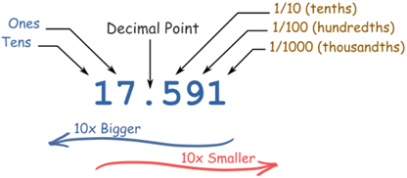
Figure 1: Decimals
Source: https://www.mathsisfun.com
• Fractions: a small part or amount of something. For example:
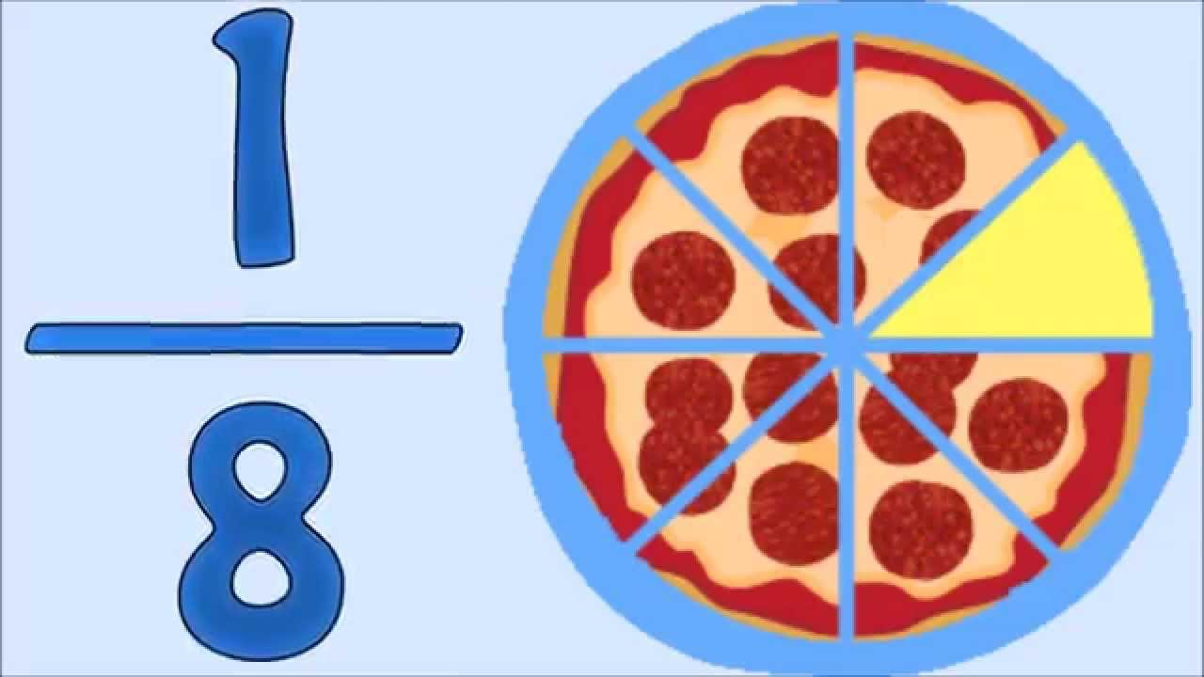
Figure 2: Fractions
Source: https://i.ytimg.com/vi/n0FZhQ_GkKw/maxresdefault.jpg
Students are going to learn how to make operations with fractions (addition, subtraction, multiplication and division).

• Equivalent fractions: when the fractions has the same result. For example:
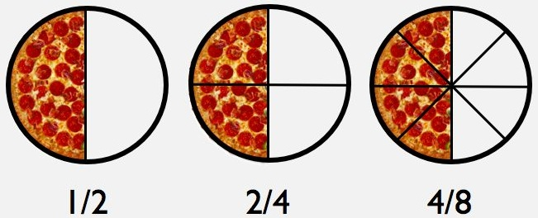
Figure 3: Equivalent fractions

Source: http://math811.com/wp-content/uploads/2015/03/Equivalent_Fractions.jpg

• Units conversion: In a recipe, students need to be able to recognize the units of each ingredient of the recipe. For that reason, they are going to know what is a tablespoon, teaspoon, cup, etc. and they need to be able to change the ingredients to adapt the recipe for more people and change the units from one unit to another unit. In the following images, we have general instructions to convert one unit into another unit.
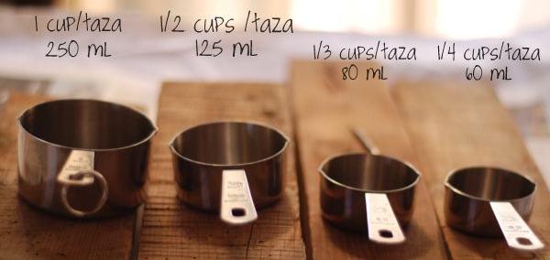
Figure 4: Units conversion (Cups)

Source: http://mylittlethings.com/2010/11/cups-tablespoon-teaspoon.html

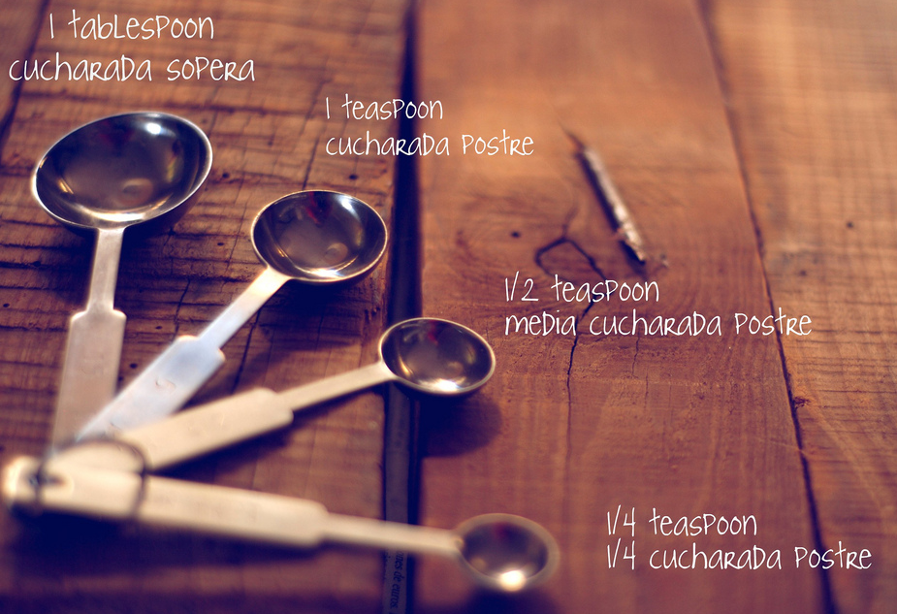

Figure 5: Units conversion (spoons)

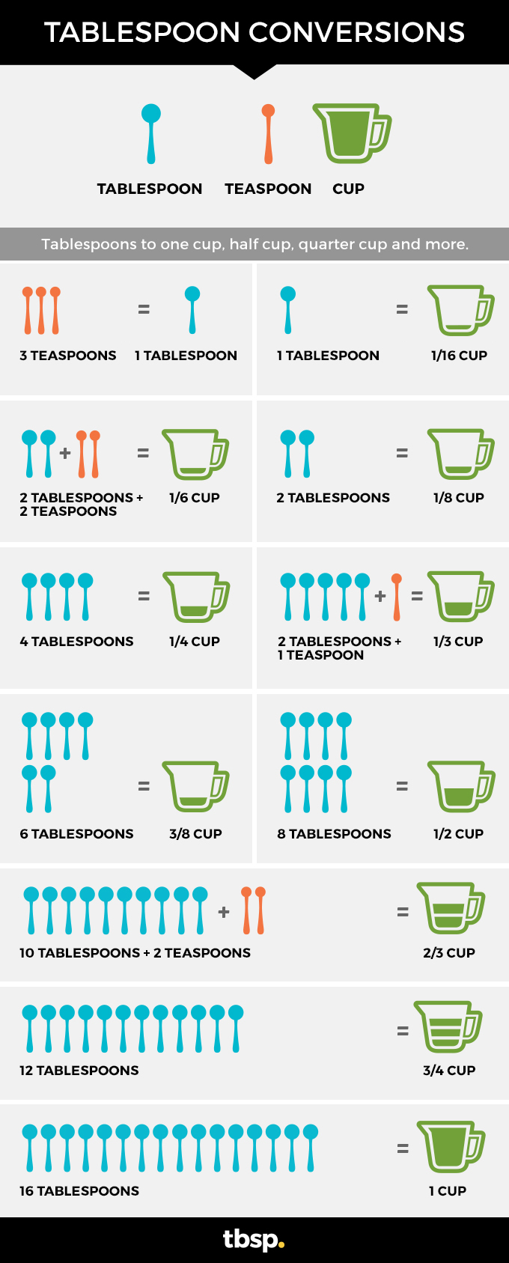
Figure 6: Tablespoon conversions

Source: http://www.tablespoon.com/posts/tablespoon-conversions-tablespoons-in-cups/bdf92edc-7542-4af5-8d55-6bd11ef77101

For example:

½ cup = 8 tablespoon = 24 teaspoon

• Money: coins or paper notes that we need to buy things. Students are going to use it in this unit to buy fictional or real ingredients.
• Operate with decimals to count money: Children have to be able to make operations (addition, subtraction, multiplication and division) with money. To do this, they will use the decimals, for example, they will have to get the total adding and doing multiplications of the ingredients prices, or they will use the subtraction to know how many money the salesperson will give back, as well as, they will use the division to know how many euros each person of the class has to pay to buy.
We can see an example of adding and doing multiplications:

INGREDIENTS | QUANTITY | PRICE | TOTAL PRICE
Butter | 1 | 1,58€ | 1,58€
Flour | 1 | 0,90% | 0,90€
Sugar | 2 | 1,11€ | 2,22€
Cheese | 1 | 2,10€ | 2,10€
Eggs | 6 | 0,35€ | 2,10€
TOTAL |  |  | 8,90€
Figure 7Figure
Figure
Figure
Figure
Table

Also, students have to take into account that there are many similar products in the supermarket that they can buy, but they will choose one or other depending on different criteria: the quantity that they need to cook their recipe, the price to save money, etc. For example, we have these following products and we have to choose one. Imagine that our recipe needs 1,5Kg, so, which one will we choose? And, how many of this product will we buy?

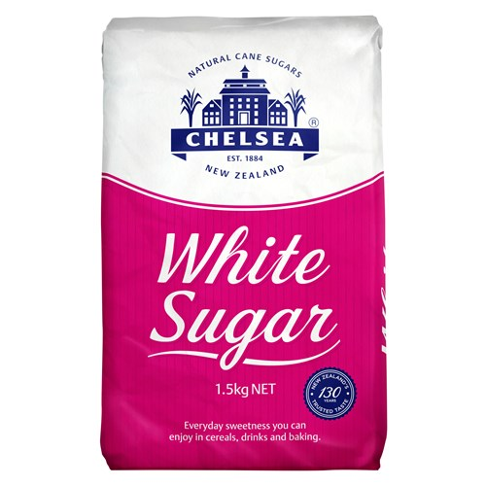 | 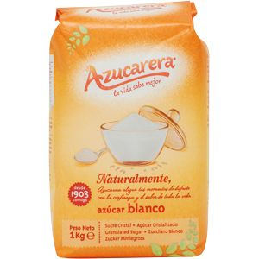 | TOTAL  QUANTITY  1  1,5Kg  2,86€  1Kg  2  1,38€
1,5Kg | 1Kg
2,86€ | 0,69€
Figure 8
We need to choose between one product of the first one or two of the second one. To do this, they will have to compare the products and choose the best product. In this case, they will choose the second one because it’s cheaper than the first one despite buying two products.

GLOSSARY (A – Z)
bake
transitive verb
beIk
to cook using dry heat at a moderately high temperature.
conversion
noun
kən vuhr zhən
the act or process of converting.
decimal (decimals)
adjective
de sə məl
pertaining to the number ten or to tenths.
fraction (fractions)
noun
fraek shən
a number expressed as one number or algebraic quantity divided by another.
measurement (measurements)
noun
me zhər mənt
the act or process of measuring specific dimensions.
money
noun
muh ni
coins or paper notes issued by the government and marked with specific values; legal currency.
purchase
transitive verb
puhr chəs
to obtain by exchanging money for; buy.
recipe
noun
re sih pi
step-by-step instructions for preparing a food dish.
share
transitive verb
sheIr
to divide and give out in shares; apportion.
spoon (spoons)
noun
spun
a utensil with a small shallow bowl at the end of a handle, used for eating, stirring, serving, or measuring.

INDEX

Assessment ii, iii, ii, iii, ii, iii, ii, iii
children iii, ii
collaboration iii, ii
CONTINUOUS iii, ii
FINAL iii, ii
group i, ii, iii, ii, iii, ii, iii, ii, iii, 2
HETERO ii, iii, ii
information i, ii
INITIAL ii, iii, ii
knowledge ii, iii
language iii, ii
LEARNING 3, i, ii, iii, ii, iii, ii, iii, ii, iii, ii, iii
motivation iii, ii
REFLECTIONS iii
REINFORCEMENT ii, iii, ii
Resources 1, 3, iii, 2
REVISION ii
Students iii, ii, iii
Teacher iii
clil 4, 6
contents ii, iii, ii, iii, ii
decimals i, ii, 4
Estimations i, ii
fractions i, ii, 2
measurements i, ii
money i, ii, 4
Materials iii
activities ii, iii, ii
computer ii, iii
dictionary i, iii, ii, iii, ii
Internet i, iii, ii, iii, ii, iii, ii, iii
nrich iii, ii, iii, ii, iii
Paper iii
products i, ii, iii, ii, iii, ii
video iii, ii, iii
Mathematics 3, i
Primary 3, i, iii
unit i, iii, ii, iii, ii
Unit
actions ii
ask iii, ii, iii
buy ii
Calculate i, ii
check ii
choose ii
convert i, ii, iii
decide ii, iii
demonstrate iii, ii
discussion ii
divide i, ii
find ii
Know i, ii, iii, ii
Participate i, ii
save ii
share ii, iii
think ii
Watch ii, iii
write ii, iii
cook i, ii
bake i, iii, ii, iii
bottle ii
butter ii
chocolate iii, ii, iii, ii
food i, ii
ingredients i, ii, iii, ii, iii, ii
Make i, ii
meals i, ii
price ii
purchase i, ii
recipe i, ii, iii, ii, iii, ii, iii, ii, 2
spoons iii, ii, iii
steps ii
supermarket i, iii, ii, iii, ii, iii, ii
topic i, ii
water iii, ii, iii
LESSON ii
UNIT i

List of Figures

Figure 1: Decimals 1
Figure 2: Fractions 1
Figure 3: Equivalent fractions 2
Figure 4: Units conversion (Cups) 2
Figure 5: Units conversion (spoons) 3
Figure 6: Tablespoon conversions 3
Figure 7 4
Figure 8 5

APPENDIXES

PLAY ROLES
In the first lesson, students are going to look for a recipe an each member of a group will have a different role. These roles are made by Saucy Resources (2015):

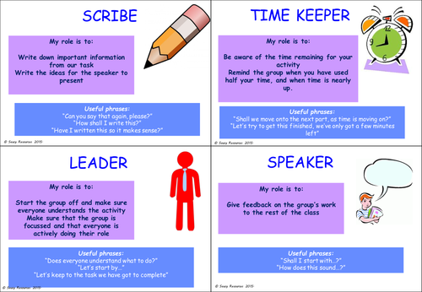

FRACTION BOTTLE

Here are a few problems made by Math 811.
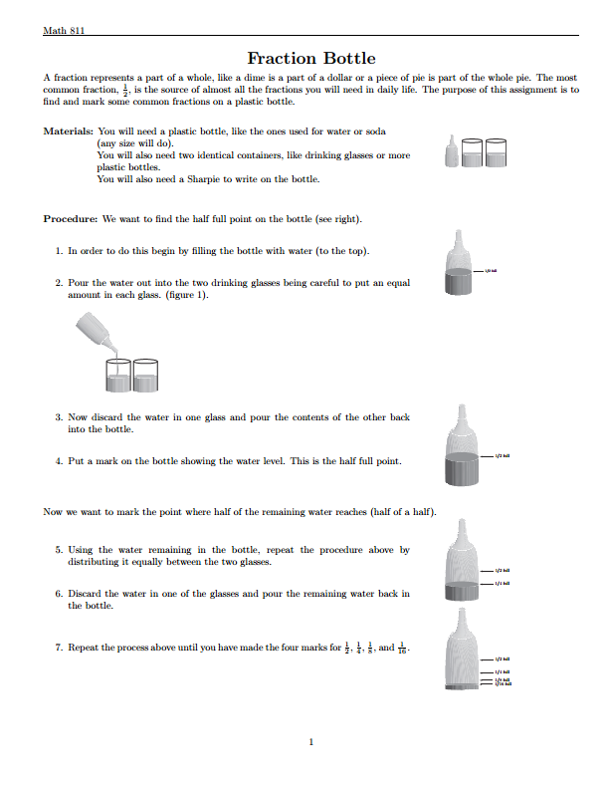

SELF-ASSESSMENT

As far as I’m concerned, my Unit has defined the global goals, the teaching aims and the leaning outcomes. I designed 5 lessons, in which I think that students can develop the contents of the unit and, at the same time, language skills. In my opinion, the activities designed allow students to acquire the objectives and develop key competences. To evaluate this unit, I am going to make an initial, formative and final evaluation and I’m going to focus on what children understand and how they are improving. In my opinion, these activities are adequate for 6th grade children, but the “time” programmed to do the activities could be adaptive, depending on the needs of my students.
I have to remark that the majority of my activities are programmed to be done in groups and it helps children to communicate in English and improve their oral skills. So, students are the main point of this unit, so they can evaluate themselves, as well as, their teammates and it allows the teacher to know what they have learnt and if they are improving.
To sum up, I think that the topic of the unit can motivate children to learn the mathematical contents (fractions, decimals…) and at the same time, they are learning how to do a recipe, the criteria that they have to take into account to buy the ingredients and the steps that they have to follow to cook their recipe.

DOUBLE BLIND PEER REVIEW

FIRST REVIEWER

SECOND REVIEWER


Research Best Practices
University of Valencia
http://www.uv.es/clil
Copyleft 2016

Definition from: http://www.oxfordlearnersdictionaries.com/
Definition from: http://www.oxfordlearnersdictionaries.com/

