Abstract Template for the IX International Workshop on Sensors and Molecular Recognition (Valencia, Spain)

Presenting Author1, Name Surname2 and Name Surname3

1 Department Name, University Name, Address, Zip/Postcode, Country – email@email.email

2 Department Name, University Name, Address, Zip/Postcode, Country

3 Department Name, University Name, Address, Zip/Postcode, Country

**Keywords:**insert, three, keywords.

This template is an example of how to prepare an abstract for the IX International Workshop on Sensors and Molecular Recognition to be held from 6th to 7th July 2015 (Valencia, Spain). The simplest way to comply with the requested abstract format is to replace the text in this template with your text.

The title should be typed in font Arial 14 pt bold.

The Authors’ names are to be typed in Arial 9 pt, **with the presenting Author underlined**.

The Authors’ affiliations are to be typed in Arial 8 pt italics. **The e-mail address of the presenting Author is requested, and he/she will be referred to also as the Corresponding Author.**

Three Keywords should be supplied and typed in Arial 8 pt.

The main text has to be typed in Arial10 pt.

Graphics/figures or schemes are allowed and welcome. Figures can be either one column-wide (7.5 cm) or two column-wide (between 7.5 and 16 cm). Any figure should be inserted in the text as a JPG file with 300 dpi resolution. Structures of the chemical formulas in ChemDraw or ISISdraw formats. Figure 1 is an example.

When using special characters such as α,β,Å etc. wherever possible use the Arial versions of these characters rather than the ‘Symbol’ font, this helps guarantee correct reproduction in the abstract book.

Formulas should be centered and, if numbering is necessary, the number should be placed on the right in parentheses. Here is an example of an equation with numbering:

 (1)

Equation (1) is the Pythagorean theorem.

A brief paragraph with Acknowledgements may be added at the end of the main text.

A limited number of citations in the text are welcome, and the relevant list of references added at the end of the abstract. Bibliografic reference is made by use of superior numerals at the appropriate place.1-16 The preferred reference format is shown in the Reference paragraph at the end of this template. However, any consistent reference procedure can be accepted.

The length of the abstract **cannot exceed two pages in this format**, but must be clearly informative of the object of the scientific contribution.

The abstract should be submitted as a DOC file. The DOC file size should not exceed 1 Mb. **The abstract has to be submitted by e-mail to** [**egarciab@eln.upv.es**](mailto:egarciab@eln.upv.es) **before 8th, June 2015.**

This sentence is written just to fill the available space and contains no useful information for the abstract submission. This sentence is written just to fill the available space and contains no useful information for the abstract submission. This sentence is written just to fill the available space and contains no useful information for the abstract submission. This sentence is written just to fill the available space and contains no useful information for the abstract submission.



Fig. 1 – The caption(s) of the figure(s) should be typed in this format. The font to be used is Arial 8 pt.

This sentence is written just to fill the available space and contains no useful information for the abstract submission. This sentence is written just to fill the available space and contains no useful information for the abstract submission. This sentence is written just to fill the available space and contains no useful information for the abstract submission. This sentence is written just to fill the available space and contains no useful information for the abstract submission.

This sentence is written just to fill the available space and contains no useful information for the abstract submission. This sentence is written just to fill the available space and contains no useful information for the abstract submission. This sentence is written just to fill the available space and contains no useful information for the abstract submission. This sentence is written just to fill the available space and contains no useful information for the abstract submission.

This sentence is written just to fill the available space and contains no useful information for the abstract submission. This sentence is written just to fill the available space and contains no useful information for the abstract submission.

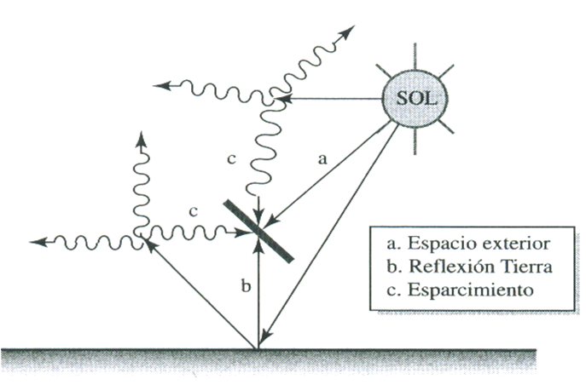

Fig. 2 – The caption(s) of the figure(s) should be typed in this format. The font to be used is Arial 8 pt.

This sentence is written just to fill the available space and contains no useful information for the abstract submission. This sentence is written just to fill the available space and contains no useful information for the abstract submission. This sentence is written just to fill the available space and contains no useful information.

This sentence is written just to fill the available space and contains no useful information for the abstract submission. This sentence is written just to fill the available space and contains no useful information for the abstract submission. This sentence is written just to fill the available space and contains no useful information for the abstract submission. This sentence is written just to fill the available space and contains no useful information for the abstract submission. This sentence is written just to fill the available space and contains no useful information for the abstract submission. This sentence is written just to fill the available space and contains no useful information for the abstract submission. This sentence is written just to fill the available space and contains no useful information for the abstract submission. This sentence is written just to fill the available space and contains no useful information for the abstract submission.

This sentence is written just to fill the available space and contains no useful information for the abstract submission. This sentence is written just to fill the available space and contains no useful information for the abstract submission.

Acknowledgements

All the Authors are kindly thanked for having submitted an abstract formatted according to this template.

References

1 R. J. Lewis, Sr., Hazardous Chemicals, Desk Reference, 5th Ed, Wiley-Interscience, New York, 2002.

2 L. J. Krebaum, US Pat., 3129241, 1964.

3 Z. Li and C.J. Li, *J. Am. Chem. Soc*. 2006, **128**, 56.

4 Y. Zhang, C. J. Li, *Eur. J. Org. Chem.* 2007, 4654.

5 J. March, Advanced Organic Chemistry, 4th Ed., John Wiley & Sons, New York, 1992.

6 P.W. N. M. van Leeuwen, P. C. J. Kamer, J. N. H. Reek, P. Dierkes, *Chem. Rev*., 2000, **100**, 2741.

7 A. P. V. Göthlich, M. Tensfeldt, H. Rothfuss, M. E. Tauchert, D. Haap, F. Rominger, P. Hofmann, *Organometallics* 2008**, 27***,* 2189.

8 P. N. Liu,F. Xia,Q. W. Wang,Y. J. Ren, J. Q. Chen, *Green Chem.*, 2010, **12**, 1049.

9 H. E. Lanman, R.V. Nguyen, X.Yao, T. H. Chan, C. J. Li, *J. Mol*. *Catal. A: Chem.*, 2008, **279**, 218.

10 G. Dyker, *Angew. Chem. Int. Ed*., 1999, **38**, 1698.

11 J. March, Advanced Organic Chemistry, 4th Ed., Wiley-Interscience, New York, 1992, p. 835.

12 F. A. Carey, R. J. Sundberg, Advanced Organic Chemistry, part B, Kluwer, Academic/Plenum, 4rth Ed, New York, 2000, p 493.

13 G. W. Wang, Y. B. Shen, X. L. Wu, L. Wang, *Tetrahedron Lett*., 2008, **49**, 5090.