Statistics. November 3

Let’s assume that we want to run a simplified repetition of the classical Peterson and Peterson (1959) study on the decay of short-term memory (does it last for just a few seconds or for longer?). You can get some additional info from the following website (https://www.simplypsychology.org/peterson-peterson.html) or you can read the original paper (Peterson, L. R. & Peterson, M. J. (1959). Short-term retention of individual verbal items. Journal of Experimental Psychology, 58, 193-198.).
The idea is easy. We have a sample of 16 students. On each trial, they are going to be presented (auditorily) a trigram composed of three consonants (FGK, for instance; no anagrams…no KFC…) and a 3-digit number. After an interval (there levels: 5 seconds, 10 seconds, 15 seconds; there were 20 trials in each level, which are later averaged; the order of the trials was randomized for each participant) they will have to recall the anagram (if they can remember…). To prevent rehearsal, just after the trigram was presented, they have to count the numbers backward. The researcher measured the percentage of trigrams correctly recalled in each condition.
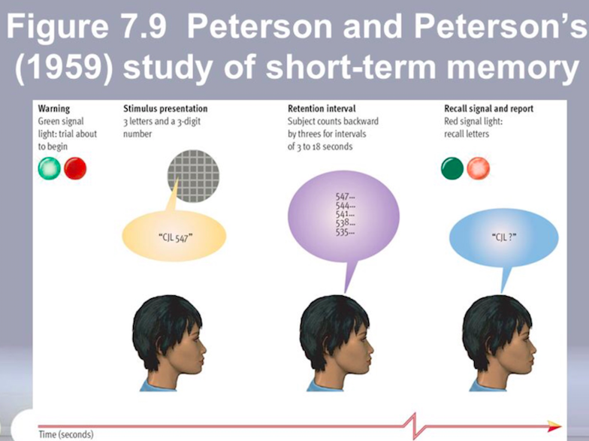

--Which is the main (big) question?

--Can you indicate the independent variable/s and the dependent variable/s?

--Is this a between-subjects or a within-subject design?

--Does the study follow the experimental tradition or the correlational tradition?

--How many rows and columns are we going to have in the SPSS dataset? Why?

--We have the data from the new study available at the following link: http://www.uv.es/mperea/petersen.sav. Can you quickly analyze the data? We want to obtain a graph and a few sentences explaining the results. (Are we replicating the original Peterson and Peterson, 1959, study?)

--This was an elegant and influential study, but can you think of any follow-up experiments to test the extent and nature of short-term memory? (Probably this experiment has already been done, anyways, but who knows.)

As you may have noticed, there are more columns than necessary in the dataset. The reason is that we have a few extra questions, not necessarily related to the Peterson & Peterson study. We have the score in an IQ test, we have the age, the gender, and we also have the answers from four anxiety questions (from 1-7 in a Likert scale; the third question is inverse…)

--Let’s compute the average of the rate of correct trigrams recalled at 5, 10, and 15 seconds so that we have an overall “short-term memory” score. Does it differ across men and women? Explain the result.
--Let’s assume that we compute the averaged anxiety score (from the 4 questions, be careful with Question #3). Do you see any differences between men and women?

--We want to create two groups on the basis of the median (i.e., a median split) in IQ (i.e., lower IQ vs. higher IQ individuals). Are there any differences in overall recall rates between lower and higher IQ individuals?

--Let’s rerun the replication the Peterson and Peterson experiment without including the “older” participants (30 y.o. or older). Are we getting the same results as with the full sample?

