Statistics. November 3

Let’s assume that we want to run a simplified repetition of the classical Peterson and Peterson (1959) study on the decay of short-term memory (does it last for just a few seconds or for longer?). You can get some additional info from the following website (https://www.simplypsychology.org/peterson-peterson.html) or you can read the original paper (Peterson, L. R. & Peterson, M. J. (1959). Short-term retention of individual verbal items. Journal of Experimental Psychology, 58, 193-198.).
The idea is easy. We have a sample of 16 students. On each trial, they are going to be presented (auditorily) a trigram composed of three consonants (FGK, for instance; no anagrams…no KFC…) and a 3-digit number. After an interval (there levels: 5 seconds, 10 seconds, 15 seconds; there were 20 trials in each level, which are later averaged; the order of the trials was randomized for each participant) they will have to recall the trigram (if they can remember…). To prevent rehearsal, just after the trigram was presented, the participants had to count the numbers backward (see Figure). The researcher measured the percentage of trigrams correctly recalled in each condition.
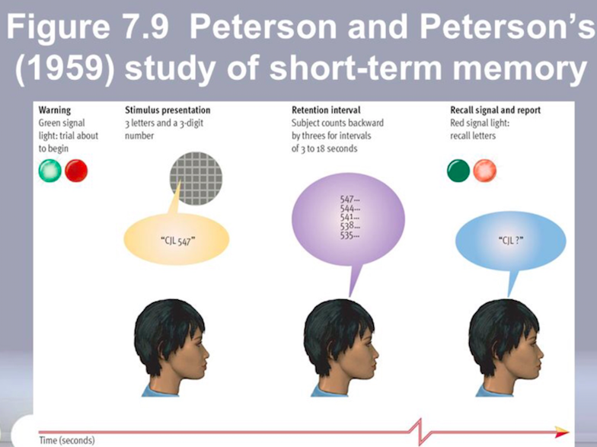

--Which is the main (big) question?

How fast information decays in short-term memory.

--Can you indicate the independent variable/s and the dependent variable/s?

Independent variable: Retention interval (5, 10, 15 seconds)
Dependent variable: % of correctly recalled trigrams

--Is this a between-subjects or a within-subject design?

This is a within-subject design. All participants take part in the three experimental conditions.

--Does the study follow the experimental tradition or the correlational tradition?

This is an experiment: there is an independent variable and a dependent variable. Therefore, we can establish causal relationships.

--How many rows and columns are we going to have in the SPSS dataset? Why?

16 rows (as many as participants)
3 columns (the percentage of correctly recalled trigrams in each of the three conditions: 5 seconds, 10 seconds, and 15 seconds).

--We have the data from the new study available at the following link: http://www.uv.es/mperea/petersen.sav. Can you quickly analyze the data? We want to obtain a graph and a few sentences explaining the results. (Are we replicating the original Peterson and Peterson, 1959, study?)

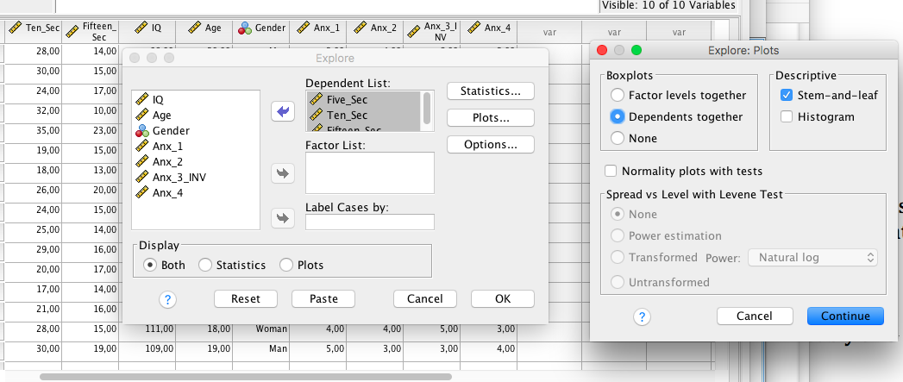

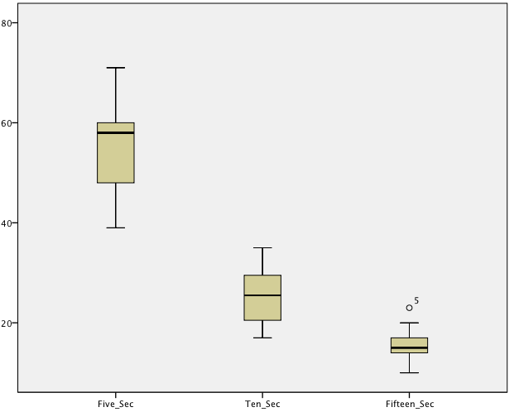
The box plot (see below) clearly shows that information decay in Short-Term Memory (STM) is extremely fast (i.e., STM is short-lived). When the average percentage of recalled trigrams is 55.75% with the 5-second retention interval, it is 23.78% with the 10-second retention interval, and it is only 15.8% with the 15-second retention interval. This pattern is quite similar to that reported by Peterson and Peterson (1959).

--This was an elegant and influential study, but can you think of any follow-up experiments to test the extent and nature of short-term memory? (Probably this experiment has already been done, anyways, but who knows.)

We can manipulate Age (i.e., an experiment with children, or with older adults). We can also examine the capacity of short-term memory for other types of stimuli (e.g., pictures). We can also employ trigrams vs. 3-letter acronyms (e.g.., FBI, KFC, …). There are other options, of course.

As you may have noticed, there are more columns than necessary in the dataset. The reason is that we have a few extra questions, not necessarily related to the Peterson & Peterson study. We have the score in an IQ test, we have the age, the gender, and we also have the answers from four anxiety questions (from 1-7 in a Likert scale; the third question is inverse…)

--Let’s compute the average of the rate of correct trigrams recalled at 5, 10, and 15 seconds so that we have an overall “short-term memory” score. Does it differ across men and women? Explain the result.

First, we compute this “composite” measure of short-term memory (i.e., we just average the 3 columns (%recalled trigrams at 5, 10, and 15 sec). And then we just get the Box Plot by having this average rate of STM as the dependent variable and Gender as (between-subject) Factor.

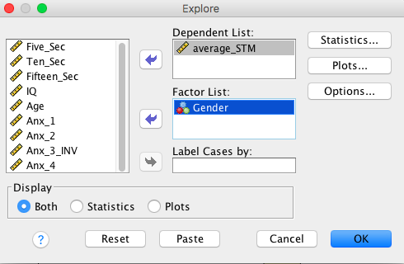

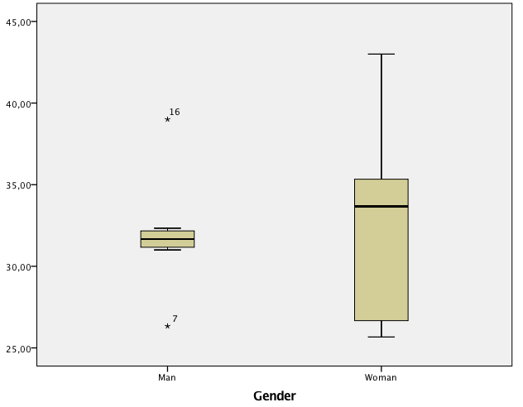

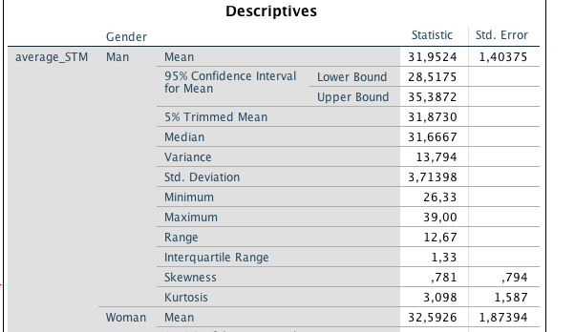

Unsurprisingly, the averages of the composite measure of STM (short-term memory) are very much the same for men and women (32.0 vs. 32.6, respectively).

(NOTE: Don’t pay much attention to the box plot, as it is based on an extremely low number of elements in each group.)

--Let’s assume that we compute the averaged anxiety score (from the 4 questions, be careful with Question #3). Do you see any differences between men and women?

First off, we need to have the “correct” format (i.e., more is more) in Question#3. (You can do that via “recoding” each value…1 is 7…2 is 6…, or you can use the formula: new_value=7+1-old_value). And then you compute the average of the 4 questions. And then this is your dependent variable in the Box Plot. The Factor is Gender.
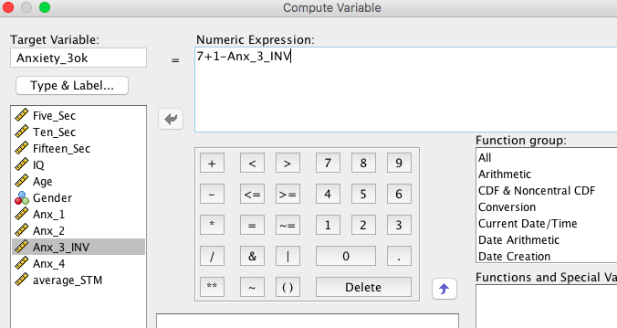

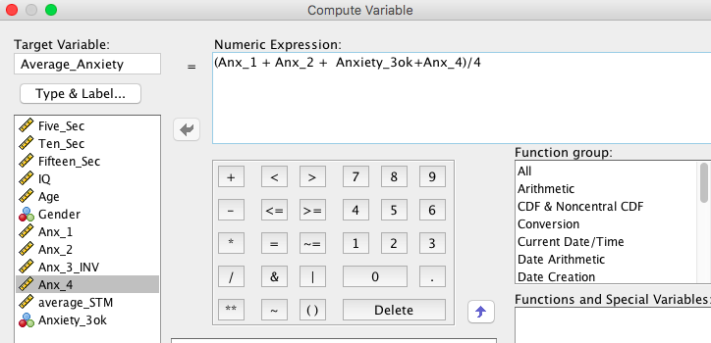
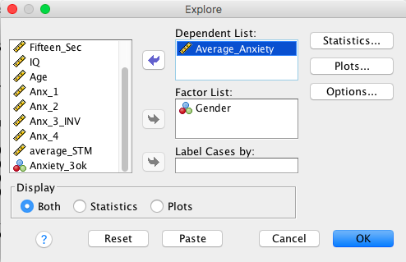

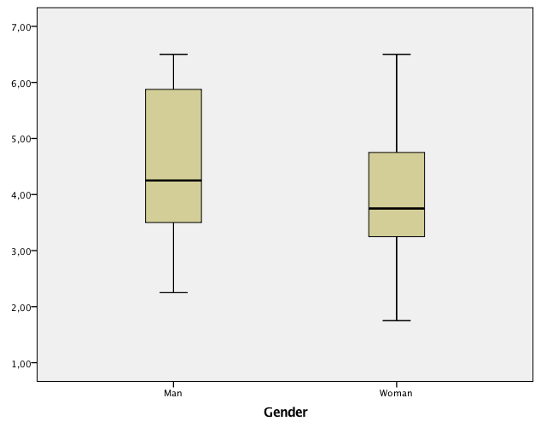

As can be seen in the Box Plot, the anxiety levels is quite similar for men and for women in the sample.
(You may want to report the means as well, as it is always useful.)
--We want to create two groups on the basis of the median (i.e., a median split) in IQ (i.e., lower IQ vs. higher IQ individuals). Are there any differences in overall recall rates between lower and higher IQ individuals?

First, we compute the median of IQ, which is 105.5. This means that there will be 8 observations above this value (the higherIQ individuals) and 8 observations below that value (the lowerIQ individuals). You just have to recode IQ into “IQgroups”, with the condition that all values lower than 105.5 belong to 1 (lowerIQ) and the other will belong to 2 (higherIQ). Once you have done that, then you can get the Box Plot, for instance.

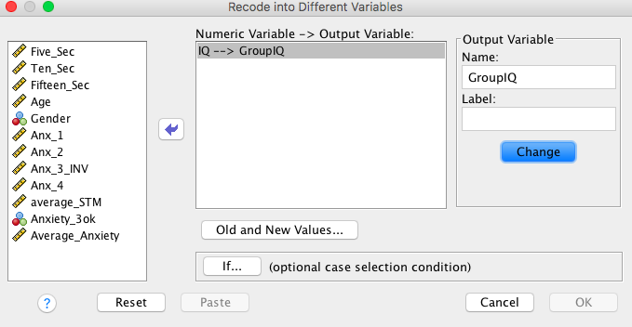

It is a good idea to have the labels of the categories (in “variable view”), 1=lowerIQ, 2=higherIQ
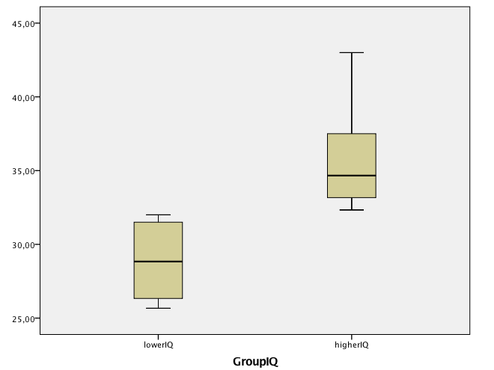

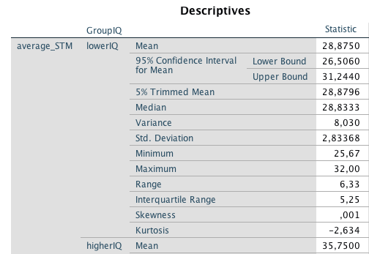

The individuals in the higherIQ group have better short-term memory capabilities than the individuals in the lowerIQ group (means of the composite STM measure: 37.5% vs. 28.7%, respectively), as can also be seen in the box plot.

--Let’s rerun the replication the Peterson and Peterson experiment without including the “older” participants (30 y.o. or older). Are we getting the same results as with the full sample?

Here we just go to “select cases” with the condition that we select the individuals younger than 30 y.o.

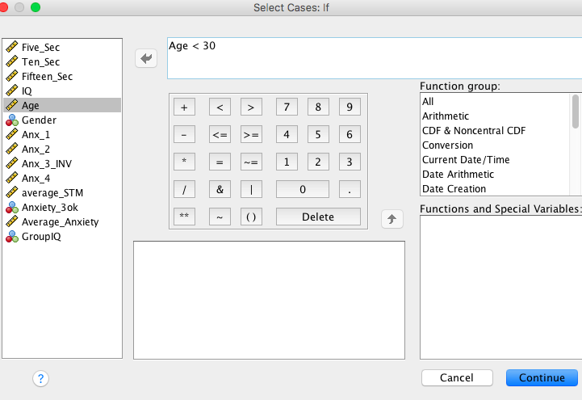
Then we do the same analyses as in the Peterson&Peterson question. The new box plot is:

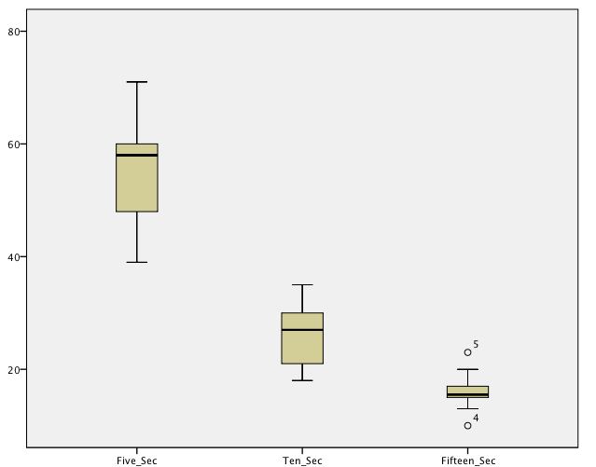

This plot is very much the same as the one we had (see below). In other words, the conclusions are the same as with the whole sample. (After all, we have only excluded two participants who were in their thirties).

