(Answers at the end of the file)

1. According to APA norms, which is the type of publication of the following reference? Paz-Rodríguez, F., Betanzos-Díaz, N., & Uribe-Barrera, N. (2014). Employability in nursing and psychology. *Aquichan, 14,* 67-78.
2. Book chapter
3. Article
4. Congress presentation

**CASE 1: A group of researchers conducted a multicenter study (at hospitals, residences of older adults, and units of attention at home) with patients to examine whether a therapeutic intervention increases the level of the resilience. The individuals were randomly assigned to one of two conditions (experimental group with a therapeutic intervention vs. control group without intervention) and found that they were equivalent in the level of the resilience variables in a pre-test. Measures of post tests showed significant changes in the level of resilience of the patients in the experimental group.**

1. (Case 1) The research described above is:
2. Experimental because the researchers manipulated an independent variable and there was random assignment to the two conditions
3. Non-experimental, because it was only based on surveys
4. Quasi-experimental because there was no random assignment to the two conditions
5. (Case 1) What type of variable is “resilience”?
6. Dependent—it is a qualitative variable
7. Independent—it is an ordinal variable
8. Dependent—it is a quantitative variable
9. (Case 1) What type of variable is “type of center” (hospital, residence, units of attention at home?
10. Qualitative
11. Ordinal
12. Quantitative
13. We have a dataset composed of 3,000 response times in an experiment. We know that some of the response times are far away from the center of the response time distribution. In this scenario, which measure (of the following) would you employ to describe central tendency?
14. Arithmetic mean

b) 5% Trimmed mean

c) Mode

1. The psychologist of a primary school wants to assess the scores in “reading comprehension” of three students. Each student’s tutor sent the information to the psychologist in a different format: Student A occupies the Percentile 50; Student B occupies the Second Quartile; and Student C occupies the Decile 4. Indicate the correct statement:
2. Student C has the worst score of the three in reading comprehension
3. All three students obtained the same scores in reading comprehension
4. Students B and C obtained the same scores in reading comprehension

**CASE 2: We have a sample of 1223 older adults (both men and women) that answered a number of psychosocial questions as wellbeing (autonomy, personal growth, purpose self-acceptance, positiveness, among others), health, satisfaction, level of religion, and socio-demographic and age, number of grandchildren, number of children, and marital status.**

|  |
| --- |
| **Statistics** |



1. (See output above) Indicate the correct statement on the variable “Autonomy”:
2. There is a strong negative asymmetry
3. The distance between Q3 and Q2 is the same as the distance between Q2 and Q1
4. Exactly 50% of individuals (i.e., 561) are below the score of 3.47
5. (See output above) Indicate the correct statement on the variable “Autonomy” and “Purpose”:
6. The two distributions are approximately symmetrical
7. The two distributions show a strong positive asymmetry
8. The two distributions show a strong negative asymmetry
9. (See output above) Indicate the correct statement on the variable “Autonomy”:
10. It shows a leptokurtic distribution
11. There are no data corresponding to kurtosis in the table
12. Q3 (i.e., the third quartile) is equal to 3.33
13. What measure of association would you use when you have two quantitative variables and want to know the linear relationship between them while controlling for the effect of a third (quantitative) variable?
14. Partial correlation
15. Spearman’s correlation
16. Cramer’s correlation
17. The Pearson coefficient between X and Y is -0.80. This implies that:
18. X explains 80% of the variance of Y
19. The two variables have an inverse [negative] relationship
20. As this is a high correlation value, the relationship must be direct [positive]



1. (See output above) Indicate the correct statement on the Regression analyses above:
2. The regression equation explains around 8.5% of the variance of Satisfaction
3. The worst predictor is Autonomy
4. The Pearson coefficient between Autonomy and Satisfaction is 0.196
5. (See output above) Indicate the correct statement on the Regression analyses above:
6. There seems to be clear problems with collinearity
7. The worst predictor of positive relationships
8. There is no information about collinearity in the table



1. (See output above) Is there an association between gender and marital status in the sample?
2. Cramer’s V coefficient showed that the two variables are not related at all
3. Cramer’s V coefficient showed that the two variables have a nearly perfect association
4. Cramer’s V coefficient showed that the two variables are moderately related

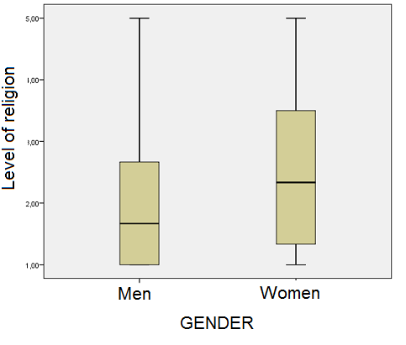

1. (See output above) Indicate the correct statement on the variable “Level of Religion”:
2. The distribution is clearly less variable in women than in men
3. For the men, the median is 1.7 and Q3 is 5
4. For the women, around 50% of them have scores between 1.5 and 3.5
5. (See output above) Indicate the correct statement on the graph on Gender and Religion:
6. This is a box and whiskers diagram
7. This is a stem and leaf diagram
8. This is a histogram
9. We have the following data on the variable “number of brothers/sisters”: 2, 2, 2, 2, 2, 2. Indicate the correct statement:
10. The standard deviation is 1

b) The mean is 0

c) The variance is 0

1. The scores in a given test follow Student’s t distribution with 20 degrees of freedom [*t*(20)], Which score will leave below it exactly 50% of data?
2. 20

b) 0.5

c) 0

1. If we want to run “goodness-of-fit” tests by comparing observed vs. expected frequencies, we will typically use the following theoretical distribution:
2. Student’s t

b) Gaussian [normal]

c) Chi-square

1. Which theoretical distribution can be considered the ratio of two chi-squares?
2. F distribution

b) Student’s t distribution

c) Normal distribution

Answers

BACAB ABAAA BACCC ACCCA