**A few comments on JASP**

This program is excellent to conduct statistical analyses—and it is free. The graphs are great (and much better than the ones with SPSS). JASP is in constant evolution and there are more and more new features every few months.

The input of the program is a .csv file. That is, a “comma separated value” file that you can create with Excel. The “qualitative” and “ordinal” variables can be written as labels. Let’s have a look. Let’s assume that we are measuring the emotional intelligence (in a scale from 0 to 20) for an experimental group that had been trained in mindfulness for 2 weeks and a control group that received classes of geography for two weeks. Let’s assume that there are 10 participants in each group. (The first row is for the name of the columns.) The Excel file would be something like:

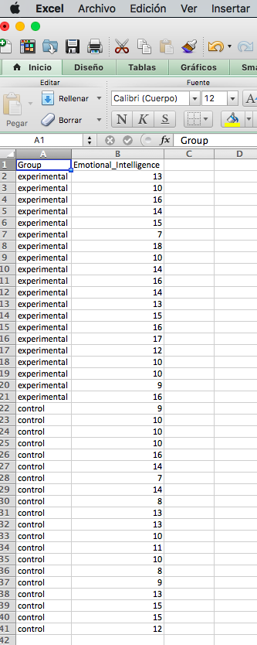

Then you save the file (“example.csv” in the example):

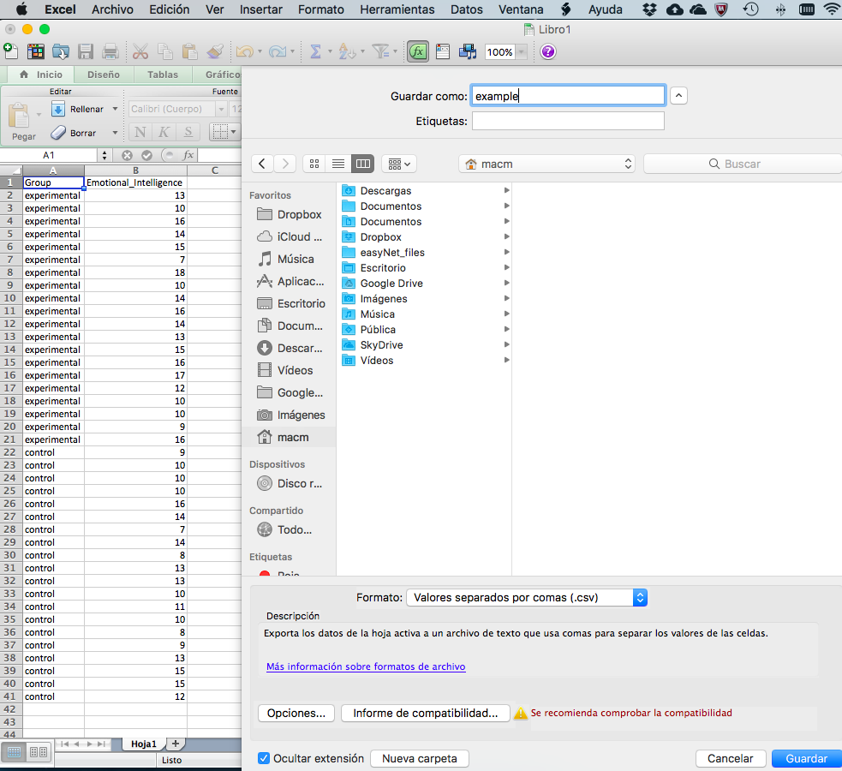

And then you open JASP, and then open the file:

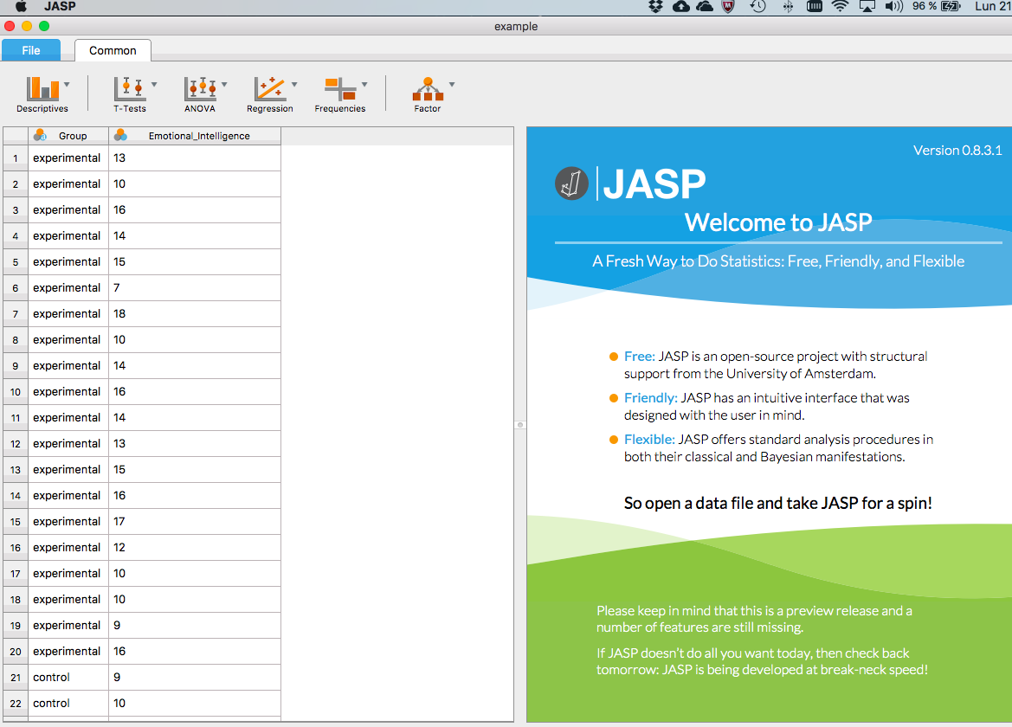

And let’s assume that you want to have the box and whisker diagram (and Descriptive analyses):

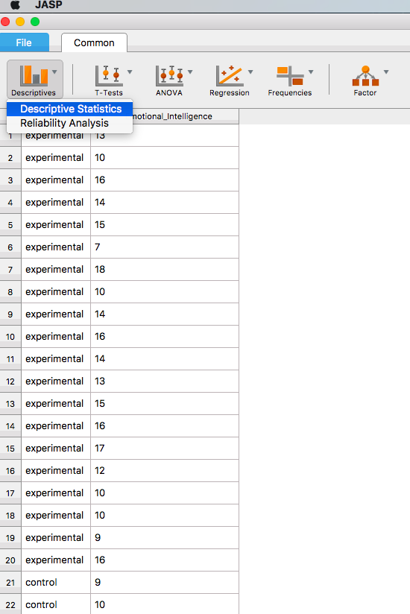

This is the output:

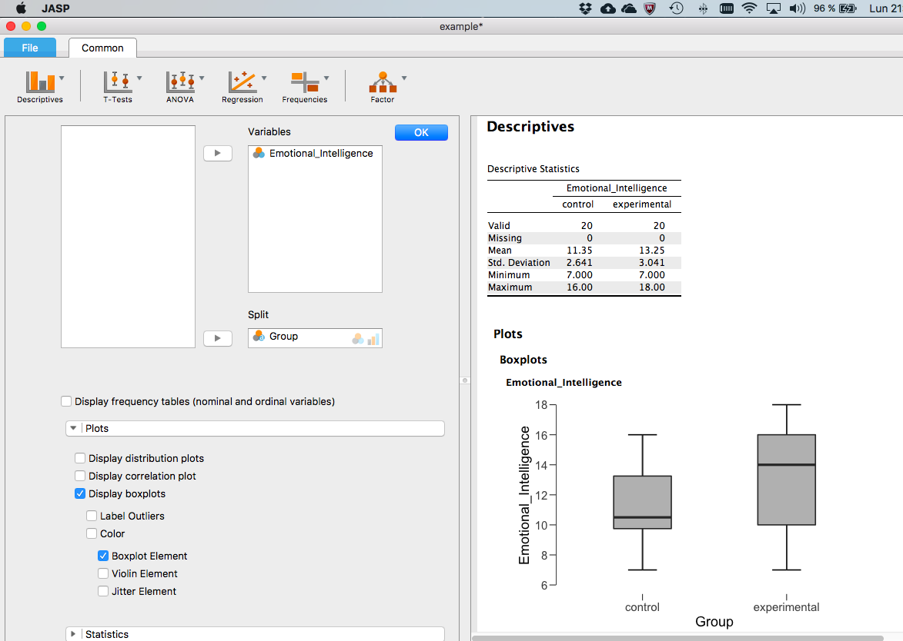

and you can also get some statistics, of course:

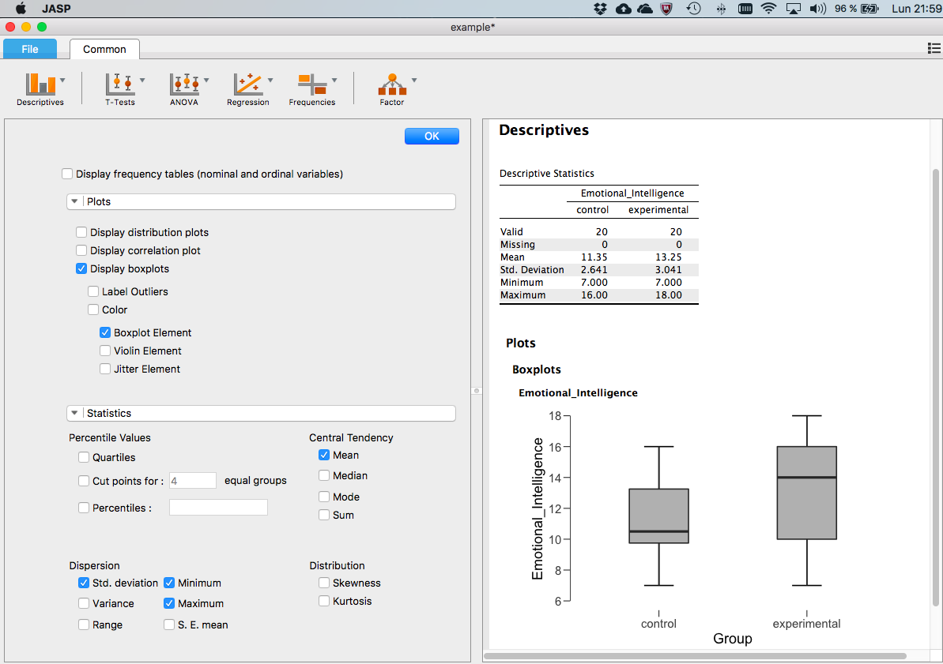

Furthermore, if you want to compute the correlation between several variables, the program offers really nice scatterplots. And much more…

The only limitation at present is that the program is mostly to get stats and graphs, and it does not have the capabilities to select cases or transform or recode…but this is something you can do in Excel anyways.