(answers at the end of the file)

1. Which of the following references follows the APA norms?

a) Jefferies, L. N., Smilek, D., Eich, E., & Enns, J. T. (2008). Emotional valence and arousal interact in attentional control. Psychological Science, 19, 290-295.
b) Jefferies, L. N., Smilek, D., Eich, E., & Enns, J. T. (2008). Emotional valence and arousal interact in attentional control. Psychological Science, 19, 290-295.
c) Jefferies, L. N., Smilek, D., Eich, E., & Enns, J. T. (2008). Emotional valence and arousal interact in attentional control. Psychological Science, 19, 290-295.

CASE 1: The effect of emotional activation on the regulation of the accuracy of witness memory. Witnesses to a crime are likely to experience negative emotions with a high degree of activation, such as anxiety or fear. Negative emotions improve the memory of central type information and worsen the memory of peripheral type information. In this research, we study the effect of emotional activation and type of information on accuracy and response times. Negative emotions were induced in 40 participants, either a high degree of activation (20 of them, randomly) or with a low degree of activation (the other 20). Then, a series of slides was presented on a crime, either central or peripheral. The participants answered questions about the central or peripheral contents of the crime, in which reaction time and accuracy were measured. Results showed that there was a greater accuracy with peripheral than central information in both groups, with no differences depending on the activation level.

2. (Case 1) What type of variable is "reaction time"?
a) Dependent, and it is a qualitative variable
b) Independent, and it is an ordinal variable
c) Dependent, and it is a quantitative variable

3. (Case 1) What type of variable is "Type of information" (central, peripheral)?
a) Qualitative
b) Quantitative (Continuous)
c) Quantitative (Discrete)

4. (Case 1) If, when analysing the reaction times, we observe many extreme scores, which of the following options would you choose to obtain an index of variability?
a) Standard deviation
b) Interquartile (or semi-interquartile) amplitude
c) Amplitude (Total amplitude)

5. (Case 1) The above-described research is:
a) Experimental because an independent variable is manipulated and participants are randomly assigned to conditions
b) Non-experimental, since only questionnaires are presented
c) Quasi-experimental because there is no random assignment to conditions

6. (Case 1) The results described above indicate:
a) Higher averages in accuracy with peripheral than central information
b) Less variability with peripheral than central information
c) Less asymmetry with peripheral than central information

CASE 2: We have a sample of children/adolescents within the autism spectrum, with several variables from the "Child Behavior CheckList (CBCL)" and the "Autism Diagnostic Interview-Revised (ADI-R)" (ADIR-Language; ADIR-Social), as well as sociodemographic information (age, gender).
Statistics (Summary)
 |  | ADIR_Language | SocialProblems_CBCL
N | Valid | 45 | 45
 | Missing | 0 | 0
Mean |  | 9.76 | 9.89
Median |  | 9.00 | 10.00
Mode |  | 5 | 11
Std. Deviation |  | 3.431 | 2.639
Variance |  | 11.771 | 6.965
Skewness |  | .664 | -.161
Std. Error of Skewness |  | .354 | .354
Kurtosis |  | -.072 | -.818
Std. Error of Kurtosis |  | .695 | .695
Range |  | XXX | XXX
Minimum |  | 5 | 4
Maximum |  | 17 | 14
Percentiles | 25 | 6.00 | 7.50
 | 50 | 9.00 | 10.00
 | 75 | XXX | XXX

7. (Output above) Which is the correct statement on the skewness of the distributions of ADIR-Language and Number of Social Problems in CBCL?
a) ADIR Language shows some positive asymmetry while Number of Social Problems in CBCL shows minimal negative asymmetry.
b) Both distributions show positive asymmetry
c) Both distributions show negative asymmetry.

8. (Output above) Which index of central tendency would you choose for Number of Social Problems with the CBCL?
a) Arithmetic mean
b) Mode, because that the variable is ordinal
c) Median, because the summary shows five outliers far from the rest

9. (Output above) Indicate the correct statement with respect to ADIR-Language:
a) 25% of the cases are below the score of 7.50.
b) The index of kurtosis is close to that of the normal distribution.
c) Exactly 50% of the cases are below the 9.76 score.
10. (Output above) What measure of association would you use if you want to examine the relationship between ADIR Language and Number of Social Problems in CBCL?
a) Pearson correlation, unless the relationship is non-linear
b) Spearman correlation, because both variables are ordinal
c) Cramer's V correlation, because one of the two variables is qualitative

11. (Output above) When indicating an index of variability for Number of Social Problems in CBCL in a paper, from the options in the table, we will choose:
a) Variance only
b) Standard deviation only
c) Indistinctly both

Variables Entered/Removedª
Model | Variables Entered | Variables Removed | Method
1 | AGE, ADIR_social, ADIR_language^{b} | . | Enter
a. Dependent Variable: Social problems CBCL
b. All requested variables entered.

Model Summary
Model | R | R Square | Adjusted R Square | Std. Error of the Estimate
1 | .408ª | .166 | .105 | 2.496
a. Predictors: (Constant), AGE, ADIR_social, ADIR_language

ANOVAª
Model |  | Sum of Squares | df | Mean Square | F | Sig.
1 | Regression | 50.941 | 3 | 16.980 | 2.725 | .056^{b}
 | Residual | 255.504 | 41 | 6.232
 | Total | 306.444 | 44
a. Dependent Variable: Social problems CBCL
b. Predictors: (Constant), AGE, ADIR_social, ADIR_language

Coefficientsª
Model |  | Unstandardized Coefficients |  | Standardized Coefficients | t | Sig.
 |  | B | Std. Error | Beta
1 | (Constant) | 9.021 | 2.376 |  | 3.797 | .000
 | ADIR_social | .253 | .093 | .443 | 2.729 | .009
 | ADIR_language | -.248 | .127 | -.323 | -1.961 | .057
 | AGE | -.079 | .141 | -.081 | -.560 | .578
a. Dependent Variable: Social problems CBCL

12. (Output above) When looking at the regression equation, we can deduce that:
a) There are serious collinearity problems
b) Age (as a predictor) adds almost nothing to the equation
c) There are no collinearity problems.

13. (Output above) What predictors have a direct relationship with Number of social problems in CBCL?
a) Only ADIR-Social
b) The three predictors
c) Only ADIR-Language and Age

14. (Output above) Explaining the variable Number of Social Problems in CBCL we can conclude that:
a) The regression equation only explains 10.5% of the variance
b) The best predictor is ADIR-Language
c) The Pearson's correlation between age and social problems is -0.079
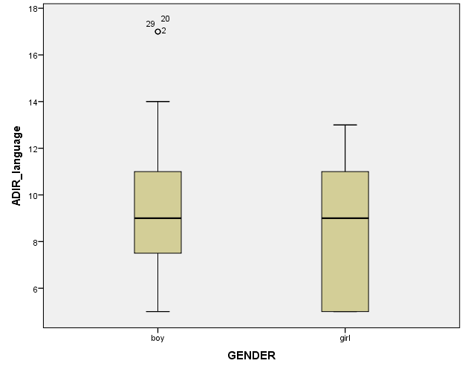
15. (Output above) Indicate the correct alternative on the graph:
a) The distance between the Percentile 75 and Percentile 25 is similar for boys and girls.
b) The median and 25th percentile are very similar in boys and girls.
c) There are several atypical scores for boys, but not for girls.

16. (Output above) Indicate the correct alternative on the graph:
a) This is a diagram of box and whiskers.
b) This is a diagram of stem and leaves
c) This is a histogram

17. We know that the probability density function of a random variable X is f(x)=1 for 0<X<1 and f(x)=0 for all other values of X. What is the value of F(0.75)?
a) 1
b) 0
c) 0.75

18. Which of the following distribution can never result in negative values? :
a) Student’s t
b) Gaussian (normal)
c) Fisher’s F

19. What distribution has a high similarity to N(0,1) [normal distribution with mean 0 and standard deviation 1] when there are many degrees of freedom?
a) Chi-square
b) Student’s t
c) Fisher’s F

20. We have a dataset that shows a very clear positive asymmetry. If we perform a linear transformation (“multiply each original value by the constant 8”), the index of asymmetry with the transformed data:
a) Will be higher b) Will be lower (c) It shall remain the same

BCABA
AAABA
BBAAC
ACCBC

