1. In a classroom of second-grade children, we want to explore the number of disruptive behaviors in a given day—which are measured by a judge looking at the video containing the classes, marking these behaviors when they occur. This type of design appears to be:

(a) Experimental (b) Quasi-experimental (c) Observational

1. In the previous question, the independent variable (IV) is:

(a) the judge (b) the classroom (c) there is no IV

1. In question 1, the number of disruptive behaviors is:
2. ordinal (ordinal scale)
3. quantitative (interval scale) (c) quantitative (ratio scale)
4. Which of the following references follows APA norms?
   1. Yonelinas, A. P. (2002). *The nature of recollection and familiarity: A review of 30 years of research.* Journal of Memory and Language, 46, 441-517. https://doi.org/10.1006/jmla.2002.2864
   2. Yonelinas, A. P. (2002). The nature of recollection and familiarity: A review of 30 years of research. *Journal of Memory and Language, 46*, 441-517. https://doi.org/10.1006/jmla.2002.2864
   3. Yonelinas, A. P. (2002). The nature of recollection and familiarity: A review of 30 years of research. Journal of Memory and Language, 46, 441-517. https://doi.org/10.1006/jmla.2002.2864
5. Figure 1 shows the box-and-whiskers plot showing the opinion of a sample of men (“males” in the plot) and a sample of women (“females” in the plot) regarding their confidence in the existence of God on a Likert-type scale from 1 to 6 points, where 1 is “I do not believe in God”, up to 6 “I know that God exists”). Who believes more in God in the sample, men or women?
   1. women because their median is higher than that of men
   2. men because the size of its box (in the box plot) is greater
   3. women because their average is higher than that of men

Figure 1.

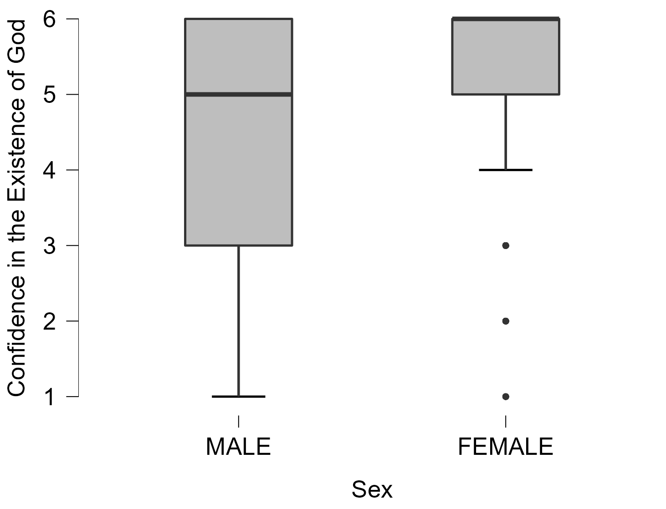

1. Regarding Figure 1, who shows more variability in their answers, men or women?
   1. men, because their standard deviation is higher
   2. men because their interquartile range is greater
   3. women because they have extreme observations (i.e., outliers)
2. Which of the following statistics cannot take negative values?

(a) the variance (b) the covariance (c) the asymmetry coefficient

1. If we wanted to analyze, in a sample from the army, whether there is an association between Educational Level (primary, secondary, …) and Military rank (Ensign, Lieutenant, Captain, …), which statistic should we calculate?

(a) Pearson's r (b) Spearman's Rho (c). Cramer's V

1. What is the minimum number of predictors that may enter a stepwise regression assuming that, originally, we have four predictors?
2. 2, as it is the square root of 4
3. 0, there is no minimum
4. 1, as at least one predictor must enter the equation
5. Which of the following statistics cannot take negative values?

(a) Spearman's Rho (b) the betas in regression (c) Cramer's V

1. When correlating the variables years of schooling of the respondent and number of children we obtain an r = - 0.05. This correlation indicates that:
2. more schooling, fewer children
3. more schooling, more children
4. there are no signs of a linear relationship between both variables
5. We want to predict the number of children people have as a function of the predictors: age, income in euros, and weekly working hours (see Table 1). Does the regression equation predict well the number of children?
   1. Yes, nearly perfectly because the standard errors are very small (less than 0.05)
   2. The other alternatives are wrong
   3. Yes, because all VIFs are quite close to 1 (and much less than 10)

Table 1



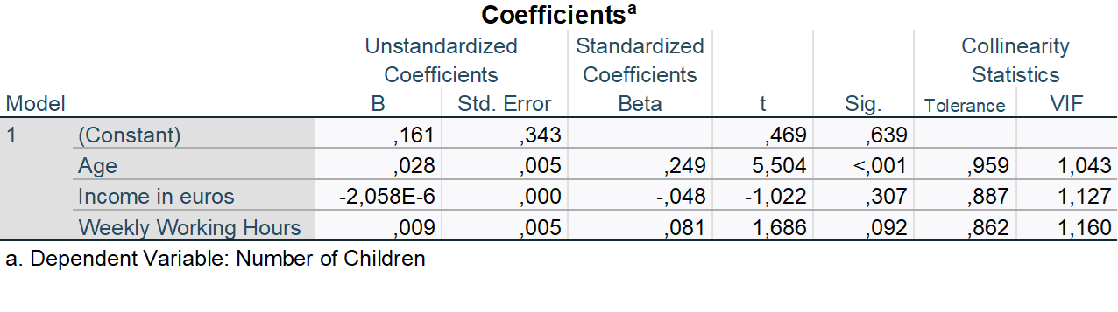

1. What percentage of variance of the dependent variable can be explained by the regression equation (Table 1) ?

a) 24.6% b) 5.4% c) 16.1%

1. Which is the weakest predictor of the model (Table 1)?
2. income
3. age
4. weekly working hours
5. When we want to examine the relationship between the quantitative variables X and Y while controlling for the effect of the quantitative variable Z, we are talking about:
6. Partial Correlation
7. Ordinal Correlation
8. Chi-Square correlation
9. If we are measuring the number of tails in a random experiment that consists of tossing a coin 30 times, the value of F(x):
10. indicates the height of the distribution, it is not a probability
11. indicates the cumulative probability P(X ≤ x)
12. indicates P(X = x)
13. Which of the following probability distributions is asymmetrical?

a) Fisher’s F b) Student’s t c) Normal distribution

1. If we measure the waiting times (in seconds) for a bus line with a fixed schedule (it arrives every 10 minutes), and assuming that we arrive at the bus stop randomly every time, the distribution of waiting times would follow approximately the:

a) Uniform distribution b) Normal distribution c) chi-square distribution

1. Which distribution is commonly used for goodness-of-fit tests?

a) Fisher’s F b) chi-square c) binomial

1. In which section of a written report is the information of the participants indicated in detail?

a) Introduction b) Method c) Results