CASE 1. In a study conducted with school children with prosopagnosia (inability to recognize faces), an intervention based on semantic association was carried out. This involved providing information related to the person's identity (occupation, age, etc.) while participants learned the face. The study participants were randomly assigned to two conditions (experimental group with semantic association intervention and control group without intervention). The results showed an improvement in the ability to recognize faces (measured by the number of faces correctly recognized, from 0 to 10) in the group with semantic association intervention.

**1.** The research described in CASE 1 is:

a) Correlational, as only questionnaires are passed.

b) Experimental because an independent variable is manipulated and participants are randomly assigned to the two conditions.

c) Quasi-experimental because participants are not randomly assigned to each of the two conditions of the independent variable.

**2.** (CASE 1) What type of variable measures the ability to recognize faces in the participants after treatment?

a) Independent, being a ratio variable.

b) Dependent, being a qualitative variable.

c) Dependent, being a quantitative variable.

**3.** The researchers in CASE 1 assess the scores of three participants on the variable "Number of faces correctly recognized". Participant number 1 corresponds to the 55th percentile, patient number 2 to the third quartile, and patient number 3 to the 6th decile. Indicate the correct statement:

a) Patient number 2 is comparatively the best in this variable.

b) Patient number 2 is comparatively the worst in this variable.

c) Patient number 3 is comparatively the best in this variable.

**4.** Indicate which of the following references of an article published in the journal "Studies in Psychology" is correctly edited according to APA standards, except for indicating the DOI:

a) Díaz, A. & Vallejo, M. A. (2011). Influence of placebo in the treatment of headache. *Studies in Psychology, 31*, 53-68.

b) Díaz, A. & Vallejo, M. A. Influence of placebo in the treatment of headache. *Studies in Psychology, 2011*, 31, 53-68.

c) Díaz, A. & Vallejo, M. A. (2011). *Influence of placebo in the treatment of headache*. Studies in Psychology, 31, 53-68.

**5.** Which of the following statistics cannot take negative values?

a) Mean b) Cramer's V c) Covariance

**6.** What measure of association would you use to assess the relationship between the variables "Gender" (male, female) and "Marital status" (married, single, divorced/separated, widowed)?

a) Pearson correlation.

b) Spearman correlation.

c) Cramer's V.

CASE 2. A study has been conducted on the relational dynamics and personality of adolescents, in which information was collected, among other things, about their sexist attitudes, as well as the Big Five personality traits (neuroticism, extraversion, openness to experience, conscientiousness, and agreeableness) and other sociodemographic variables (age, gender, type of institute they study in, etc.). Next, a series of descriptive statistics on three variables of interest in the research are offered: age, sexism, and neuroticism.

**Descriptives**

Age Sexism Neuroticism

N 546 552 551

Missing 6 0 1

Mean 16.8 1.07 2.03

Median 17.0 0.867 2.00

Standard Deviation 0.729 0.927 0.784

Minimum 16.0 0.00 0.00

Maximum 21.0 4.40 4.00

Skewness 1.13 0.899 0.00385

SE Skewness 0.105 0.104 0.104

Kurtosis 3.17 0.273 -0.261

SE Kurtosis 0.209 0.208 0.208

25th percentile 16.0 0.300 1.50

50th percentile 17.0 0.867 2.00

75th percentile 17.0 1.60 2.50

**7.** (CASE 2). Which variable shows the greatest symmetry?

a) Age.

b) Neuroticism.

c) The three variables show very similar skewness indices.

**8.** (CASE 2). If we add 0.2 points to the sexism score of each adolescent...

a) The mean and standard deviation would vary, but not the skewness.

b) The mean, standard deviation, and skewness would vary.

c) The mean would vary, but not the standard deviation nor the skewness.

GRAPH 1. Academic Motivation According to the Grade in Which Students are Enrolled.

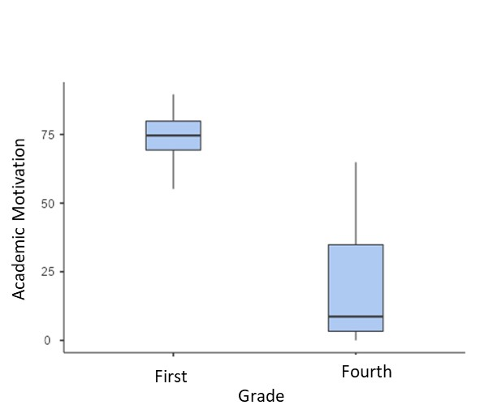

**9.** (GRAPH 1). Which group shows greater variability in their academic motivation scores?

a) First-year students.

b) Fourth-year students.

c) Cannot be determined without additional data.

**10.** (GRAPH 1). The shape of the scores in both groups is:

a) Cannot determine information about skewness with box plots.

b) Approximately symmetric in first-year, but quite asymmetric in fourth-year.

c) Very asymmetric in both groups.

**11.** Correlating "academic motivation" and "average grade" yields an r = 0.73, indicating that:

a) Academic motivation and average grade have a strong and direct relationship.

b) Academic motivation and average grade have an inverse relationship.

c) Both variables are positively related, but the association is weak

**12.** We performed a simple linear regression where "Study Hours" is a predictor of "Hours Watching Tik Tok Videos". At the top of the multiple regression module, we see that the coefficient R is 0.10. We can conclude that:

a) The relationship between both variables is negative (inverse) and very high.

b) The relationship between both variables is positive (direct) but low.

c) The relationship between both variables is low, but we cannot determine from this information if the relationship was positive or negative.

CASE 3. A neuropsychology research group is interested in studying whether different lifestyle factors can affect the memory of older people. They conducted a survey study, recording participants' memory performance using a recall test (scores from 0 to 10), as well as their age (in years), depressive symptoms (on a scale from 0 to 12), and involvement in cognitive activities (like doing Sudoku, playing chess, or reading, measured on a scale from 0 to 3). The results of the multiple linear regression model to predict memory performance are as follows:

| Model fits | | | | |
| --- | --- | --- | --- | --- |
| **Model** | | **R** | **R²** | |
| 1 |  | 0.487 | 0.237 | |
|  | | | | |
| Coefficients | | | | | | | | | |
| **Predictor** | | | | **Estimate (b)** | | **St.Error** | **t** | **p** | **Standarized Estimate (Beta)** |
| Constant | | | | 9.3842 | | 0.05686 | 165.1 | < .001 |  |
| Age | | | | -0.0643 | | 7.92e-4 | -81.2 | < .001 | -0.340 |
| Depression | | | | -0.1083 | | 0.00330 | -32.9 | < .001 | -0.139 |
| Cognitive Abilities | | | | 0.4512 | | 0.00723 | 62.4 | < .001 | 0.263 |

**13.** (CASE 3). What percentage of the variance of the dependent variable does the equation with the three predictors explain?

a) 23.7% b) 8.7% c) 9.4%

**14.**  (CASE 3). What is the most important predictor in the model?

a) Age, indicating that older age leads to higher memory performance.

b) Cognitive activities, indicating that greater participation in cognitive activities leads to higher memory performance.

c) Age, indicating that older age leads to lower memory performance.

**15.**  (CASE 3). When a person's age increases by one year, keeping other predictors constant, how much does the direct memory performance score change?

a) The score increases by 0.0643 points.

b) The score decreases by 0.340 points.

c) The score decreases by 0.0643 points.

**16.** What is the probability of guessing at least one question correctly in an exam of 10 independent questions, each with 3 options, when answering completely at random?

a) 1-(2/3)^10

b) 1-(1/3)^10

c) (2/3)^10-(1/3)^10

**17.** We have the random variable X ("Number of tails in 10 coin tosses"). We are told that there was a value f(x)=1.1 for this random variable X. Is this possible?

a) No, it's impossible.

b) It is possible as long as the total area is 1.

c) It is possible as long as there are no negative probabilities.

**18.** Which type of distribution presents the strongest positive skewness?

a) Chi-square distribution with 30 degrees of freedom.

b) Chi-square distribution with 10 degrees of freedom.

c) The same because the skewness of the chi-square distribution does not vary with the degrees of freedom.

**19.**  A subject's z-score in intelligence is -2.35. How would we interpret this?

a) The subject is well below the average of their sample.

b) The subject is slightly below the average of their sample.

c) There has been an error because a z-score cannot be negative.

**20.** What does it mean for a continuous distribution to have a uniform (rectangular) distribution, as in the case of f(x)=0.2 between 0<X<5?

a) All values of X between 0 and 5 have the same probability density.

b) As the values of X approach 5, they become progressively more probable.

c) The distribution would approach a normal distribution as X increases.