(Answers at the end of the file)

1. Which of the following references, from the journal "Psychological Studies", follows the APA norms:
- Diaz, A., & Vallejo, M. Influence of placebo in the treatment of headaches. Psychological Studies, 2011, 31, 53-68.
- Diaz, A., & Vallejo, M. (2011). Influence of placebo in the treatment of headaches. Psychological Studies, 31, 53-68.
- Diaz, A., & Vallejo, M. Influence of placebo in the treatment of headaches. Psychological Studies, 2011, 31, 53-68.

2. In what section of the research report would you include all the information regarding the instruments/procedure used in the study?
A) Introduction B) Method C) Results

3. If we want to determine the causal relationships on the influence of the shape of a dish (square, round, oval) on the perceived flavor intensity, what research methodology would you use?

A) Correlational B) Quasi-experimental C) Experimental

Abstract. Chronic pain is a major problem in Europe because, as reported in the European study "Pain in Europe", 20% of European population suffers from chronic pain. To evaluate the psychological correlates of pain, we conducted a pilot study with a sample of 50 individuals in Spain. We collected the following variables: age; sex [man, woman]; Perception of Pain [rated on a scale of 1 (minimal pain) to 10 (maximum pain)]; Acceptance of pain [rated on a scale from 1 (minimum acceptance) to 10 (maximum acceptance)]; Neuroticism [rated on a scale of 1 to 50]; impairment of physical/intellectual capacities [assessed by an expert on a scale of 1 (minimal degree of impairment) to 10 (maximum degree of impairment)]; Pain Control (low, moderate, or high).

We present several results from SPSS below.
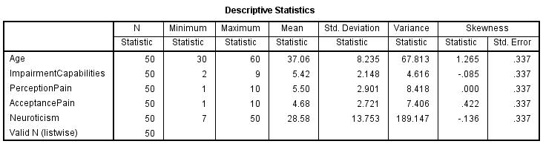

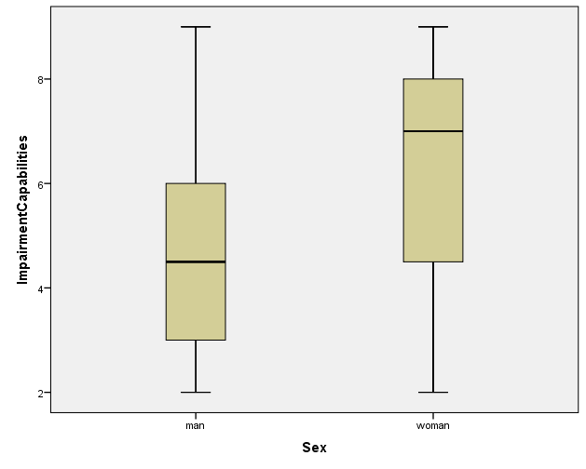
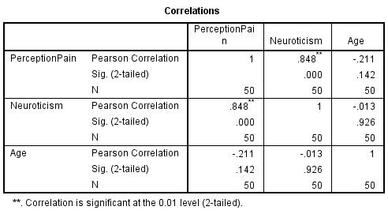
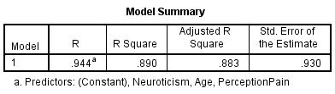
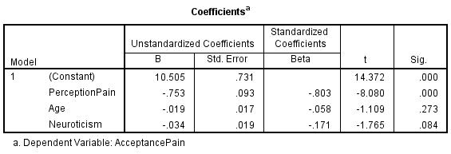

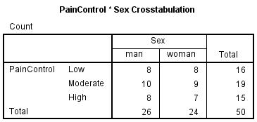
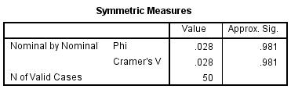
4. Of the following variables, which one has a less skewed distribution?
A) Neuroticism B) Age C) Impairment of Capabilities

5. Anna has a z-score of -1.4 in the variable Age. How old is Anna?
A) 25 y.o. approximately B) 35 y.o. approximately C) 48 y.o. approximately

6. What is the most appropriate graph to represent the relationship between the variables Age and Acceptance of Pain?
A) Scatterplot B) box and whisker graph C) Histogram

7. We want to present an index of variability for the variable Age, which one would you use?
A) 8.235 y.o. B) 1.265 y.o. C) 67.813 y.o.

8. Vanessa’s score in Perception of Pain corresponds to Percentile 20, Peter’s score corresponds Quartile 1 and John’s score corresponds to Decile 8. Who has the higher score in pain perception?
A) Vanessa B) Peter C) John

- If the most appropriate index of central tendency to describe the variable Age is not the mean but the median, what would be the most appropriate variability (dispersion) measure for that variable?
A) Standard deviation B) Variance C) Interquartile range

- From the box and whisker diagram of Impairment of Capabilities as a function of sex, you can conclude that, for the women:
A) The Impairment of Capabilities is greater, and the distribution shows positive asymmetry.
B) The Impairment of Capabilities is greater, and the distribution shows negative asymmetry.
C) The Impairment of Capabilities is smaller, and the distribution shows negative asymmetry.
- In the equation, which is the best predictor for the dependent variable Acceptance of pain?
A) Perception of Pain B) Neuroticism C) Age

- What percentage of the variance of Acceptance of Pain is explained by the regression model?
A) 94.4% B) 93% C) 89%
- From the Pearson correlation coefficient between Neuroticism and Perception of Pain, we can conclude that:
- The higher the Neuroticism, the lower the Perception of Pain
- The relationship between the two variables is very weak
- The higher the Neuroticism, the higher the Perception of Pain

- Which of the following claims is true regarding the relationship between PainControl and Sex:
A) The relationship between the two variables is moderately strong
B) The relationship between the two variables is very strong
C) The relationship between the two variables is very weak

- In the regression model, we introduced simultaneously the three predictors…But if we had performed stepwise regression, what predictors would have entered the regression equation?
- Perception of Pain and, probably, Age
- Perception of Pain and, probably, Neuroticism
- Neuroticism and, probably, Age
-----------------------------------------------------------------------------------------------------------------------------------------------
- If we have a Student's t distribution with 100 degrees of freedom, the distribution will be virtually...
- An F-distribution with 100,100 degrees of freedom
- An F-distribution with 100 degrees of freedom
- A normal distribution, N(0,1)

- What is the probability of having at least one response correct from a 20-question multiple-choice exam (3 alternatives per question) when we answer all questions randomly?
A) 1- (2/3)²⁰
B) (2/3)²⁰-(1/3)²⁰
C) 1- (1/3)²⁰

- In a game consisting of rolling a dice (for instance, if a "6" you receive 10 €, if a "5" you receive 7 €, ...), how can we determine if it's worth playing in the long run?
A) By determining the probability density function of the continuous random variable “gain”
B) By calculating the three quartiles in a normal distribution, N(0,1)
C) By calculating the expected value of the random variable “gain”

- If we have a scatter plot between Solitude and Intelligence and there is a strong relationship but it is not linear, what would you do?
A) I would calculate the Pearson correlation coefficient.
B) I would perform a nonlinear transformation in (at least) one of the variables; if the relationship after the transformation were approximately linear, then I’d calculate the Pearson correlation coefficient.
C) I would transform both variables to standard scores, and then I’d calculate the Pearson correlation coefficient.

- If we have a variable measured in a nominal scale, what measure/s of central tendency can we compute?
A) Mode B) None C) Mode and Median

Answers
BBCCA
AACCB
ACCCB
CACBA

