**ALLIANCE FOR ORGANIZATIONAL PSYCHOLOGY INITIATIVE**

On the 2nd of April 2009, during the SIOP annual conference opening plenary, Division 1 of Organizational Psychology of the International Association of Applied Psychology, the European Association of Work and Organizational Psychology, and the Society for Industrial and Organizational Psychology, signed a declaration to initiate an open and collaborative process with the objective of creating and promoting an Alliance for Organizational Psychology.

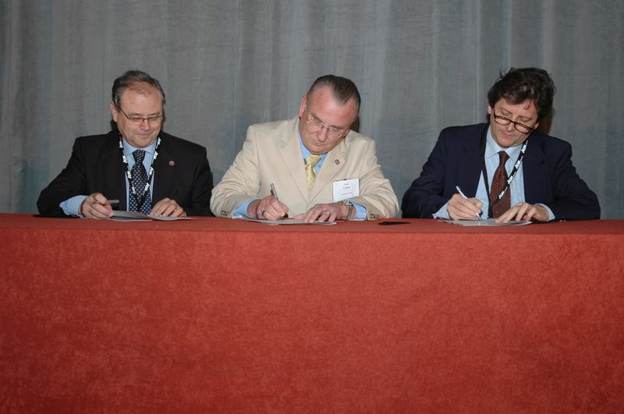

**During the annual 2009 SIOP conference. José M. Peiró, Gary Latham and Franco Fraccaroli signed a declaration of collaboration for the Alliance for Organizational Psychology.**

The green light for the creation of this alliance was given by the IAAP Board of Directors at the last meeting in Berlin in 2008. At this meeting José María Peiró, president of the Division 1, asked for the approval to start the cooperation with SIOP and EAWOP that would lead to a letter of agreement between implied associations. After obtaining the approval by the IAAP Board of Officers, the Presidents of the three associations signed a declaration to organize an open and collaborative process with the objective of founding the Alliance for Organizational Psychology.

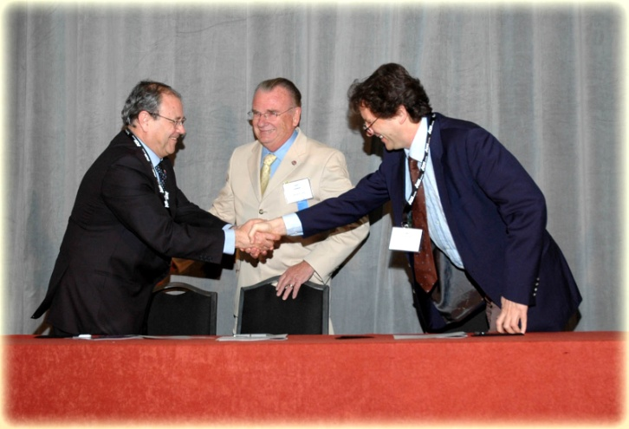

The mission of the Alliance for Organizational Psychology (AOP) is envisioned as to support and advance the science and practice of organizational psychology in the global world, and to expand its scope of application and contribution to society to improve the quality of working life. The Alliance should enhance the contributions of organizational psychology in the global society, to advance the science and practice of organizational psychology internationally and to promote cross-national cooperation and more effective communication among the members of the associations taking part in the Alliance.

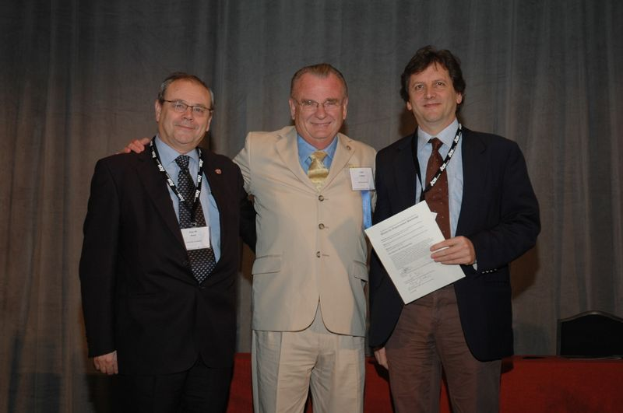

During 2009 and the first half of 2010, representatives from the three associations will draft articles of incorporation, bylaws, and operational guidelines. The current plan is to establish the Alliance formally during the International Congress of Applied Psychology, July 11-16, 2010, in Melbourne, Australia. Any comments, suggestions, or ideas regarding this initiative are more than welcome. You could forward them to our mailing list ([iaapdivision1@listserv.cop.es](mailto:iaapdivision1@listserv.cop.es)) so that all our members might have an opportunity to participate in the discussion.

For more information regarding this initiative and for the updates and progress, please visit [www.allianceorgpsych.org](http://www.allianceorgpsych.org).