 |  |  | 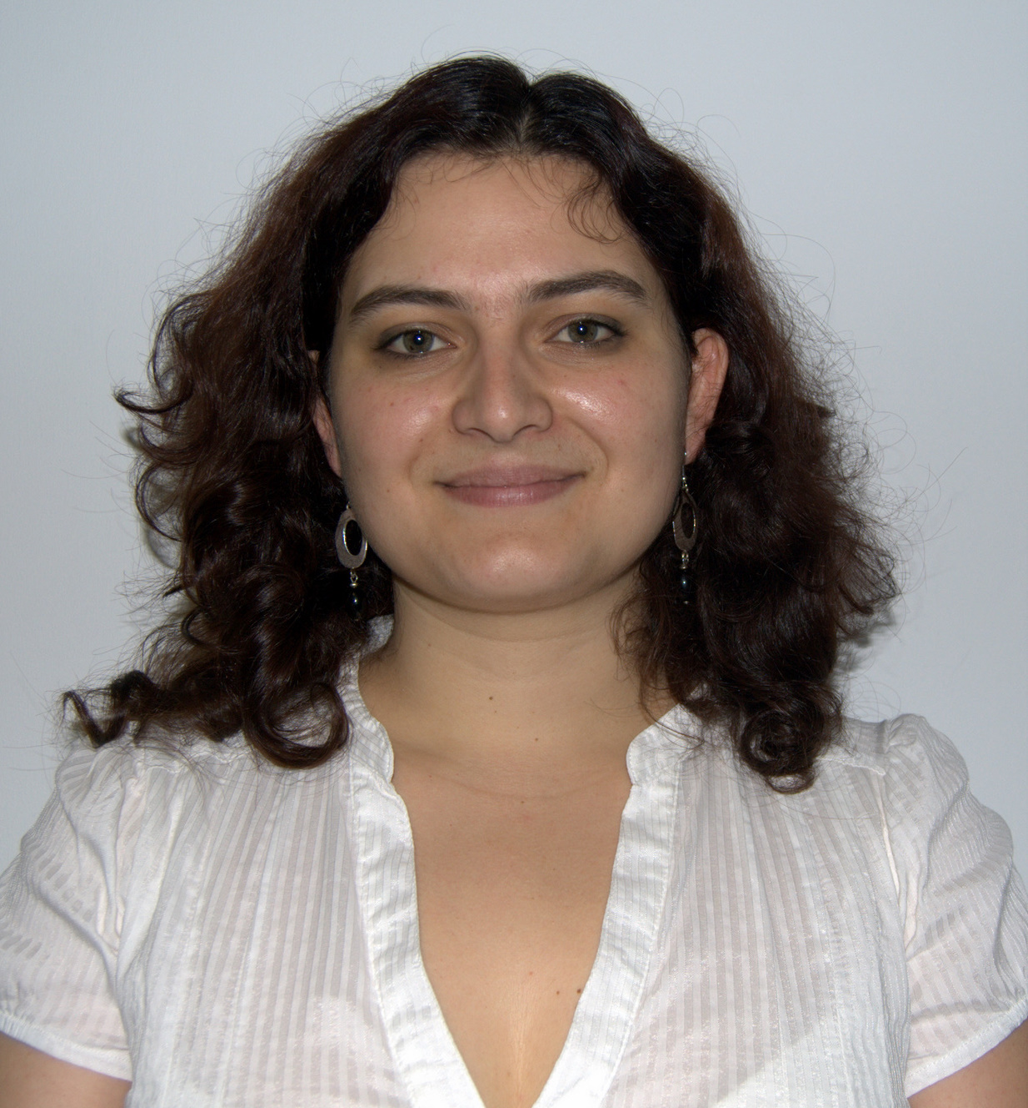
 | Europass-Curriculum Vitae
 | Personal Information
 | Surname(s) / First(s) name(s) |  | Martins, Maria Helena Gonçalves
 | Mobile Phone |  | +351 933264219 |  |  |  |  |  |  |  |  |  | 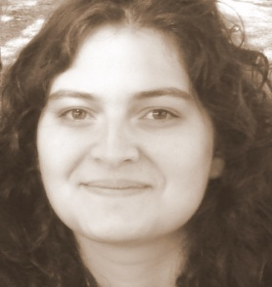
Address |  |  | Porto, Portugal
 | e-mail adresse(s) |  | helenagmartins@gmail.com |  |  |  |  |  |  |  | helenagmartins@hotmail.com
 | Nationality |  | Portuguese
 | Birthdate |  | 21/1/1981 (29 years old)
 | Driving License |  | n.º BR – 305489-8, since 14/11/2001
 | Professional Experience
 | Dates |  | Since September 2008
 | Employer |  | INSTITUTO POLITÉCNICO DO PORTO - ESCOLA SUPERIOR DE TECNOLOGIAS DE SAÚDE DO PORTO
 | Job |  | Lecturer
 | Main Activities and Responsibilities |  | - Undergraduate Subjects: Psycho-sociology of the Organizations and School Life Management, Psycho-sociology  - Post Graduate Subjects: Organizational Behaviour and Human Resources Management
 | Dates |  | September 2008 – September 2009
 | Employer |  | ATLANCO
 | Job |  | HR Consultant
 | Main Activities and Responsibilities |  | - Commercial contact with new clients;  - Designing and developing innovative and custom made training programs for companies;  - Designing and developing innovative training programs for individuals;  - Training management and evaluation.
 | Dates |  | March to October 2006
 | Employer |  | MINHOSOFT
 | Job |  | Training Consultant
 | Main Activities and Responsibilities |  | - Contacting companies and establishing commercial partnerships;  - Elaborating and coordinating training projects;
 | Dates |  | January 2006 to January 2008
 | Employer |  | CENTRO DE NOVAS OPORTUNIDADES DO ANTUÃ
 | Job |  | Accreditation of Prior Learning Professional
 | Main Activities and Responsibilities |  | - Orienting the candidates through the APL Process;  - Evaluating competences in an individual and collective setting;  - Issuing statements and reports on the candidates’ performance;
 | Dates |  | Since January 2005
 | Employer |  | TECNIN/QUALITIVIDADE
 | Job |  | External Trainer (Behavioural area)
 | Main Activities and Responsibilities |  | - Developing innovating, interactive training sessions and manuals; |  |  |  |  |  |  |  |  |  |  |  |  |  | Main Activities and Responsibilities
 | Academic background
 | Dates |  | Since September 2009
 | Name |  | PhD in Management Studies
 | Responsible Organization |  | University of Porto
 | Dates |  | September 2006 to July 2008
 | Name |  | European Erasmus Mundus Masters on Work, Organizations and Personnel Psychology (WOP-P)
 | Website |  | www.erasmuswop.org
 | Responsible Organizations |  | University of Coimbra and University of Valencia
 | Dates |  | September 2000 to July 2005
 | Degree |  | Graduation in Psychology
 | Responsible Organization |  | University of Minho
Publications and Communications
 |  |  | Communication and proceedings, together with Teresa Rebelo (University of Coimbra, Portugal) and Inés Tomás (University of Valencia, Spain): “The impact of Firm-promoted Accreditation of Prior Learning Processes on the Worker-Organization Relationship”. 14/7/2008
 |  |  | Instrumentos de Avaliação Psicológica adaptados à População Portuguesa (in press– Quarteto Editores)
 |  |  | Book Chapter “A Escala de Compromisso Organizacional – Afectivo, Normativo e de Continuidade (ECO-ANC)”, (The Organizational Commitment Scale – Affective, Normative and Commitment Scale) together with Teresa Rebelo (University of Coimbra, Portugal) and Inés Tomás (University of Valencia, Spain).
 |  |  | IV Conferência de Desenvolvimento Vocacional – Universidade do Minho – 28/2/2008
 |  |  | Communication and proceedings, together with Teresa Rebelo (University of Coimbra, Portugal) and Inés Tomás (University of Valencia, Spain) “O Impacto da Promoção do Processo de RVCC pelas Empresas na Relação do Trabalhador com a Organização.” (The impact of Firm-promoted Accreditation of Prior Learning Processes on the Worker-Organization Relationship).
 | Personal Skills and Competencies
 | Mother tongue |  | Portuguese
 | Other idioms |  |  | Understanding |  |  |  |  | Conversation |  |  |  |  |  | Writing
 | Self-Evaluation European Level |  |  | Oral Understanding |  | Reading |  |  | Verbal interaction |  |  | Verbal Production
 | English |  |  | C2 | Proficient User | C2 | Proficient User |  | C2 | Proficient User |  | C2 |  | Proficient User | C2 | Proficient User
 | French |  |  | C1 | Proficient User | C2 | Proficient User |  | C1 | Proficient User |  | C1 |  | Proficient User | C1 | Proficient User
 | Spanish |  |  | C1 | Proficient User | C2 | Proficient User |  | C1 | Proficient User |  | C1 |  | Proficient User | B2 | Independent User
 | German |  |  | A2 | Basic User | A1 | Basic User |  | A1 | Basic User |  | A1 |  | Basic User | A1 | Basic User
 | Social Skills and Competences |  | - Team spirit;  - Adaptability and love of multicultural experiences (I did Erasmus in Valencia and I’m involved in Couch Surfing);  - Communicational and commercial competences obtained by training and professional experience;  - I do volunteer work in the children’s oncology section of Porto for Acreditar – Associação de Pais e Amigos de Crianças com Cancro;
 | Organization Skills and Competences |  | - Dynamics and Pro-activeness;  - Leadership (I’ve coordinated several projects and associations in College)
 | Computer Skills and Competences |  | Microsoft Office (Word, Excel, Access, PowerPoint and Outlook), SPSS – Statistics Program for Social Sciences; Internet Explorer; Mozilla Firefox; GTT;
 | Other Information |  | I’m available for travelling and/or changing residence or country

