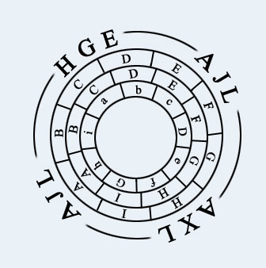

izkuntzalari Gazteen Elkartea | Asociación de Xoves Lingüistas
Associació de Joves Lingüistes | Asociación de Jóvenes Lingüistas

XIX CONFERENCE OF THE YOUNG LINGUISTS ASSOCIATION

UNIVERSITY OF VALENCIA, 10-12 MARCH 2004
(REGISTRATION FORM)

Principio del formulario
FAMILY NAME(S):
FIRST NAME: PASSPORT:
UNIVERSITY:
ADDRESS:
COUNTRY:
ZIP CODE:
TELEPHONE: E-MAIL:
I WOULD LIKE TO PARTICIPATE IN THE XIX INTERNATIONAL CONFERENCE OF THE YOUNG LINGUISTS ASSOCIATION AS:
ASSOCIATION MEMBER SPEAKER: 36€ _____
NON-MEMBER SPEAKER: 42€ _____
NON-MEMBER & NON-SPEAKER ATTENDANT: 20€ _____
PRESENTATION OF A PAPER?
YES _____
NO _____
PAPER TITLE:
RESEARCH FIELD:
PHONETICS AND PHONOLOGY _____
MORPHOLOGY _____
SYNTAX _____
SEMANTICS AND LEXICOLOGY _____
PRAGMATICS _____
DISCOURSE ANALYSIS _____
SOCIOLONGUISTICS _____
PSICOLNGUISTICS _____
APPLIED LINGUISTICS _____
THEORY AND LINGUISTIC METHODOLOGY _____
COMPUTATIONAL LINGUISTICS _____
LINGUISTIC HISTORIOGRAPHY _____
LINGUISTIC TYPOLOGY _____
LEXICOGRAPHY _____
ONOMASTICS _____
TRANSLATION _____
DIALECTOLOGY _____
OTHER, SPECIFY:
LANGUAGE OF COMMUNICATION:
LANGUAGE PREFERRED FOR THE FOLLOWING CALL:
ABSTRACT (15- 25 lines)

Final del formulario

