Hands-on sustainability:

How can we contribute to the construction of a sustainable future?

Amparo Vilches, *Benito Vázquez Dorrío

and Daniel Gil Pérez

Departament de Didàctica de les Ciències Experimentals i Socials, Universitat de València

*Dpto. Física Aplicada. Universidade de Vigo

amparo.vilches@uv.es, bvazquez@uvigo.es, daniel.gil@uv.es

Abstract. The scant response of citizens to reiterated calls for attention to the serious problems affecting all humanity leads to a belief that there are serious obstacles that must be studied in order to understand how to overcome them.
In this work we will focus on one of the more important of these obstacles – the widespread yet incorrect perception that the action of the individual is of little importance – and we will attempt to show from an eminently practical viewpoint the relevance, for the construction of a sustainable future, of what each one of us does or does not do, in general - as a consumer, professional and citizen - and in particular – in the sphere of education.

Keywords. Planetary emergency, Environmental Education for a sustainable future, Hands-on Science.

1. Introduction

Until the second half of the 20th century, our planet seemed huge, practically limitless, and the effects of human activity remained locally compartmentalised. These compartments, however, have begun to fade over recent decades and many problems have taken on a global character that has made “the world situation” a direct cause for concern. News on climate change, environmental deterioration, excessive, unchecked consumption of energy and raw materials with the subsequent exhaustion of resources and, in short, the serious situation of planetary emergency in which we are immersed [1-3], have all jumped to the front pages and opinion sections of the media. Calls by the international scientific community, NGOs and the UN itself, are multiplying. At the same time, there are over twenty international agreements on environmental protection linked to the same number again of protocols putting them into practice [4-5]. And yet most citizens, including policy makers and educators, continue not to react in the face of serious threats of social collapse [6] and even the extinction of our species [7], which is in principle in contradiction to existing positive social interest, as seen in innumerable information resources regarding necessary respect for the environment [8-11].
It can be concluded, therefore, that there are serious obstacles which hinder necessary changes in attitude and behaviour and impede even a determined involvement of educators from all areas and levels to contribute to the formation of citizens aware of the situation of planetary emergency and its causes, and prepared to adopt the necessary measures to face up to the situation [12].
It is necessary, then, to keep up efforts to bring these obstacles to light and study how to overcome them. In this article we focus on one that most directly hinders finding a positive answer to the key question “How can each one of us contribute to building a sustainable future?” This is a reference to the widespread perception that individual actions are irrelevant. We will critically analyse this misconception and put forward some proposals for action to overcome it.

2. Are individual actions irrelevant?

Participants in courses and workshops on education for sustainability often express doubt about the effectiveness of individual actions, small changes in our habits or our lifestyles, that education can foster: The problems of exhausted energy resources and pollution – they usually state, for instance – are due, fundamentally, to big industry; what each one of us can do regarding this is, comparatively, insignificant.
Quite simple calculations that participants themselves can make with regard to everyday situations (Figure 1) show, however, that individual commitment has a global repercussion. For example, although small reductions in energy consumption mean a small per capita saving, when this is multiplied by millions of people it can mean huge amounts of energy, with the subsequent reduction in pollution.
These calculations and estimations can be reinforced with hands-on activities [13-14] such as, for example, determining how much water is lost from a badly turned off dripping tap.
It should be stressed, therefore, that not only is it not true that our small actions are insignificant and irrelevant, but also that we are dealing with necessary, indispensable measures if we want to contribute in progressing towards a sustainable future and increased involvement of citizens.
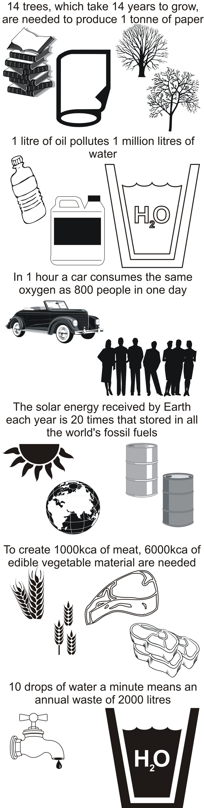
Figure 1. The importance of individual actions
For the future is going to depend to a great extent upon the model of living we follow and, although attempts are made to impose this on us, the capacity we all have to change it should not be underestimated [11]. Agenda 21, fruit of the first Earth Summit, already indicated that participation by civil society is a vital element in the advance towards sustainability.
A systematic effort is therefore necessary to incorporate education for sustainability as a key objective in the formation of future citizens, and make the need understood for actions that contribute to a sustainable future in several spheres: responsible consumption, professional activity and action by citizens.
A careful follow up of these actions is also needed. Continued educational activities are therefore required that transform our conceptions, our habits, our perspectives… and that guide us in the actions to be taken.
But it is not enough to understand the importance of our actions and have a general view of the fields of action: we need to move into action. In the same way that scientific education calls for hands-on experiments, education for sustainability demands involvement in specific actions that need to be defined and transformed into a commitment to act.

3. Specific proposals

In different workshops imparted to secondary and university students and trainee and working teachers, we have been able to ascertain that collective work in small groups, followed by group sharing, gives rise to numerous proposals for concrete action that can become the basis for real commitment that can be (self) evaluated for the building of a sustainable future.
Together with the classic “3Rs” (reduce, reuse and recycle), that correspond to us as consumers and that can give rise to numerous specific proposals of interest, another three guideline principles also arise that respond to our roles as professionals and citizens:
- Use technologies that respect the environment and people
- Contribute to the education of citizens (we are all educators as we interact with each other)
- Participate in socio-political actions for sustainability
And it is equally understood that there is a need for continual evaluation of the effects of our actions that introduces, if needs be, corrective offsets.
They are proposals that occur again and again in the workshops, as the fruit of collective work, and they turn out to coincide essentially with what is collected in wide-ranging literature [18-22]. Below (Boxes B1 to B7) we outline the most frequently formulated specific proposals:

B1. Reduce (Do no waste resources) [26-30]

Reduce water consumption, for hygiene, watering, swimming pools…
Short showers
Turn off taps (whilst cleaning teeth, putting on soap, etc.)
Drip feed watering
Reduce energy use for lighting
Use energy saving light bulbs
Switch off unnecessary lights (beat inertia)
Make the most of natural light
Reduce energy consumption in heating and cooling
Insulate housing adequately
Do not programme very high temperatures (wear warmer clothing) or very low temperatures (ventilate better, use canopies…)
Switch off unnecessary radiators or air conditioners
Reduce energy consumption in transport
Use public transport
Use a bicycle and/or go on foot
Organise shared transport
Reduce speed, drive efficiently
Avoid plane travel whenever possible
Avoid lifts whenever possible
Reduce energy consumption in other household appliances
Load washing machines, dishwashers, etc. appropriately
Turn off the TV, PC, etc completely when not in use
Defrost the freezer, check boilers and heaters, etc.
Reduce energy consumption in food, improving it at the same time
Eat more vegetables, pulses and fruit, and less meat
Respect closed seasons and do not eat small, young fish
Avoid exotic products that demand high cost transport
Eat products in season and produced organically
Reduce paper use
Avoid printing documents that can be read on screen
Write, photocopy and print on both sides of the paper
Do not leave excessive margins
Combat Consumerism
Analyse advertising critically
Mute commercials
Do not be pulled in by commercial campaigns around St Valentines, Festive season, etc.
Programme purchases with a needs list

B2. Reuse [23-24]
Print on the other side of already used paper
Collect sink and shower water for the WC
Also collect rain water for watering or WC
Do not use disposable objects
In particular, avoid plastic bags and wrappers, aluminium foil, paper cups, etc.
Substitute them with reusable ones, repair these when necessary for as long as possible
Use recycled and recyclable products (paper, toner, etc)
Encourage the reuse of computers, toys, clothes, etc.
Donate to charities that manage this
Rehabilitate housing
To make it more sustainable (better insulation, etc.) and avoid new construction

B3. Recycle [9,26,31]

Separate waste for selective collection
Take what cannot be left in the usual bin to “civil amenity sites”:
Batteries, mobile phones, computers, oil, toxic chemicals, etc.
Do not pour waste down WCs or drains

B4. Avoid products that do not respect the environment and people [9,26,32]

Personally apply the precaution principal
Do not buy products without finding out how harmful they are: check the ingredients of foodstuffs, cleaning materials, clothes, etc., and avoid those that do not offer guarantees
Avoid sprays and aerosols (use hand sprays)
Apply safety norms at work, at home, etc.
Opt for renewable energies at home, in the car, etc.
Use efficient, low energy, low contamination (A++) household appliances
Reduce battery consumption and use rechargeable ones

B5. Contribute to civil education and action [33-38]

Get well informed and discuss the situation with others (family members, friends, colleagues, students, etc.) and, above all, what we can do
Carry out dissemination and encouragement tasks:
Use the press, Internet, video, ecology fairs, schools materials, etc.
Help raise awareness of unsustainable and closely linked problems such as consumerism, demographic explosion, environmental degradation, extreme inequalities, etc.
Inform about actions we can take and encourage them to be put into practice, promoting campaigns such as the use of energy saving light bulbs, reforestation, responsible parenthood, forming associations, political work, etc.
Aid in conceiving measures for sustainability as an opportunity that guarantees the future of everyone and not as a limitation
Encourage social recognition of positive measures
Study and apply what one can do for sustainability as a professional
Research, innovate, teach…
Contribute to promoting the environment at work, in the neighbourhood and city where we live, etc.

B6. Participate in socio-political actions for sustainability [1, 19, 39]

Respect and help others respect legislation that protects the environment and biodiversity
Avoid contributing to noise, light or visual pollution
Do not smoke where this might damage others, and never throw cigarette butts to the ground
Do not leave rubbish in the woods, on the beach, etc.
Avoid moving to housing that contributes to the destruction of ecosystems
Take care not to damage wildlife
Comply with traffic norms for the protection of people and the environment
Denounce continued growth policies that are incompatible with sustainability
Report ecological crimes:
Illegal tree felling, forest fires, waste dumping, predatory development planning, etc.
Respect and help respect Human Rights
Report any discrimination based on ethnic, social, gender or other reasons
Collaborate actively and/or economically with associations that defend sustainability:
Aid programmes for the Third World, environmental defence, aid to people in difficulty, human rights promotion, etc.
Call for the application of the 0.7 aid for the Third World and contribute personally to this
Promote Fair Trade:
Reject products produced through predatory practices (such as tropical timber, animal pelts, over fishing, predatory tourism, etc.) or that are obtained using a workforce without labour rights, child labour
Support fair trade enterprises
Demand clear informative policies on all the problems
Defend the right for research without ideological censure
Demand the application of the precaution principle
Oppose unilateralism, wars and political predators:
Demand respect for international law
Promote democracy in world institutions (IMF, WTO, World Bank, etc.)
Respect and defend cultural diversity
Respect and defend language diversity
Respect and defend lore, customs and traditions (that do not contravene human rights)
Vote for parties with more favourable policies on sustainability
Work so that governments and political parties take on the defence of sustainability
Demand local, state and universal legislation for environmental protection
“Cyberactivism”: Support solidarity and sustainability campaigns from the computer

B7. Evaluate and offset [40-41]

Carry out personal behaviour audits
At home, with transport, civil and professional action, etc.
Offset the negative repercussions of our acts (CO₂ emissions, use of contaminating products, etc.) through positive actions
Contribute to reforestation, help NGOs,etc.

4. The educational role of action

It is essential, without doubt, to understand the relevance our actions have – what we do or do not do – and construct a global view of the measures in which we can become involved. But educative action cannot be limited to achieving this understanding, taking for granted that this will lead to effective shifts in behaviour: a fundamental obstacle in obtaining the involvement of citizens in building a sustainable future is the reduction of educative action to conceptual study
It is necessary, therefore, to establish action commitments in education centres, workplaces, neighbourhoods and in households themselves, in order to put into practice some of the measures [42] and carry out follow up of the results obtained. These actions, properly evaluated, become the best procedure for profound understanding of the challenges, and the impulse for new commitments.
With this aim it is helpful to transform the specific proposals given above into a follow up or (self) evaluation network, starting with the acquisition of concrete commitments that can be evaluated periodically, such as can be seen in Figure 2.
But before implementing this task in our courses and workshops, it is necessary to create our own network of commitments that can be evaluated, both in the realm of consumers and citizens (which allows us to aim better at those we work with, thanks to knowledge gained through our own experience), and with regards to our professional realm: In what way are we contributing, as educators and researchers, to the Decade of Education for Sustainable Development? What is our response to the call from the United Nations aimed at educators from all areas and levels for us to contribute to the formation of citizens prepared to contribute to the building of a sustainable future?

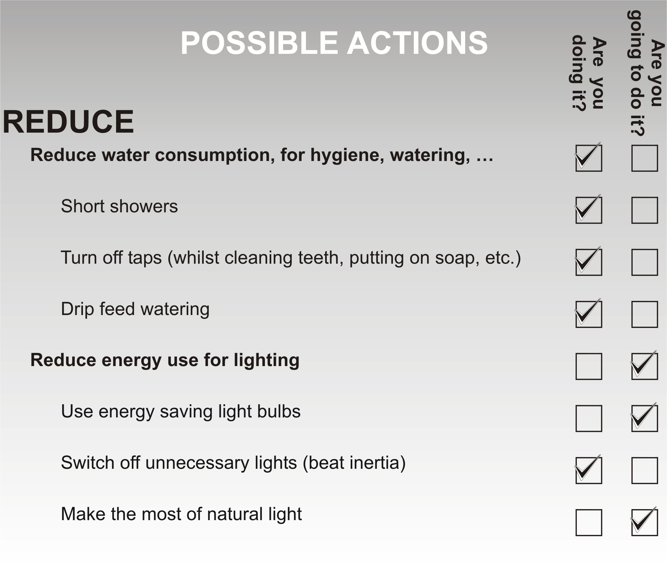
Figure 2. Network of concrete and (self) evaluation commitments

5. Conclusions
We end by remembering that we are at the start of a Decade that will be decisive for the future of humanity in one sense or another: sadly decisive if we cling to our inertia and do not become aware of the need to reverse a process of decay that constantly sends us unmistakable signs in the form of global warming, anti-natural catastrophes, loss of biological and cultural diversity, millions dying through starvation and war – the suicidal fruit of short term interests and fundamentalisms, of dramatic migrations, etc. Fortunately decisive if we are able to create a universal movement in favour of a sustainable future that has to start today. That is the objective that we can and must set ourselves, aware of the difficulties, but determined to contribute, as educators, as scientists and as citizens, to forging the conditions for a sustainable future.

6. Credits
This communication has been conceived as a contribution to the Decade of Education for Sustainable Development [43] adopted by the United Nations for the period 2005-2014.

7. References

[1] A. Vilches, and D. Gil-Pérez, Construyamos un futuro sostenible. Diálogos de supervivencia, Madrid: Cambridge University Presss, 2003.
[2] M. Delibes and M. Delibes de Castro, La Tierra herida. ¿Qué mundo heredarán nuestros hijos? Barcelona: Destino, 2005.
[3] C. Duarte, Cambio Global. Impacto de la actividad humana sobre el sistema Tierra. Madrid: CSIC, 2006.
[4] http://www.biodiv.org/
[5] http://www.unece.org/
[6] J. Diamond, Colapso. Barcelona: Debate, 2006.
[7] F.J. Broswimmer, Ecocidio. Breve historia de la extinción en masa de las especies. Pamplona: Laetoli, 2005.
[8] http://ec.europa.eu/environment/
[9] http://www.wri.org/
[10] http://www.globalreporting.org/
[11] http://www.eyep.info/
[12] D. Gil-Pérez and A. Vilches, La atención al futuro en la educación ciudadana. Posibles obstáculos a superar para su inclusión en la enseñanza de las ciencias. En, Martins, I., Paixao, F. y Marques, R. (Eds.) Perspectivas Ciencia-Tecnología-Sociedade na Inovação da Educação em Ciência, Aveiro: Universidade de Aveiro, 2004.
[13] UNESCO, 700 Science experiments for everyone, Doubleday: New York, 1962.
[14] M.F.M. Costa, B.V. Dorrío, P. Michaelides and S. Divjak, Selected Papers on Hands-on Science, Universidade do Minho: Braga, 2008.
[15] P. Comin and B. Font, Consumo sostenible. Preguntas con respuesta, Barcelona: Icaria, 1999.
[16] L.R. Brown, Salvar el planeta. Plan B: ecología para un mundo en peligro, Barcelona: Paidós, 2004.
[17] A. Calvo Roy and I. Fernández Bayo, Misión Verde: ¡Salva tu planeta!, Madrid: Ediciones SM, 2002.
[18] A. Gore, Una verdad incómoda. La crisis planetaria del calentamiento global y cómo afrontarla, Barcelona: Gedisa, 2007.
[19] E. Laszlo, Tú puedes cambiar el mundo. Manual del ciudadano global para lograr un planeta sostenible y sin violencia, Madrid: Nowtilus, 2004.
[20] A. Pessoa and A. Cassasin, Salvar la Tierra. Barcelona: Egedsa, 2007.
[21] M. Riba, Mañana. Guía de desarrollo sostenible, Barcelona: Intermón Oxfam, 2003.
[22] The Earth Works Group, 50 cosas sencillas que tú puedes hacer para salvar la Tierra, Barcelona: Naturart, 2006.
[23] http://www.unesco.org/water/wwap/
[24] http://www.agua-dulce.org/
[25] http://www.energy.eu/
[26] http://www.idae.es/consejos/
[27] http://www.eufic.org/
[28] http://europa.eu/pol/food/
[29] http://www.vivelaagriculturaecologica.com/
[30] http://www.consumehastamorir.com/
[31] http://www.recyclenow.org/
[32] http://www.eco-label.com/
[33] http://www.enviroliteracy.org/
[34] http://www.setem.org
[35] http://www.actionfornature.org/
[36] http://www.cites.org/
[37] http://www.sellocomerciojusto.org
[38] http://www.ilo.org/
[39] F. Mayor Zaragoza, Un mundo nuevo, Barcelona, UNESCO, Circulo de Lectores, 2000.
[40] http://www.greenpeace.org
[41] http://ecologistasenaccion.org
[42] J.S.M. Moreno and A. Pedrosa, Ecologic Sustainability and Individual and Collective Everyday Practices, In Azeiteiro, U. M. et al. (Eds.) Science and Environmental Education. Frankfurt: Peter Lang, 2006.
[43] http://www.oei.es/decada/

