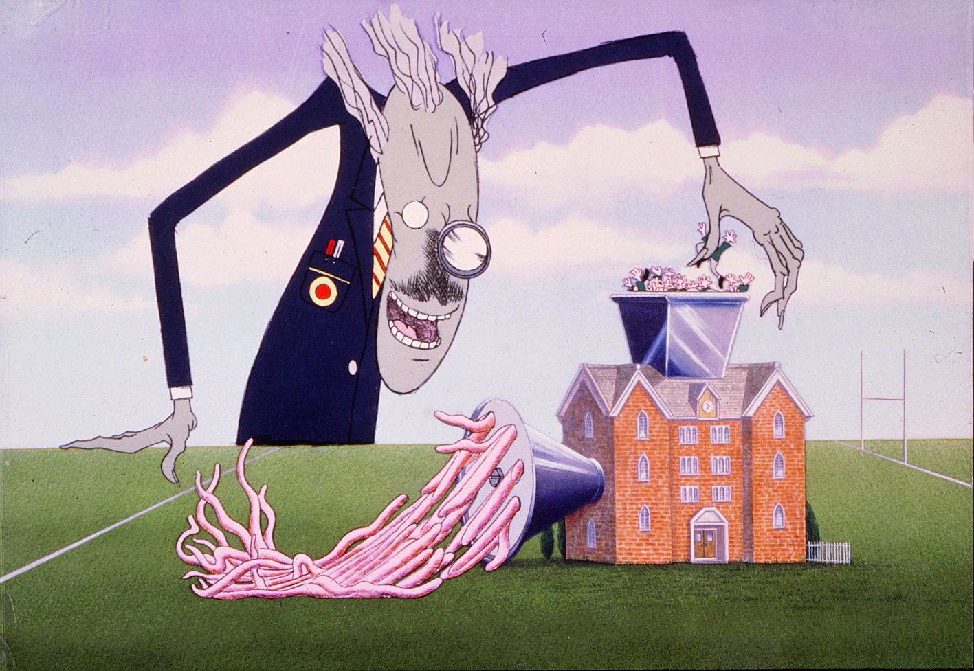
Listen to the song 
Another brick in the wall, verse 2.

Listen to the song and write an essay of 500 words maximum.
What is your opinion about the educational system you’ve been through so far?
Genre: Name at least 5 pros & and 5 cons, explain why they are pros or cons. Then make a final balance of the system itself.
Please do not forget to include a list of bibliographic references (both online and/or printed) at the end of your essay.

