**Exercise 2, 2024 (answers). Statistics-I**

A group of researchers wanted to know the attitude toward a brand after watching an advertisement. In all advertisements appeared a model, but there were four versions of the ad that differed only in the eye color of the model (blue color, brown color, green color, undefined [the eye color cannot be seen]). Participants were randomly assigned to one of the four versions of the ad. After watching the ad, participants had to respond to 10 survey questions about attitudes towards the brand (a 7-point Likert scale). Higher averages correspond to more positive attitudes—the column we have is the averaged to these 10 questions per participant.

*Which is the independent variable? And how many levels?*

The model's eye color, which has 4 levels (blue, brown, green, undefined)

*Which is the dependent variable? Is it quantitative?*

It is the attitude towards the brand.

Yes, it is treated as quantitative (it is an average of 10 questions with a Likert-type scale).

*Is this an experiment? If so, why?*

It is an experiment. The assignment of participants to the groups was random

*Have the researchers used a between-subjects design?*

Yes, each participant was assigned to only ONE group.

*How many rows do we need to analyze the data? And columns*

Rows: As many as participants.

Columns: two, one to indicate the group (1,2,3,4) and another to indicate the dependent variable.

(Actually, one could argue that there are also 10 other columns containing the answers to each of the questions.)

The data are available at <https://www.uv.es/mperea/icolor.csv>. Please save the file and open it with JASP. (We also added a few other variables…) (you can also download the JASP file here <https://www.uv.es/mperea/icolor.jasp>)

*Choose your preferred plot and then interpret the results—you can also have a look at the means per condition. Can you think of a follow-up experiment to pursue this topic?*

The most practical option is a box plot (it is also the most compact): in a single graph we have the distributions of the four conditions. We could have also used four histograms, but it is more difficult to see everything as a whole. And, logically, we must also pay attention to central tendency indices such as the mean, which JASP provides

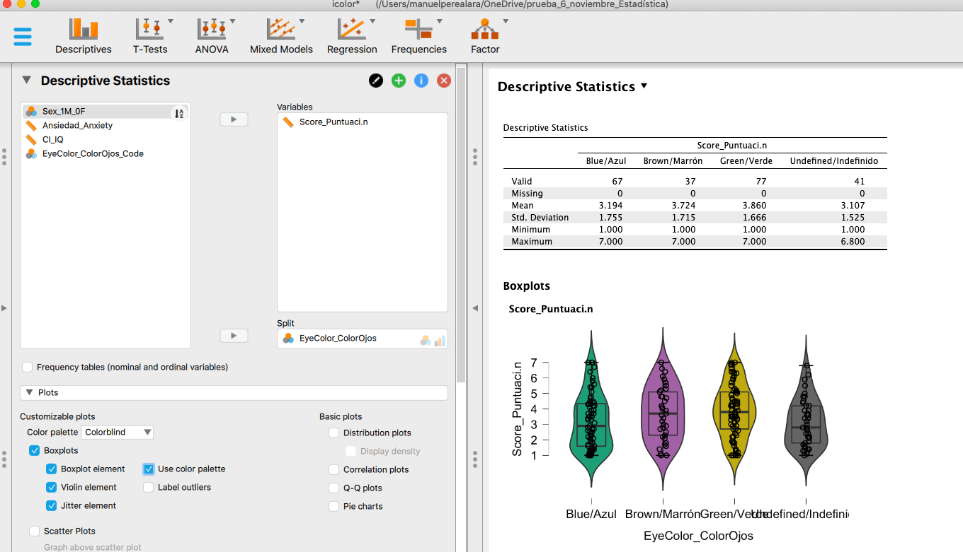

Participants assigned higher scores to the advertisement when the model had brown eyes (M = 3.72) or green eye (M = 3.86) than when s/he had blue eyes (M = 3.19) or the color of the eyes could not be appreciated (M = 3.11).

Why? When interpreting these data, we have to take into account a key element. The experiment was conducted with people from Texas, in which more than 90% of participants were of Hispanic origin. It is possible that people of Hispanic origin could consider the model with blue eyes as “from another group” and therefore that the participants were not the target of the advertisement (that is, they could think that it is directed more to the Anglo-Saxon population ). Logically, to test this hypothesis, the same experiment would have to be carried out in another state in the US where there is a much larger sample of people whose origin was northern Europe (Michigan or Wisconsin, surely).

Incidentally, the experiment could have been done with an “within-subjects” design. In this case, each person would have to evaluate FOUR ads (one for each eye color).

*Was the number of men and women balanced in the set of participants? Which is the scale of measurement? Which plot/s would you prefer? Would you just opt for the frequency table?*

We can make either a bar chart (it is the “Distribution Plot” option) or a pie chart. We have a nominal scale. Actually, the frequency table would be enough. All three options offer essentially the same information.

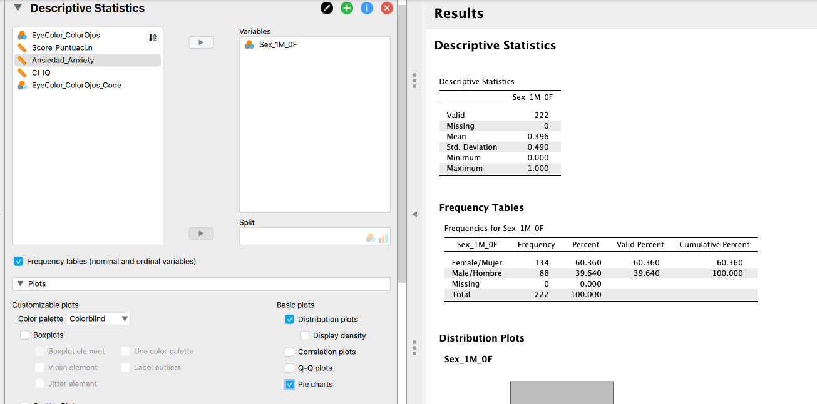

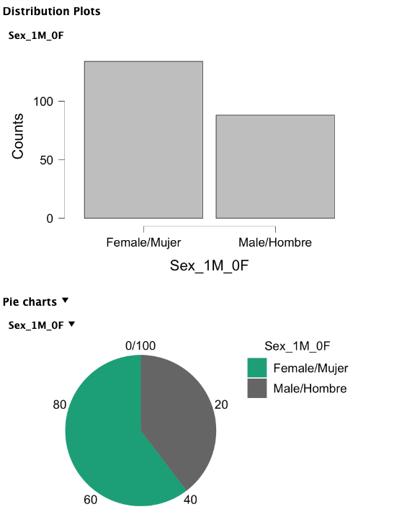

As can be seen above, that the sample was not completely balanced: 60.4% of women vs. 39.6% of men.

*We also obtained a measure of anxiety of the participants. Do you think “anxiety” followed a normal distribution?*

Here we have to plot a histogram and smooth it. How? Well, again you have to choose "Distribution Plot" (being a quantitative variable, JASP displays a histogram) and press the "display density" option to have the smooth curve.

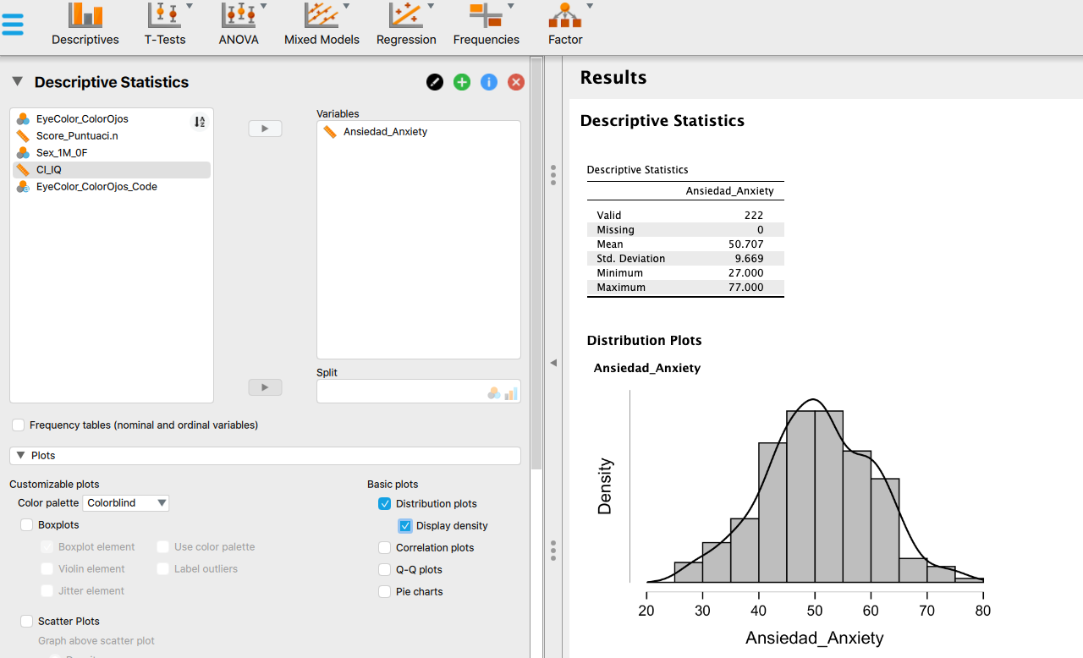

Yes, the distribution looks like a normal distribution — we'll discuss other ways of looking at the “normality” of the curve in later themes.

*Idem for IQ.*

We use the same steps as before. And yes, it seems that intelligence follows roughly a normal distribution.

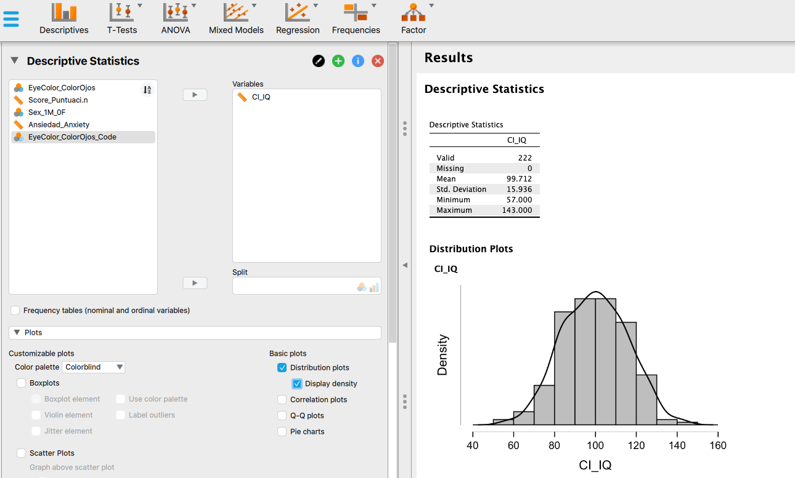

*Are Anxiety and IQ related? Choose the appropriate plot.*

We want to see if both variables are related. In this case, you have to choose “correlation plot”. Note that the scatterplot is accompanied by two other graphs, which are simply the histograms of each of the two variables.

Clearly, there is no relationship between both Anxiety and Intelligence. There is a random cloud of dots.

**Correlation plot**

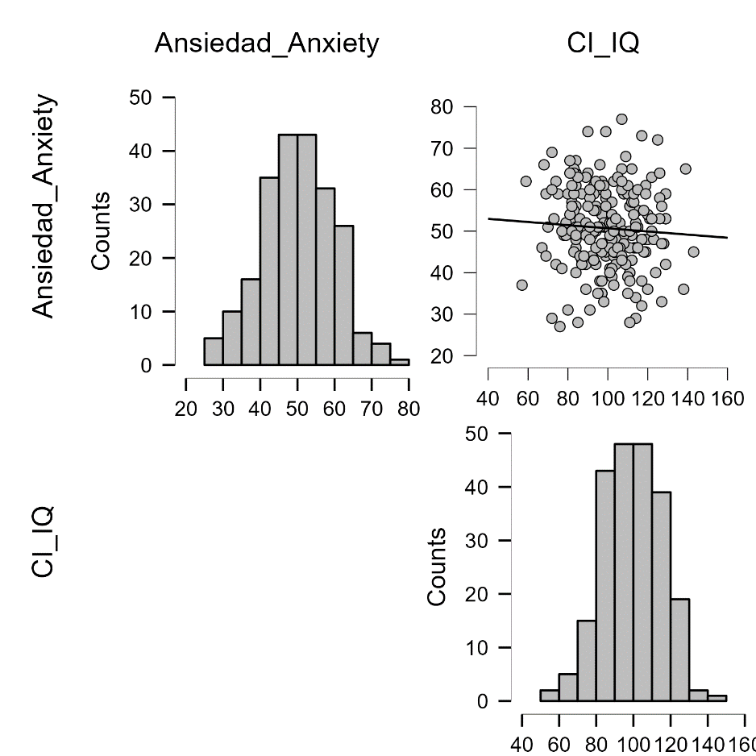

*Can you select only the women in the sample and do the analyses (the ones on the ad) again to see whether the pattern is similar to the analysis of the whole sample?*

One has to filter in the column named “sex” and choose only “women”. For the analysis of the ad, the pattern with this subsample is more or less the same as with the full sample.

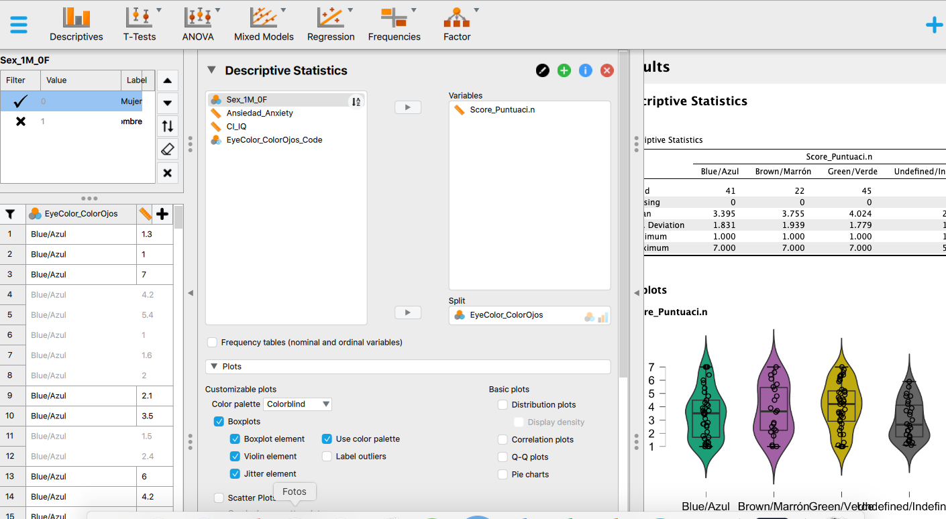

References (not in APA format…)

Moore, D. S., McCabe, G. P., and Craig, B. A. (2012). Introduction to the Practice of Statistics (7th ed.). New York: Freeman.

Simpson, P. M., Sturges, D. L., and Tanguma, J. (2008). The eyes have it, or do they? The effects of model eye color and eye gaze on consumer as response. The Journal of Applied Business and Economics, 8: 60-72.