Exercise 6. Statistics. Correlation and regression

We have the following data set (https://www.uv.es/mperea/PRIM_SE.jasp). This file contains information on the grades in the first semester of a group of students in a science career, as well as information on the average grades (in secondary school) in math, science, and language. We also have their math and language test scores (PAU; “Prueba de Acceso a la Universidad”), as well as sex and whether individuals wear glasses (or not).

The idea (overall) is to see how predictive the grades in high school are once the students arrive at college (i.e., the grades in their first semester in college).

Correlation

--What is the relationship (sign and strength) between the grades in the first semester (Y) and the math test score (PAU) (X)? Obtain the appropriate graph and compute the appropriate index.
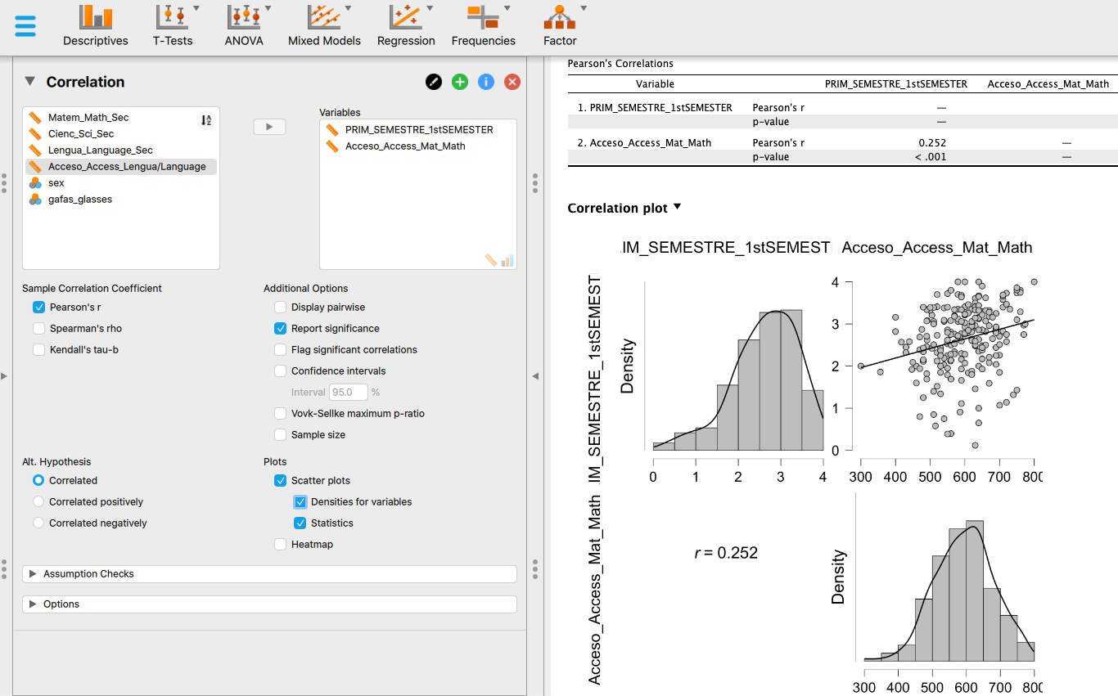

There is a positive but relatively weak relationship between the two variables, as attested by the scatterplot and the value of the Pearson correlation coefficient (r = 0.252).

--We want to have a correlation matrix with the following variables: average high school grades in mathematics, average high school grades in science, math test score (PAU), and language test score (PAU). For which variables was the relationship strongest? And weakest? Do you think it would have been possible to find negative relationships between these variables?
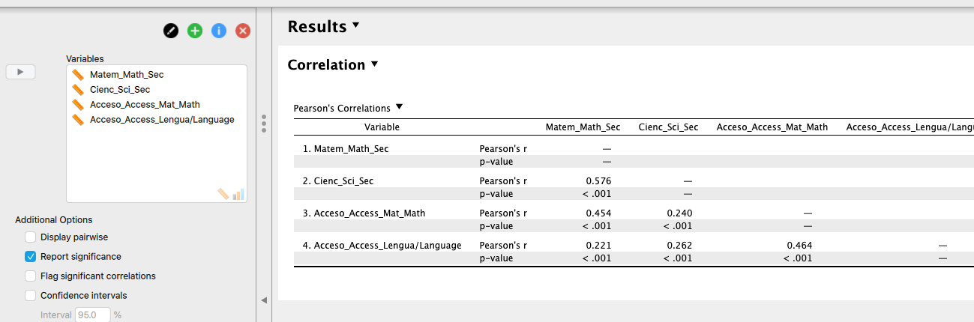

The strongest relationship is in the case of the highest Pearson's correlation coefficient in absolute value: the scores in Sciences and Math in high-school (r= 0.576). The weakest is between the PAU-Language scores and Math scores in high-school (r=0.221).

All the relationships were positive (in various degrees) since good students tend to be have high grades in the different subjects (ie, math, science, language, etc).

--Is there a relationship between wearing glasses (yes/no) and sex (man, woman)? Obtain the contingency table and compute the appropriate correlation index.

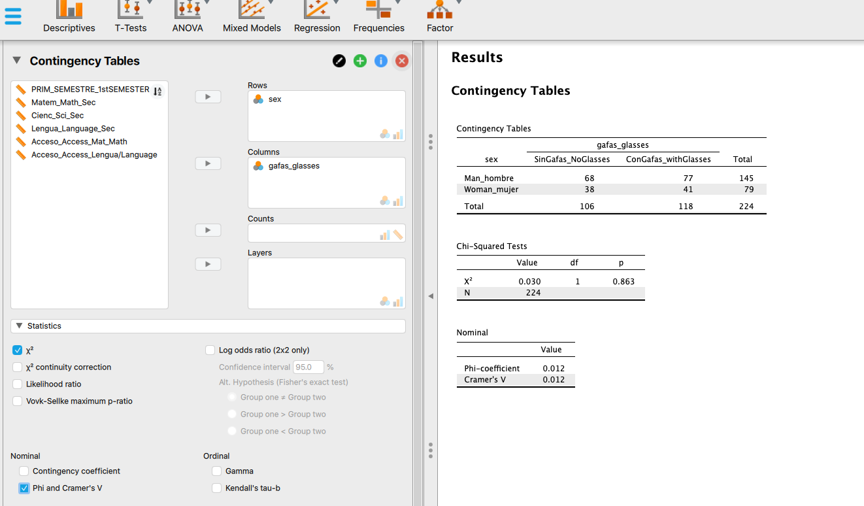

The aim is to obtain the contingency table ("Frequencies" menu) and as index, Cramers’ V. Clearly, there is no relation between the two variables (V = 0.012): in the sample, the proportion of men with glasses is similar to that of women with glasses.

Simple Regression

--What is the regression line for the grades in the first semester (Y) when using the math test score (PAU) (X) as a predictor (in direct scores)? What is the meaning of the intercept and slope in that equation?

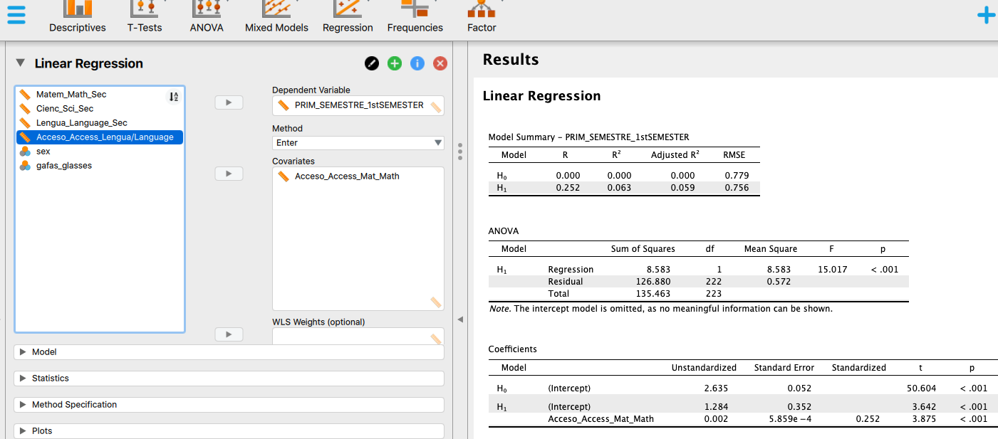

GRADE_UNI ' = 1.284 + 0.002 PAU_MATH

1,284 (A, intercept) is what you would predict to someone with a ZERO in PAU_MATH
0.002 (B, slope) indicates how much predicted variable increases (GRADE_UNI) for each unit of the variable X (the predictor, PAU_MATH).

--Idem in typical (standardized) scores. Does the value of the slope necessarily coincide with...?

You just have to look at the "standardized" column. In simple regression, the slope in typical scores necessarily coincides with Pearson's correlation coefficient: 0.252

--What percentage of variance of the scores in the first semester (Y) can explain the regression line?

It is R^2. If we look at the adjusted R^2, the value is 0.059. That is, the regression line can explain 5.9% of the variance of the grades in the first semester at the uni.

--What is the grade in the first semester that you’d predict to the person in the first row of the JASP database?

It's just substituting PAU_MATH in the formula...

GRADE_UNI ' = 1.284 + 0.002 PAU_MATH

And where it says PAU_MAT, you indicate the value of the first person in that variable. You do the calculation and that's it.

You could also create the entire column of "predicted scores" with the above formula. And so you have not only the first person, but also the rest.

Multiple regression

--What is the regression equation for the grades in the first semester (Y) when the predictors are math test score (PAU), and language test score (PAU)? What are the components of the regression equation in direct scores?

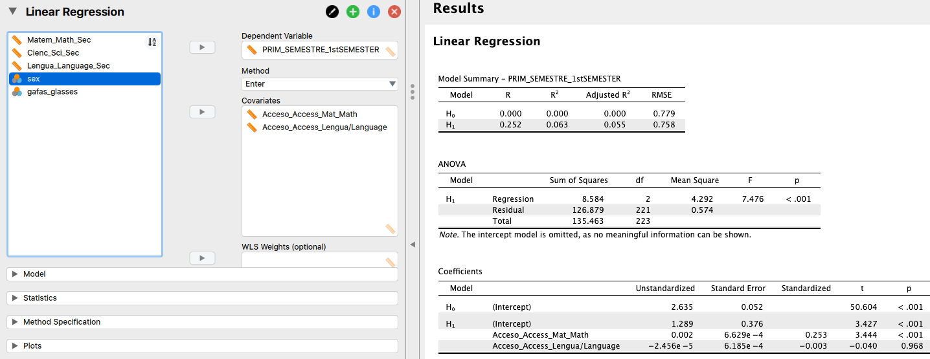

GRADE_UNI ' = 1.289 + 0.002 PAU_MATH + 0.002 PAU_LENGUAGE

We have the intercept, as before, and now we have a coefficient for each predictor.

--What percentage of variance of the grades in the first semester can explain the regression equation in the previous question?

It is R^2. If we look at the adjusted R^2 it is 0.055. That is, the regression equation can explain 5.5% of the variance of GRADE_UNI.

--What is the best predictor of the above equation and why? What is the worst predictor of the above equation and why?

The best predictor in the equation is the one with a larger standardized value (in absolute terms, without looking at the sign). In this case PAU_MATH.

--Do you think there were collinearity problems in the equation? (remember: look at the VIF, in the ideal case it would be 1.0)

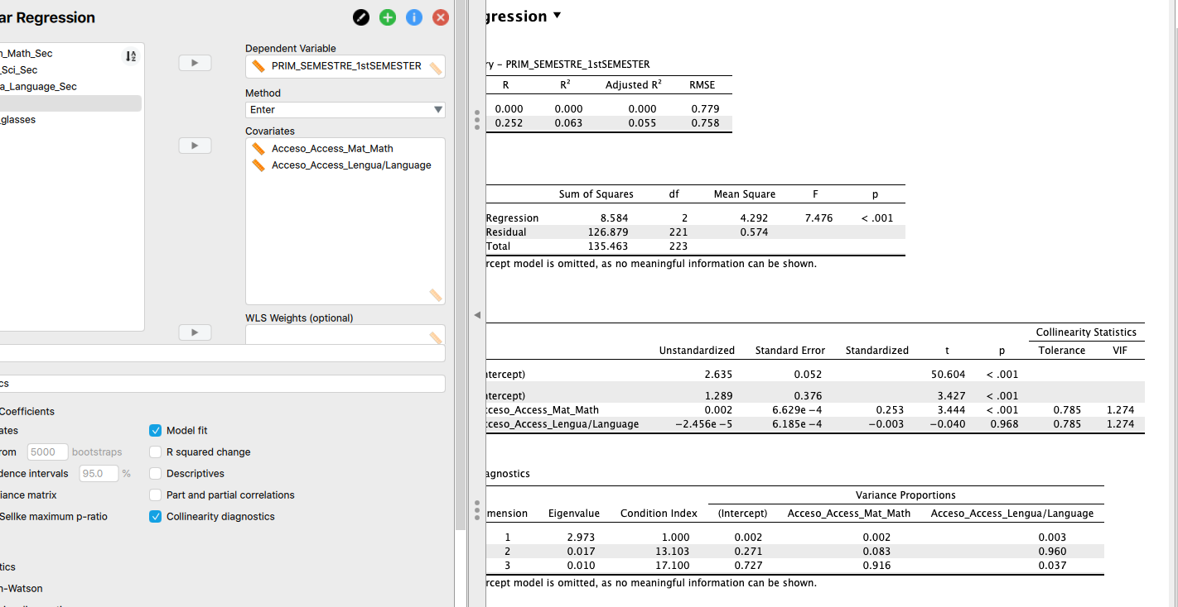

VIF has been 1.274. The ideal value is 1.0. Since the limit was indicated in 10...it can be concluded:

There were no serious problems of collinearity (VIF = 1.27).

--Let's assume that, for parsimony, we want to compute a stepwise regression. What would be the resulting equation? Why?

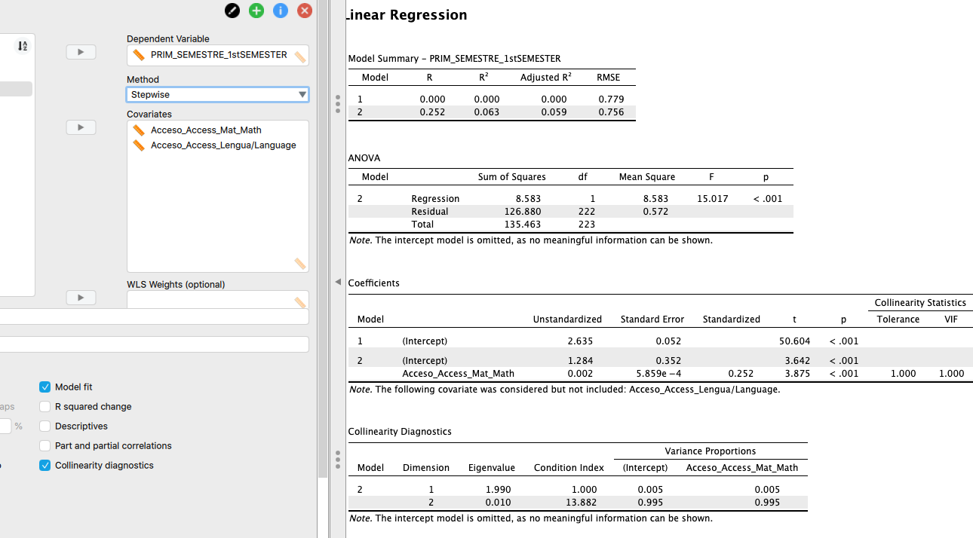

The predictor PAU_LANGUAGE has not entered the equation. In fact, in the previous question this predictor hardly contributed anything to the equation (its standardized coefficient was -0.003, that is, this value is virtually null).

Therefore, the most parsimonious choice is to exclude PAU_Language from the regression equation.

