Data organization (in JASP)

--1. Select cases (filter)

--2. Create new columns (add, transform, etc.)

--3. Recoding variables (converting a quantitative variable into 2 groups)

--4. Going further using the R option (the case of z-scores)

**--1. Select cases (filter)**

If it is a nominal/ordinal variable, a quick and easy option is to click on the variable name. And then if you want to remove a category is to click on the row where the column "Filter" (it is on / off, so you can restore)

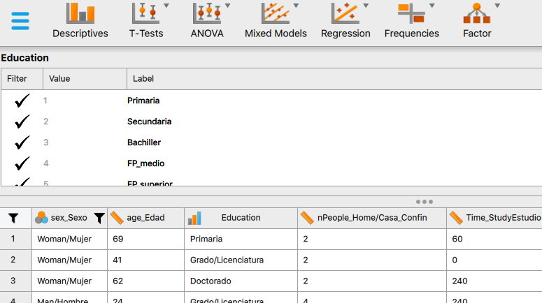

If it is a quantitative variable then it is to go to the bottleneck icon above the first row, and indicate the condition or conditions.

For example, choose only that number of people at home in confinement was less than 4. And click on "Apply pass-through filter".

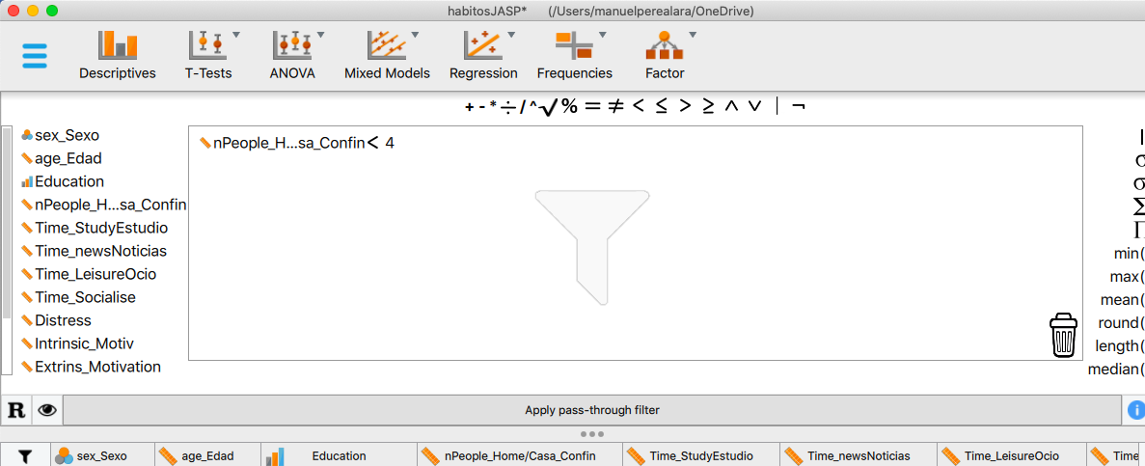

You can add several filters. Let's add that they must be under 60 years old:

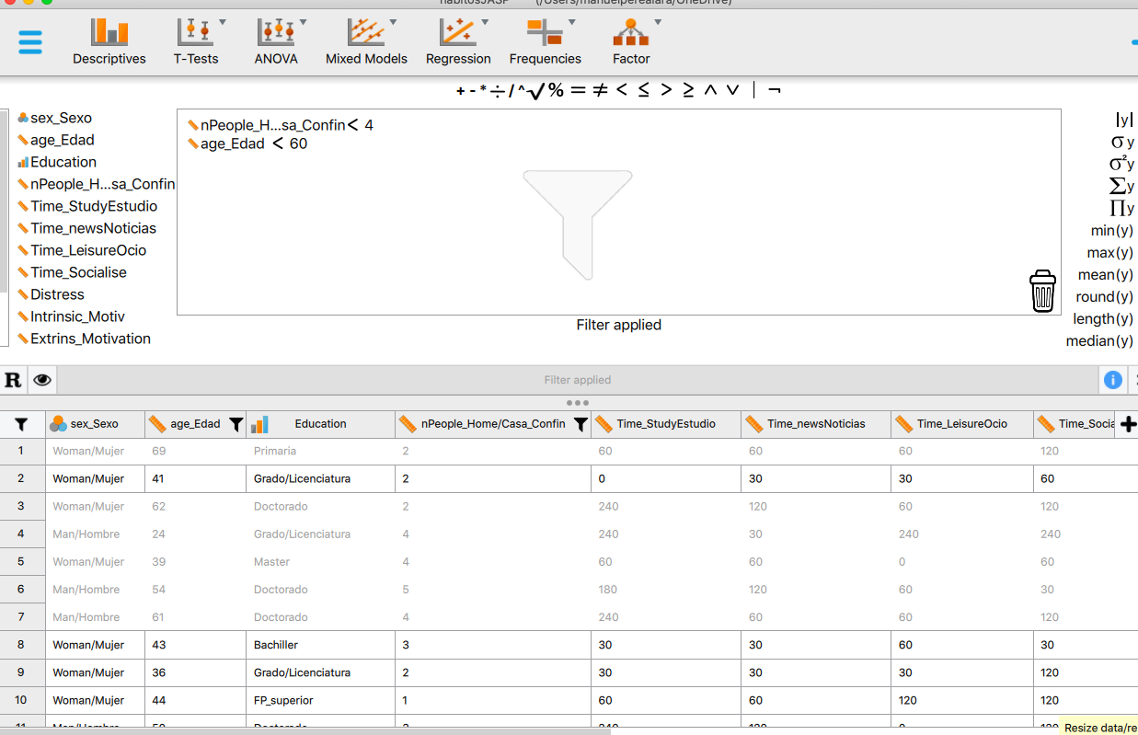

The non-selected cases are in grey. JASP updates all calculations. And you can always drag the filters to the trash and return to the initial situation.

**--2. Create new columns (add, transform, etc)**

We can easily create new columns by clicking on the + sign to the right of the data matrix.

Let's think that we want to add up the study reading time, news, entertainment and social networks. First, we name the variable: Total time (to give an example):

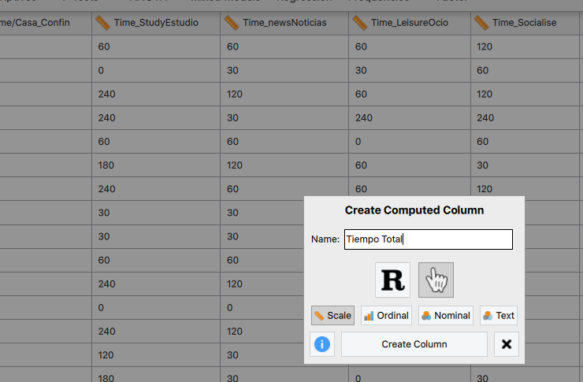

Leave the default option (the hand, the R option we comment later)

Now you just have to drag the icons on the left and add the "+" (sum). And then "Compute column"

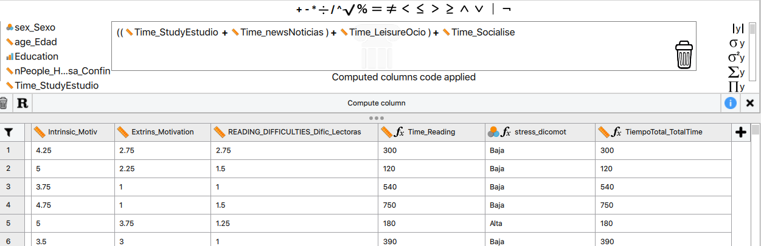

And this is the result.

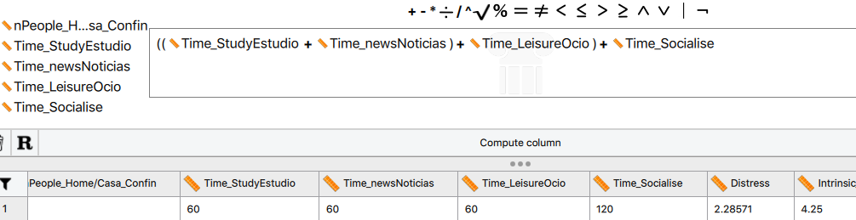

Logically, you can do all kinds of other operations, add values, subtract, multiply, etc.

**--3. Recoding variables (converting a quantitative variable into 2 groups)**

Let's have a look at two options. The first is the "median Split" which is to divide the observations (in our case, from "distress" to low vs. high from the median, so that the number of people in each group is similar).

This is the "cut(y)" option on the right. And say that you "cut" it in two pieces. To do this, first is to create a new column, the + sign on the right

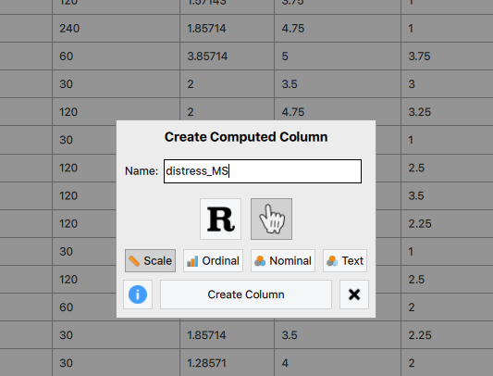

We now choose the variable and also indicate the number of groups (two, but we could have said three to form 3 groups, etc)

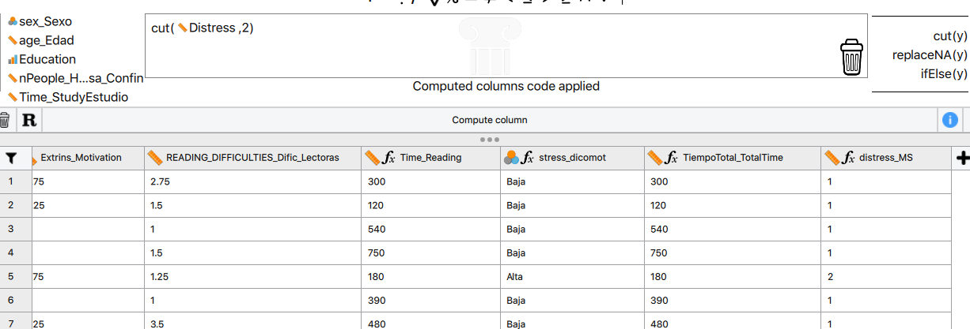

Then you have to convert the variable to ordinal/nominal and to indicate the categories (low vs. high) where it corresponds)

Another option if they tell you: "from this value the distress is high and if not, it is low" is the following:

Let's think that this value was 3. From 3 onwards distress the assigned value would be "2" (high) and if not, the value is "1" (low).

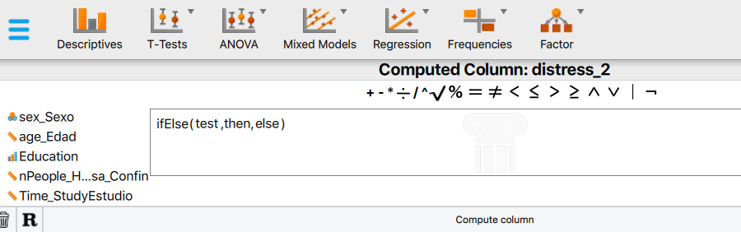

The option is "ifElse". Now drag the "greater or equal" sign (this is first) and then drag the column, etc.

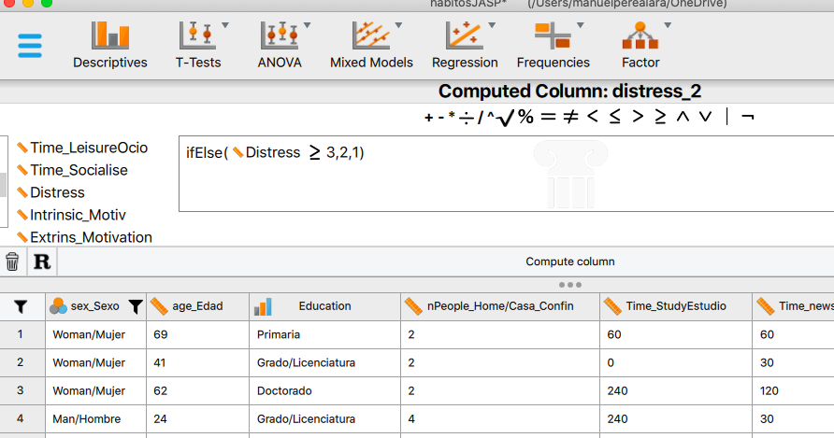

And then you calculate the column that’s it.

**--4. Going further using the option of R**

Sometimes it is useful to use R-code to save time.

Let's think that, for each observation, we want to calculate:

Z= (DATA - MEAN OF THE VARIABLE) / STANDARD DEVIATION OF THE VARIABLE

(these are “z-scores", from Theme 4)

We know that in R:

mean(Distress)

is the average distress

sd(Distress) is the standard deviation of distress.

So we can indicate the formula and we will have the scores "z" (typical) of distress:

Now when creating the new column, is to click on R

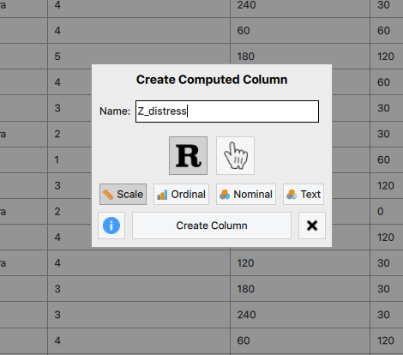

You write in the line following the happy emoticon. Be careful that it is "case-sensitive" (uppercase in uppercase, lowercase in lowercase)

#Enter your R code here :)

(Distress-mean(Distress))/sd(Distress)

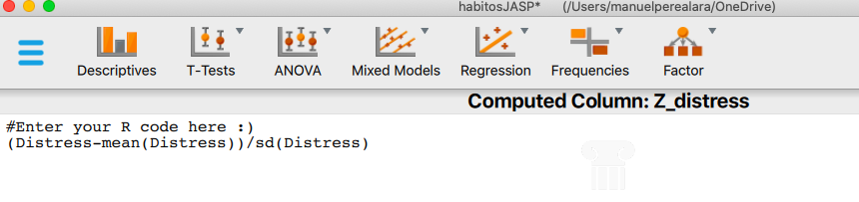

And "compute column": it's the column on the right

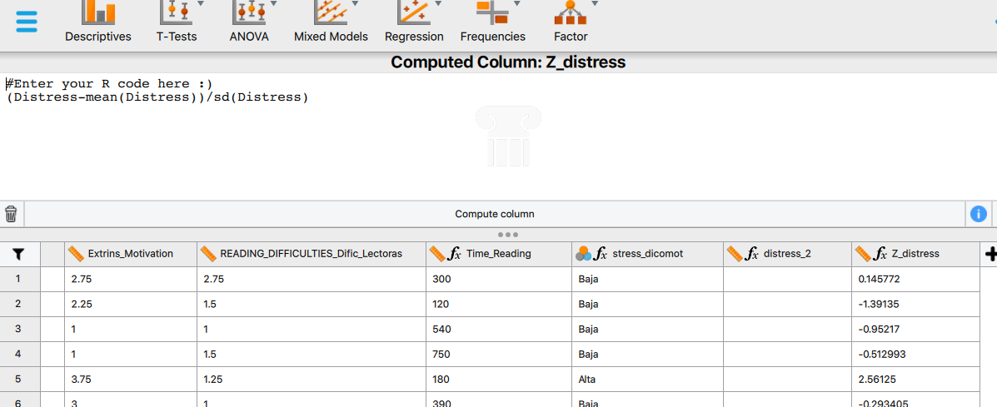

This calculation could have been done in the traditional way, but in more steps (and a little bit more trouble actually). That is, using R-code, you actually save time.

The other option would be to subtract the average in a new column:

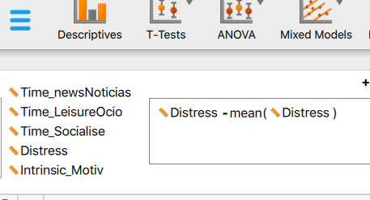

And then from the new divide by the standard deviation of Distress. Clearly with R it is faster and easier.

Remember that there are videos in the JASP blog demonstrating these and other options.