 | EXTRACTIVE DISTILLATION ANALYSIS OF THE SYSTEM ISOBUTYL ALCOHOL (IBA) + ISOBUTYL ACETATE (IBAc) + N,N-DIMETHYLFORMAMIDE (DMF)

A. Aucejo, J.B Montón, M.C. Burguet, R. Muñoz, N. Martínez, M. Sanchotello, S. Loras
Escuela Técnica Superior de Ingeniería, Departamento de Ingeniería Química, Universitat de València, 46100 Burjassot, Valencia, Spain.

INTRODUCTION  - The azeotropic compositions presence in industrial mixtures is very common. The separation of these mixtures can be carried out either changing the work conditions (mainly the pressure, if the azeotrope is sensible to this variable), or adding an entrainer to modify the mixture relative volatility and using distillation on the new multicomponent mixture. The present work shows the study of the system IBA + IBAc (azeotropic composition at normal pressure 0.884 molar % in IBA) using DMF as entrainer.  - The experimental work has been carried out in a 4 m height and 0,20 m diameter pilot distillation column with 30 real plates (fig. 1). First, the column was operated at total reflux in order to obtain the experimental residual curves. Later, the column worked with continuous addition of azeotropic feed and entrainer. The azeotropic mixture was fed in the 10th plate of the column. In order to know the distillation behaviour the experimental conditions have been changed. So the entrainer was introduced at the 24 th or 29 th plate, the entrainer/feed molar ratio was changed between 2.7 and 5.6 and the vapour flow between 6.4·10 ⁻³ and 3.5·10⁻² kmol/h.  RESULTS AND DISCUSSION  - The residual curves were simulated by DISTIL and the column behaviour by HYSYS. In both cases the thermodynamic model was UNIQUAC with the parameters previously correlated from experimental data (R. Muñoz, 2005). In figure 2, the experimental points obtained at total reflux and the residual curves simulated by DISTIL are shown. As an example, in table 1 are presented the work conditions of the column used in the experiment showed in figure 3.  - The comparation of experimental results obtained in pilot plant with the simulation of this separation by means of a commercial software program (HYSYS) used appropriately is a very powerful tool to analyze the separation alternatives. Therefore, this study can offer an important and reliable information to carry out efficient and economical process designs. When applied this comparation to the separation of IBA + IBAc azeotropic mixture, it has produced satisfactory results, as can be seen in figures 2 and 3.  Table 1. Operation conditions.  Vapor flowrate (kmol/h) 1.50·10⁻²  Feed entry stage 10  Solvent entry stage 24  Reflux rate 19  Entrainer/feed molar ratio 4.0 | 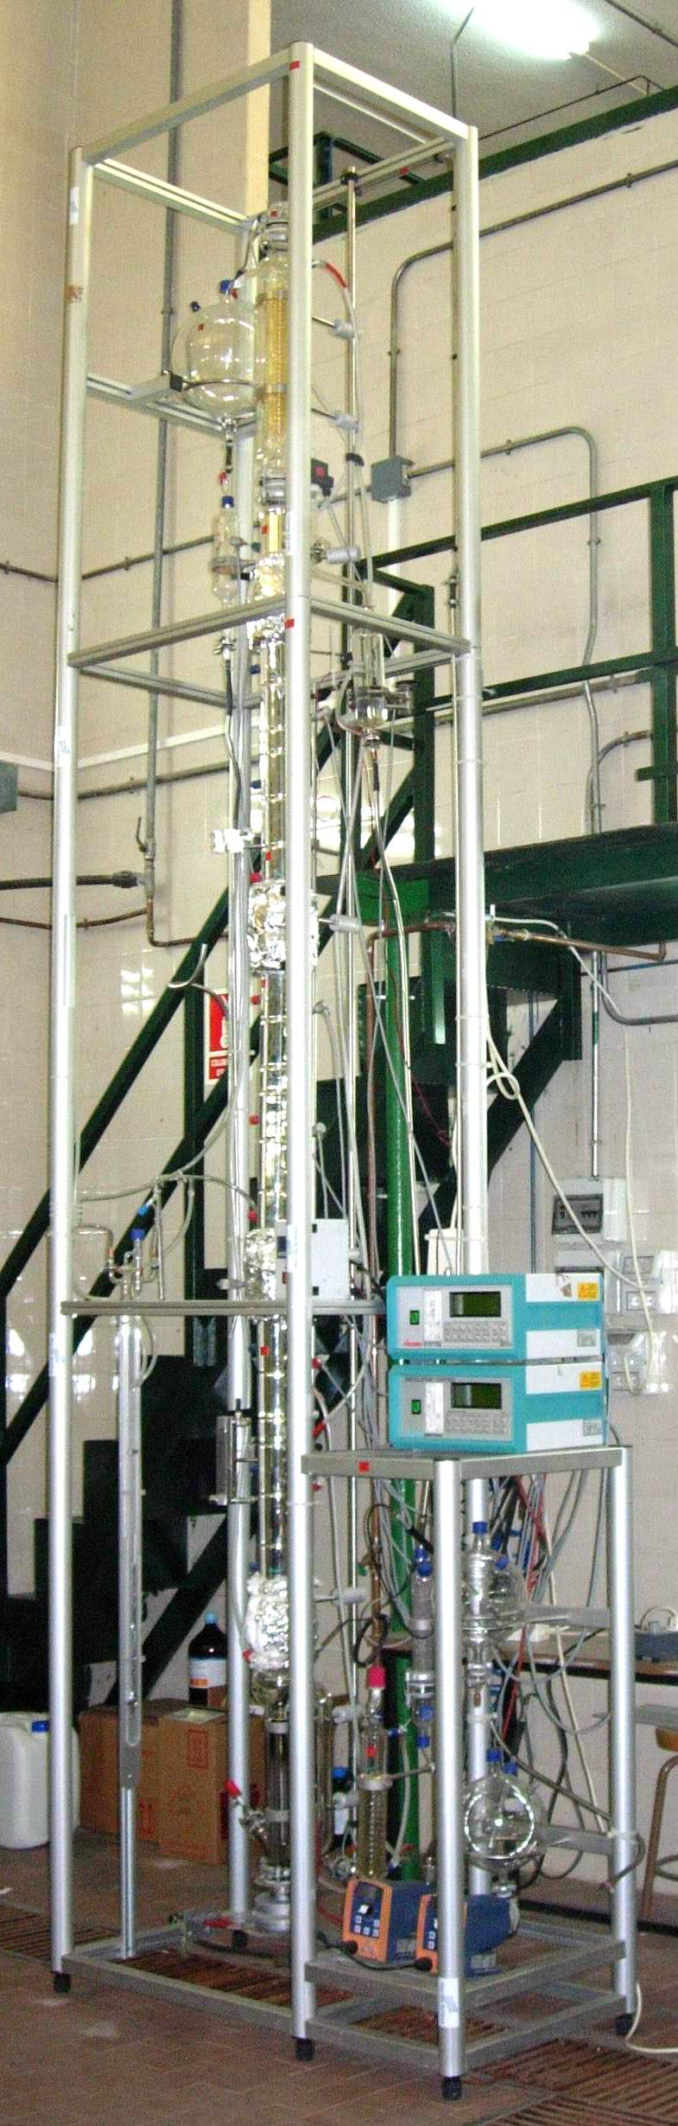  Figure 1. Pilot distillation column

Figure 2. Residue curve continuos lines simulated DESTIL.  Experimental data ▲Exp. 1, ▲Exp. 2, ▲Exp. 3,  ▲Exp. 4, ▲ Exp. 5 | Figure 3. Destillation curve: continuos line simulated by HYSYS.  ▲ Experimental data. ▲Azeotrope. ▲Feed composition
[1] R. Muñoz; J.B. Montón; M.C. Burguert; J. de la Torre. Fluid Phase Equilibria 232 (2005) 62-69
Acknowledgements. Financial support from the Ministerio de Ciencia y Tecnología of Spain, through Project no. CTQ2004-04477/PPQ

