 | ANALYSIS OF THE ISOBUTYL ALCOHOL (IBA) + ISOBUTYL ACETATE (IBAc) + BUTIL PROPIANATE (BUP) SYSTEM IN A PILOT DISTILLATION COLUMN

A. Aucejo, M.C. Burguet, N. Martínez, J.B Montón, R. Muñoz
Escuela Técnica Superior de Ingeniería, Departamento de Ingeniería Química, Universitat de València, 46100 Burjassot, Valencia, Spain.

INTRODUCTION

As a part of a continuing program of work, we have identified a selection of possible solvents for break the azeotrope formed by esthers and homologous alcohol by means of Scheibel’s criterion, which suggests selection among compounds of the same homologous series. In this case, the binary system studied is a mixture of IBA (1) + IBAc (2), which presents a minimum boiling azeotrope at 101.3 kPa. The azeotropic composition at normal pressure is 88.4 molar % in IBA. In this study BUP has been used as entrainer. The IBA + BUP and IBAc + BUP binary systems and the IBA + IBAc + BUP ternary system do not present azeotropes and there have not different distillation regions. Moreover, the system at the experimental conditions is miscible in all the compositions range. The vapor-liquid equilibrium (VLE) data of the binary and ternary systems have been reported in previous works [1, 2].

The pilot column study presented here has tow parts: 1. Estimation of the global efficiency of the column working with the IBA + IBAc + BUP ternary system at total reflux with different operations loads. 2. Analysis of experimental residue curve map (RCM) of the ternary system obtained at total reflux and the comparison with the RCM obtained with DISTIL simulator (Aspentech).
RESULTS AND DISCUSSION  - The experiments have been carried out in the pilot column showed in Figure 1. The column, provided with systems of measurement and control of temperature and reboiler heat flow, consists of three sections of 10 real bubble cap trays each one, isolated of the outside by a vacuum-jacked and with three possible feed inlets in each section.  - To estimate the global efficiency of the column, two experiments, at total reflux, were carried out for different starting compositions loads and an optimum vapour flow rate (≈ 80% flooding velocity). For this purpose, the plate efficiency, defined as the change in actual composition in the liquid phase divided by the change predicted by the equilibrium [3], has been determined. Finally, the global efficiency was calculated as an average value of the individual tray efficiency previously estimated. In all experiments the obtained value was around 60 %. Figure 2 shows the experimental and calculated with equilibrium composition profiles for the two experiments.  - Eight experiments, at total reflux, with the ternary mixture have been done, in order to evaluate the solvent (BUP) influence in the liquid phase behaviour. As an example, in figure 3 are shown the concentration profile of the components corresponding to the experiment number 7. In this figure, it can be observed a maximum in the IBAc profile due to the change of the volatility in the trays where the solvent concentration is significant.  - The residue curves were simulated by DISTIL using UNIQUAC as thermodynamic model, with the parameters previously correlated from experimental data [1, 2]. In figure 4, the experimental points obtained at total reflux and the residue curves simulated by DISTIL are shown. |  | 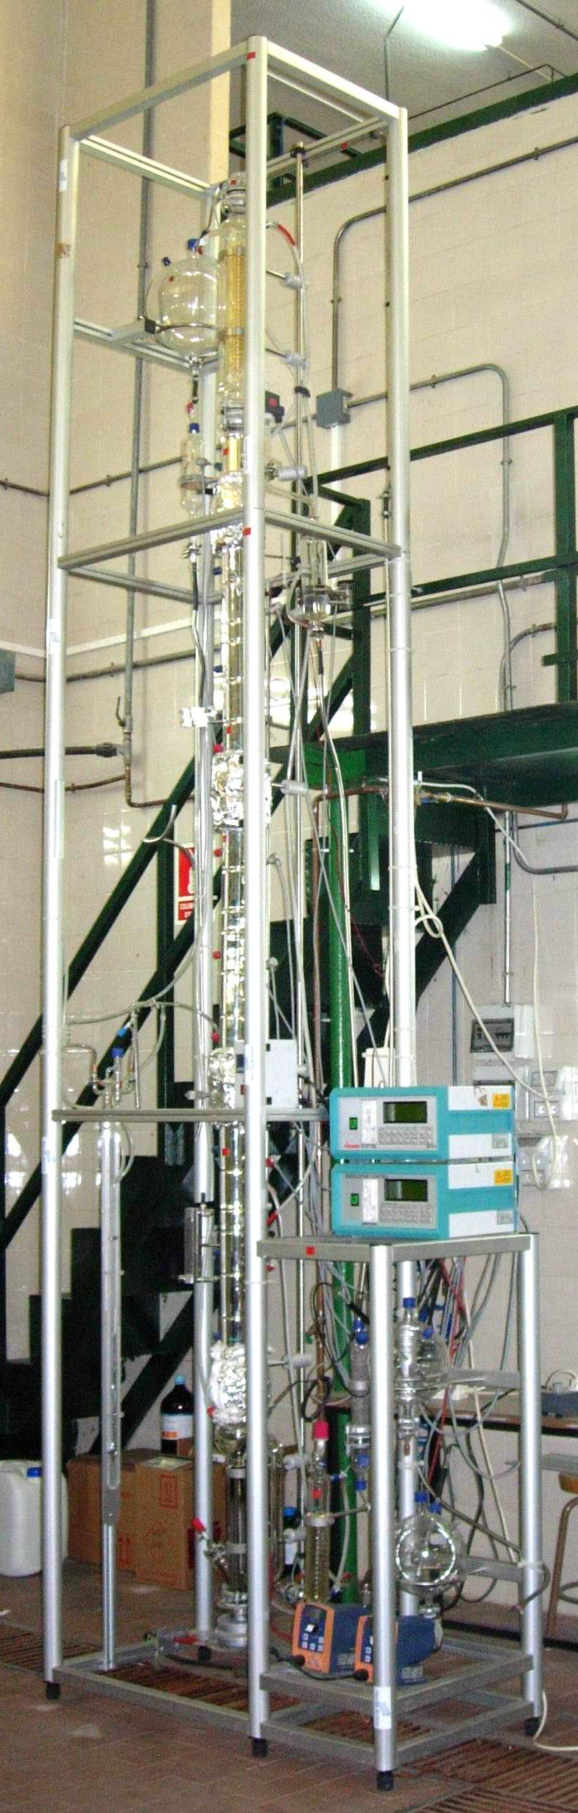  Figure 1. Pilot distillation column
Figure 2. Experimental (●) and calculated with equilibrium (▲) composition profiles for the plate efficiency estimation. | Figure 3. Experimental composition profile (ternary system): (•) IBA , (▲) IBAc, (■) BUP |  | Figure 4. Residue curve continuous lines simulated by DISTIL. Experimental data: (●) Exp. 1; (▲) Exp. 2; (●) Exp. 3; (▲) Exp. 4; (▲) Exp. 5; (▲) Exp. 6; (●) Exp. 7; (●) Exp. 8
[1] J.B. Montón; R. Muñoz ,M.C. Burguet; J. de la Torre. Fluid Phase Equilibria 227 (2005) 19-25 [3] R. Taylor; R. Baur; R. Krishna. AIChE Journal 50 (2004) 3134-48
[2] J.B. Montón; R. Muñoz ,M.C. Burguet; J. de la Torre. Fluid Phase Equilibria 238 (2005) 65-71
Acknowledgements: Financial support from the Ministerio de Ciencia y Tecnología of Spain, through Project no. CTQ2004-04477/PPQ

