 | EXTRACTIVE DISTILLATION OF ISOBUTYL ALCOHOL (IBA) + ISOBUTYL ACETATE (IBAc) USING BUTYL PROPIANATE (BUP) AS ENTRAINER. PILOT PLANT ANALYSYS

- Aucejo, M.C. Burguet, N. Martínez, J.B Montón
Escuela Técnica Superior de Ingeniería, Departamento de Ingeniería Química, Universitat de València, 46100 Burjassot, Valencia, Spain.

INTRODUCTION  The present work is the logical continuation of the work displayed in the Eleventh International Conference on Properties and Phase Equilibrium for Product and Process Design, about the extractive distillation [1]. In this congress the analysis of the distillate curves was presented (working at total reflux), and now the study continues with the analysis of the experimental and simulated results of continuous distillations with different operation conditions. The vapor-liquid equilibrium (VLE) data of the binary and ternary systems have been reported in previous works the IBA + BUP and IBAc + BUP binary systems and the IBA + IBAc + BUP ternary system do not present azeotropes and there are not different distillation regions [2,3]. Moreover, the system at the experimental conditions is miscible in all the compositions range. The problem is focused then on breaking the IBA + IBAc azeotrope.  RESULTS AND DISCUSSION  - The experiments have been carried out in the pilot column showed in Figure 1. The column consists of three sections of 10 real bubble cap trays each one, isolated of the outside by a vacuum-jacketed and with three possible feed inlets in each section. In all experiments the azeotropic mixture is introduced in the 10th tray and the entrainer in the 24th.  - The composition and flow values have been obtained as average of different measurements made throughout each experiment (around 2 hours in steady-state). We have worked at two different values of reflux ratio and two vapor flows. The molar relation Entrainer/Feed was 2 in all the experiments, (4.077. 10⁻³ Kmol/h of entrainer and 8.066.10⁻³ Kmol/h of feed). The molar composition of feed was: IBA= 0.7422, IBAc = 0.2578. The material balance does not fulfil exactly. In any case the errors between input and output values of the compositions are less than 5%. All the variables values of the experiments are showed in Table 1.  - Figure 2 and 3, shows the composition experimental curves for the experiments 3 and 4. In these experiments the vapor flow was constant and the value of the reflux ratio has been changed.  - Figure 4 shows the comparation between the experimental curves and the simulated one made by HYSYS at the work conditions for the experiment 4. In order to make the simulation 60% effectiveness had been used in each stage. This value was obtained in experiments with ternary systems[1]  Table 1. Operation conditions |  | 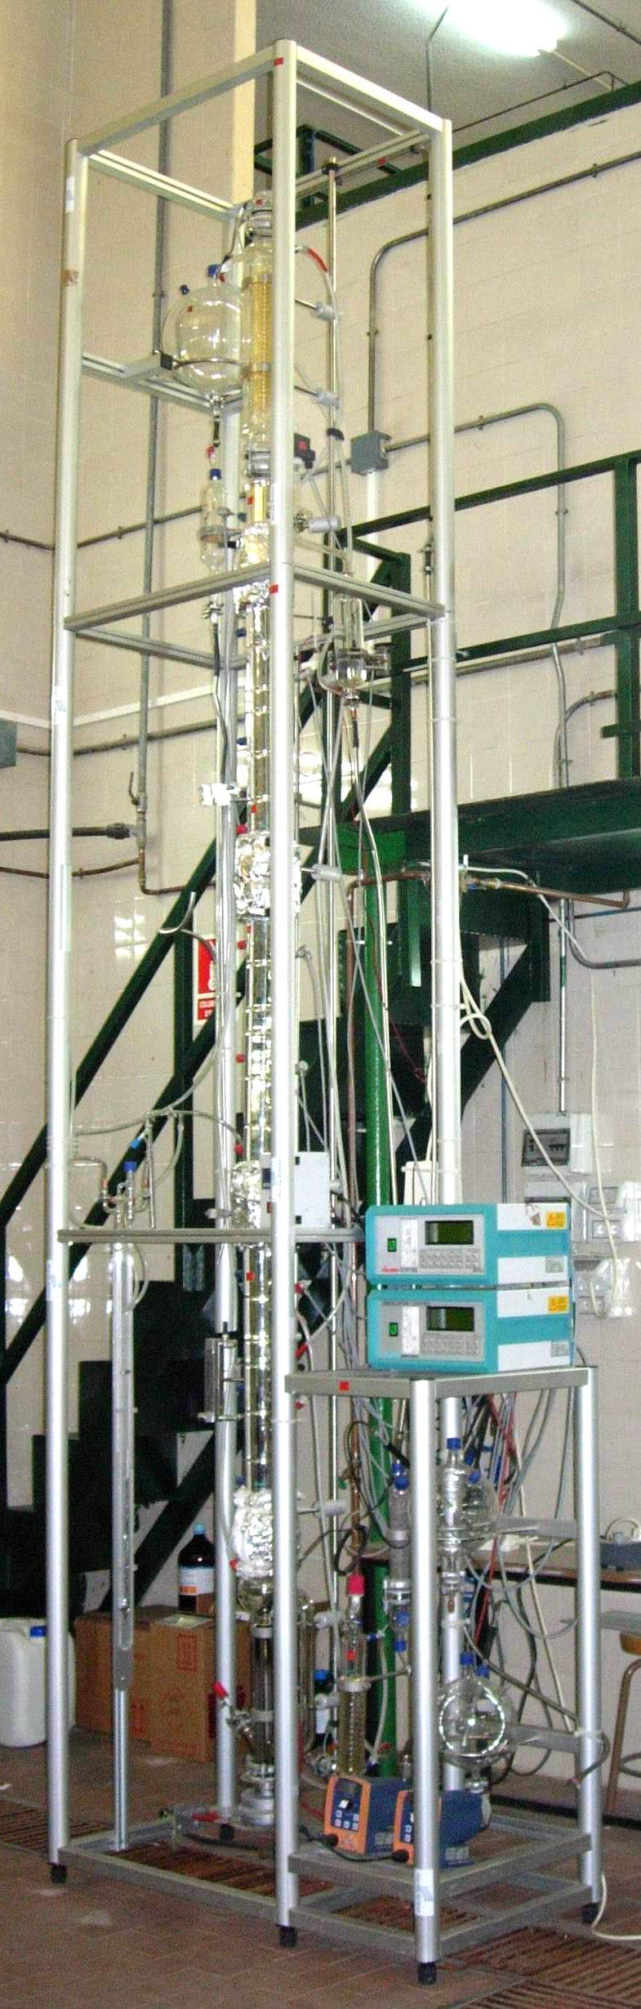  Figure 1. Pilot distillation column
  Exp.  nº | Vapor flow  Kmol/h 10² | Reflux Ratio | Distillated  flow  Kmol/h  10³ | Bottoms flow  Kmol/h  10³ | Composition  Distillate |  |  | Composition  Bottom
   |  |  |  |  | IBA | IBAc | BUP | IBA | IBAc | BUP
  1 | 3.29 | 16 | 1.95 | 10.06 | 0.9353 | 0.0430 | 0.0217 | 0.1432 | 0.1151 | 0.7417
  2  2 | 3.29 | 7.5 | 3.12 | 8.95 | 0.9174 | 0.0614 | 0.0211 | 0.0334 | 0.1051 | 0.8615
  3 | 2.06 | 16 | 1.33 | 11.6. | 0.9554 | 0.0222 | 0.0224 | 0.1656 | 0.0988 | 0.7356
  4 | 2.06 | 7.5 | 2.21 | 9.41  8.95.10⁻³9.41.10⁻³ | 0.9419 | 0.0279 | 0.0302 | 0.0709 | 0.1003 | 0.8288
0.0  0.1  0.2  0.3  0.4  0.5  0.6  0.7  0.8  0.9  1.0  0  5  10  15  20  25  30  35  N = nº piso  x  i  IBA  IBAc  BUP  Figure 2. Experimental composition profile (ternary system) | Figure 3. Experimental composition profile (ternary system)  0.0  0.1  0.2  0.3  0.4  0.5  0.6  0.7  0.8  0.9  1.0  0  5  10  15  20  25  30  35  N = nº piso  x  i  IBA  IBAc  BUP | Figure 4: Distillation Continuous.  (o) Simulation by HYSYS;  (▲) Experimental data
[1]A. Aucejo, M.C. Burguet, N. Martínez, J.B Montón. Eleventh International Conference on Properties and Phase Equilibrium for Product and Process Design. Creta 2007.
[2] J.B. Montón; R. Muñoz ,M.C. Burguert; J. de la Torre. Fluid Phase Equilibria 227 (2005) 19-25
[3] J.B. Montón; R. Muñoz ,M.C. Burguert; J. de la Torre. Fluid Phase Equilibria 238 (2005) 65-71

