 | EXTRACTIVE DISTILLATION OF ISOBUTYL ALCOHOL (IBA) + ISOBUTYL ACETATE (IBAc) USING N,N-DIMETYLFORMAMIDE (DMF) AS ENTRAINER. PILOT PLANT ANALYSYS

A. Aucejo, M.C. Burguet, N. Martínez, J.B Montón, R. Muñoz
Escuela Técnica Superior de Ingeniería, Departamento de Ingeniería Química, Universitat de València, 46100 Burjassot, Valencia, Spain.

INTRODUCTION
The present work is the logical continuation of the work displayed in the 10th Mediterranean Congress of Chemical Engineering about the extractive distillation. In this congress the analysis of the distillate curves was presented (working at total reflux), and now the study continues with the analysis of the experimental and simulated curves of continuous distillations with different operation conditions. The binary system is a mixture of IBA(1) + IBAc(2), which presents a minimum boiling azeotrope at 101.3 kPa. The azeotropic composition of this mixture at normal pressure is 0.884 molar % in IBA. In this study DMF has been used as entrainer. The vapor-liquid equilibrium (VLE) data of the binary and ternary systems have been reported in previous works [1, 2]. The IBA + DMF and IBAc + DMF binary systems and the IBA + IBAc + DMF ternary system do not present azeotropes and there are not different distillation regions. Moreover, the system at the experimental conditions is miscible in all the compositions range. The problem is focused then on breaking the IBA + IBAc azeotrope.
RESULTS AND DISCUSSION  - The experiments have been carried out in the pilot column showed in Figure 1. The column consists of three sections of 10 real bubble cap trays each one, isolated of the outside by a vacuum-jacketed and with three possible feed inlets in each section. In all experiments the azeotropic mixture is introduced in the 10th tray.  - The composition and flow values have been obtained as average of different measurements made throughout each experiment (around 2 hours in steady-state); therefore do not fulfil the material balance exactly. In any case the errors between input and output values of the three components are less than 5%. These values are showed in Table 1  - Figure 2 shows the experimental curves for the 6, 7 and 8 experiments in which the entrainer inlet is in the 29th tray. In Figure 3, the experimental curves corresponding to the experiments 9 and 10 have been represented in both cases the entrainer is introduced in the 24th tray.  - As compared Figure 2 with Figure 3, it can be observed that when the solvent is fed in the 29th tray, the DMF composition in the distillate stream is high because there are not enough stages in the rectifying section to separate and incorporate the solvent to the liquid that goes down. However, when the DMF enters to the 24th tray, the distillate stream is practically free of solvent, but the IBA + IBAc mixture tends to move towards the azeotropic composition. This fact is due to two opposing effects, by one side, the solvent reverses the volatility of the original mixture in the extractive section (enriching the vapor phase in IBAc) [2] and, on the other hand, in the upper rectifying section (without solvent) the original mixture behaves in the normal way (enriching the vapor phase in IBA).  - Figure 4 shows the experimental curve corresponding to 10th experiment together with the simulated curve made by HYSYS, fixing the conditions of the inlet streams, the reflux ratio and the distillate flow. In order to make the simulation 50% effectiveness has been assumed to each stage, being the average value that was obtained in experiments with binary systems at total reflux.  Table 1. Experiments and operation conditions |  | 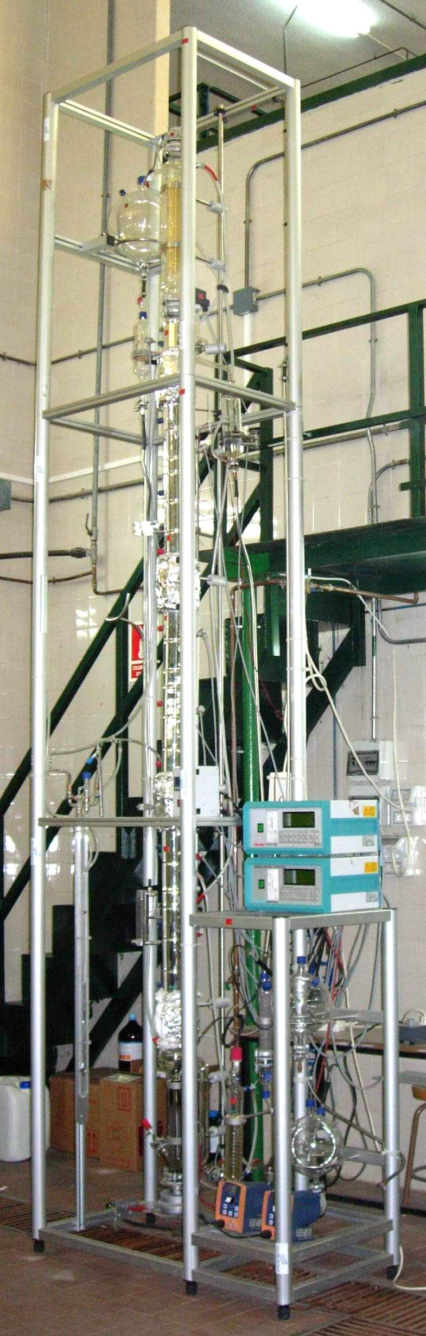  Figure 1. Pilot distillation column
  Experiment | 6 | 7 | 8 | 9 | 10
  Solvent stage inlet  Solvent/Feed ratio | 29  3.8 | 29  4.3 | 29  4.5 | 24  4.8 | 24  4.0
  Feed (kmol/h)  z₁  z₂ | 3.701.10⁻³  0.749  0.251 | 3.524.10⁻³  0.749  0.251 | 4.288.10⁻³  0.749  0.251 | 4.112.10⁻³  0.749  0.251 | 4.699.10⁻³  0.749  0.251
  Destillate (kmol/h)  y₁  y₂ | 3.401.10⁻⁴  0.069  0.486 | 7.433.10⁻⁴  0.195  0.551 | 5.364.10⁻⁴  0.109  0.582 | 8.280.10⁻⁴  0.455  0.525 | 8.071.10⁻⁴  0.405  0.563
  Bottom (kmol/h)  x₁  x₂ | 1.635.10⁻²  0.176  0.045 | 1.742.10⁻²  0.130  0.027 | 2.126.10⁻²  0.160  0.036 | 2.175.10⁻²  0.140  0.033 | 2.134.10⁻²  0.140  0.035
Figure 2: Continue operation Experimental data:  (•) Exp. 6; (∆) Exp. 7; (□) Exp. 8 | Figure 3: Continuous operation. Experimental data:  (●) Exp. 9; (∆) Exp. 10 |  | Figure 4: Continue operation. (----) Simulated by HYSYS; (▲) Experimental data, exp 10
[1] J.B. Montón; R. Muñoz ,M.C. Burguet; J. de la Torre. Fluid Phase Equilibria 227 (2005) 19-25
[2] J.B. Montón; R. Muñoz ,M.C. Burguet; J. de la Torre. Fluid Phase Equilibria 232 (2005) 62-69

