Full Title - The Title Should Be Bold and Centred
(Century Gothic 20)

Presenting Author (Century Gothic 11)
Co-Authors (Century Gothic 10)

Organization, Address, City, Country (Century Gothic 10)

Contact@E-mail (Century Gothic 10)

Abstract (Century Gothic 11)

ONE page abstract format: including figures and references.
Do not change the font sizes or line spacing to squeeze more text into a limited number of pages.
Please follow the model below.
Single-spaced and a single paragraph
Page margins are 2 cm top and down; 1,90 cm left and right.
Greek letters, sub- and superscripts should be formatted as such.

The full text and the figures should get into ONE PAGE abstract, following the consigns of the template and including the requested information about the authors and affiliations for the size of the characters and general format.

Figures

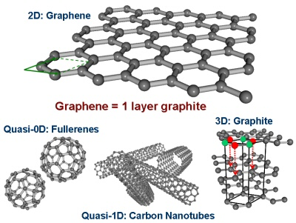

Figure 1: Insert caption to place caption below figure (Century Gothic 10)
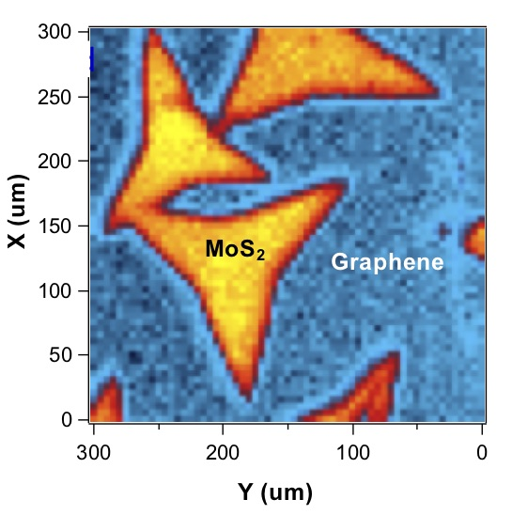

Figure 2: Insert caption to place caption below figure (Century Gothic 109

Normal text, text, text…..
Normal text, text, text…..
Normal text, text, text…..
Normal text, text, text…..
Normal text, text, text…..
Normal text, text, text…..
Normal text, text, text…..
Normal text, text, text…..
Normal text, text, text…..

References

- Authors, Journal, Issue (Year) page (Century Gothic 11) Indicate references with sequential numbers within [square brackets].
- Authors, Journal, Issue (Year) page
- Authors, Journal, Issue (Year) page
- Authors, Journal, Issue (Year) page

