Enhanced hydrogenation catalytic activity with polydopamine as interfacial glue between Pd NPs and porous UVM-7 silica supports
Jamal El Haskouri¹, José Vicente Ros-Lis², M. Dolores Marcos³, Pedro Amorós¹, M. Ángeles Úbeda^{2,*} and Francisco Pérez-Pla^{1*}
¹⁾ Institut de Ciència dels Materials (ICMUV), Universitat de València, Catedrático José Beltrán 2, 46980 Paterna, Valencia, Spain
²⁾ Departament de Quimica Inorgànica, Universitat de València, Dr. Moliner 50, 46980 46100 Burjassot, Valencia, Spain
³⁾ Centro de Reconocimiento Molecular y Desarrollo Tecnológico (IDM), Departamento de Química, Universitat Politècnica de València, Camino de Vera s/n, 46022, Valencia, Spain
*E-mail: angeles.ubeda@uv.es; francisco.perez@uv.es
The immobilization of metal nanoparticles (NPs) on supports has attracted a considerable attention by their potential applications as efficient heterogeneous catalysts. Inspired by the adhesive proteins in mussels, we used PDA as interfacial glue that provides strong adhesion by intensive covalent and noncovalent bindings. In order to improve the dispersion and avoid the Pd NPs aggregation on the UVM-7, we have decorated the silica with PDA which will allow the interfacial assembly of the Pd NPs stabilizing them on the support [1]. We have used two preparative strategies to incorporate both Pd and PDA on the UVM-7 silica: sequential or joint incorporation of Pd and PDA. The best catalysts were synthesized through a "two pot" methodology in which in a first step the silica surface is covered with PDA. During the second step the incorporation of Pd(II) is carried out by using H₂[PdCl₄] or K₂[PdCl₄] complexes as metal source followed by the reduction with NaBH₄ to favour the Pd(0) particle formation (Figure 1a and b). Different Pd NPs-UVM-7/PDA catalysts have been synthesized and their activity has been studied using the model reaction of 4-nitrophenol reduction with NEt₄BH₄ (Figure 1c). The most active Pd (0) centres seem to be Pd NPs of less than 1 nm on the PDA surface. The efficiency of the catalysts obtained is superior to that of similar materials without PDA. The TOF values achieved are among the best described in the literature: TOF_{1/2}/h⁻¹= 8470.
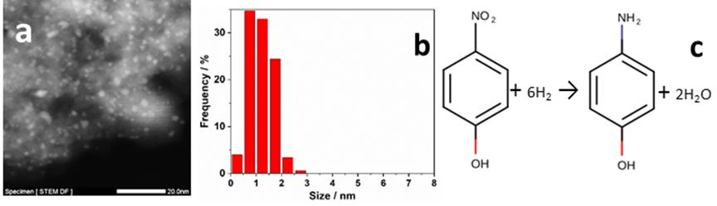
Figure 1: (a) HAADF-STEM image. (b) NP size distribution. (c) Model reaction used.
[1] Highly active hydrogenation catalysts based on Pd nanoparticles dispersed along hierarchical porous silica covered with polydopamine as interfacial glue M. Ródenas et al., Catalysts 2020, 10(4), 449; doi.org/10.3390/catal100404

