Size, roughness and porosity control in mesoporous Stöber-type particles
M. Dolores Garrido¹, Jamal El Haskouri¹, José Vicente Ros-Lis², Aurelio Beltrán¹ and Pedro Amorós^{1,*}
¹⁾ Institut de Ciència dels Materials (ICMUV), Universitat de València, Catedrático José Beltrán 2, 46980 Paterna, Valencia, Spain
²⁾ Redoli Group, Departament de Quimica Inorgànica, Universitat de València, Dr. Moliner 50, 46980 46100 Burjassot, Valencia, Spain
*E-mail: pedro.amoros@uv.es
Mesoporous silica particles are the inorganic bedrock on which, through functionalization processes, it is possible to build up inorganic and hybrid nanomaterials with multiple emerging applications. In fact, they have been designed very complex systems involving sophisticated functionalities, although the role played by the inorganic silica support is frequently underestimated. Here, we report on mesoporous spherical silica particles synthesized by combining the atrane route (which starts from complexes including triethanolamine-related ligands as Si source) [1] and the Stöber method (which implies using hydro-alcoholic reaction media) [2]. A fine-tuning of the aging time (from minutes to 1 day) allows a kinetic control of the particle size (in the ca. 100-200 nm range) together with a remarkable particle-size homogeneity (Figure 1a). On the other hand, the particle-size dispersion is even reduced when the particles are aged under hydrothermal conditions, process that in turns results in a regular surface roughness (Figure 1b). Also, post-treatments at fixed pH values and using different media (water, PBS...) can induce a massive and controlled degradation, without size reduction, that generates a meso/macroporosity additional to that typical of the original material (associated to the templating effect of the micelles) (Figure 1c). The resulting Stöber-type particles show an enhanced porosity able to accommodate relatively large guest species.
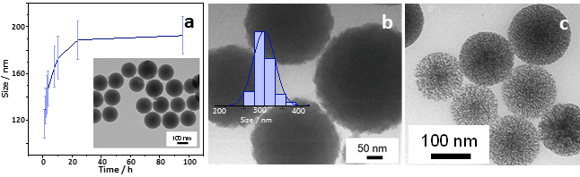
Figure 1: (a) Size vs time. TEM of the hydrothermal treated (b) and degraded (c) samples.
[1] Nanoparticulated silicas with bimodal porosity: chemical control of the pore sizes. J. El Haskouri et al., Inorg. Chem., 2008, 47, 8267; doi.org/10.1021/ic800893a
[2] Controlled growth of monodisperse silica spheres in the micron size range. W. Stöber et al., J. Colloid Interface Sci., 1968, 26, 62; doi.org/10.1016/0021-9797(68)90272-5

