Biocompatible polymer/perovskite nanocrystals composites for sensing applications
Eduardo Aznar-Gadea *, Pedro J. Rodríguez-Cantó, Juan P. Martínez-Pastor, Rafael Abargues¹
¹⁾ Institut de Ciència dels Materials (ICMUV), Universitat de València, Catedrático José Beltrán 2, 46980 Paterna, Valencia, Spain
*E-mail: eduardo.aznar@uv.es
Chemical sensors based on lead halide perovskite nanocrystals (NCs) have attracted intense interest because of their excellent optical electronic, high absorption coefficients, high quantum emission efficiencies, tunable properties, and solution processability properties [1]. The sensing mechanism of the CsPbBr₃ NCs sensor is based on the changes of the chemical composition of their surroundings. Possible sensing mechanisms include doping, gas-induced defect reparation, trap passivation and, ion-exchange [2].
In this work, we have developed a photoluminescent chemosensor based on a molecularly imprinted polymer (MIP) nanocomposite of CsPbBr₃ NCs embedded in a polymer for the selective detection of explosive or explosive-like molecules. Moreover, we synthesize non-molecularly imprinted polymers (NIP) to compare the results. The sensor is based on homogeneous and transparent thin films of CsPbBr3 NCs embedded in polycaprolactone (PCL) as a polymer host matrix and 3-nitrotoluene (3-NT) as a template.
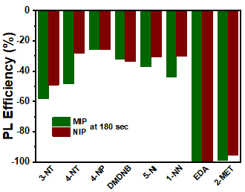
We evaluate the sensing capability of MIP and NIP nanocomposites by exposing the thin films to vapours of some explosive taggants. There are molecules that show moderate vapour pressures and slowly evaporate from the explosive. The addition of these compounds is required in all legally manufactured explosives. Additionally, two volatile organic compounds such as 2-mercaptoethanol (MET) and ethylenediamine (EDA) are also tested for comparison. We observe that the change in intensity and response times for MIP and NIP nanocomposites depend on the analyte to which it is exposed. We demonstrate an enhanced sensing performance when MIP approach is used.

Figure 1. Selectivity of CsPbBr3-PCL MIP/NIP sensor to 3-NT, 4-NT, 4-NP, DMDNB, 5-NI, 1-NN, EDA and 2-MET.
[1] E. Kymakis, A. Panagiotopoulos, M. M. Stylianakis and K. Petridis, 2D Nanomaterials for Energy Applications, 2020, 131-147
[2] Z. Zhu, Q. Sun, Z. Zhang, J. Die, G. Xing, S. Li, X. Huang and W. Huang, J. Mater. Chem C, 2018, 6, 10121-10137

