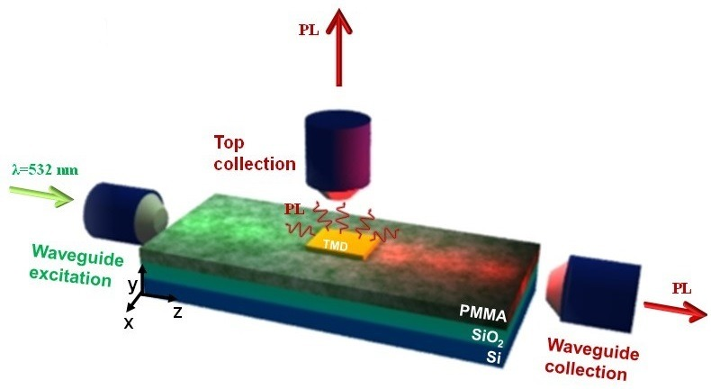
Distinguishable separation of charged and neutral excitons at room temperature in anisotropic photoluminescence of TMD monolayers integrated in polymer waveguides
Daniel Andres-Penares^{1,†}, Isaac Suárez¹, Rodolfo E. Canet-Albiach¹, Juan P. Martínez-Pastor^{1,2}, Juan F. Sánchez-Royo^{1,2*}
- ICMUV, Instituto de Ciencia de Materiales, Universidad de Valencia, P.O. Box 22085, 46071 Valencia, Spain
- MATINÉE: CSIC Associated Unit-(ICMM-ICMUV of the University of Valencia), Universidad de Valencia, P.O. Box 22085, 46071 Valencia, Spain
† Current address: Institute of Photonics and Quantum Sciences, SUPA, Heriot-Watt University, Edinburgh EH14 4AS, UK
*Corresponding author: Juan.F.Sanchez@uv.es
In this work, we propose a suitable integration of WSe2 and MoSe2 in a Poly(methyl methacrylate) (PMMA) in order to properly study the excitation and generation of light of transition metal dichalcogenides (TMD) materials in a waveguide configuration. In particular, we demonstrate that the monolayer (ML) can be homogeneously pumped by the evanescent field of the modes confined in the PMMA, and efficiently excited at room temperature. In addition, the PL emitted by the TMD is not only measured from the surface, but also coupled to the modes of the structure and decoupled at the output edge of the waveguide with an anisotropic behaviour, with a room temperature separation between the TMD photoluminescent components related to the neutral [1, 2] and charged excitons (X⁰ and X^{C}, respectively). To the best of our knowledge, this is the first time where PL of TMD is properly coupled in a purely horizontal waveguide configuration, and the first approximation to distinguish the X^{C} and X⁰ contributions within the same device at room temperature. Thus, we believe that these results can pave the road of new photonic devices based on TMDs.

Figure 1. Geometry of the experimental setup and different collection possibilities.
(1) Zheng, W.; Jiang, Y.; Hu, X.; Li, H.; Zeng, Z.; Wang, X.; Pan, A. Light Emission Properties of 2D Transition Metal Dichalcogenides: Fundamentals and Applications. Adv. Opt. Mater. 2018, 6 (21), 1–29. DOI : 10.1002/adom.201800420
(2) Mueller, T.; Malic, E. Exciton Physics and Device Application of Two-Dimensional Transition Metal Dichalcogenide Semiconductors. npj 2D Mater. Appl. 2018, No. July, 1–12. DOI : 10.1515/nanoph-2016-0165

