Efficient interrogation method of forward Brillouin scattering in optical fibers using a narrow bandwidth long-period grating
L. A. Sánchez^{1,*}, A. Díez^{1,2}, J. L. Cruz^{1,2}, and M. V. Andrés^{1,2}
¹ Laboratory of Fiber Optics, ICMUV, Universidad de Valencia, Dr. Moliner 50, 46100, Burjassot, Spain
² Departamento de Física Aplicada y Electromagnetismo, Universidad de Valencia, Dr. Moliner 50, 46100, Burjassot, Spain
*E-mail: luis.sanchez@uv.es
Transverse acoustic waves in optical fibers are excited by electrostriction when a high power optical pulse propagates in the fiber. This effect is known as forward stimulated Brillouin scattering (FSBS). The acoustic vibrational modes behind this interaction are the radial modes R_{0m} and torsional-radial modes TR_{2m} [1]. Typically, the detection techniques of these modes are mostly based on the direct analysis of the light scattered by the acoustic waves using interferometric techniques [2]. Here we propose an alternative method employing a long-period fiber grating (LPG) which is used to translate effective index modulation into amplitude modulation of a probe beam. LPGs are fiber devices that couple energy from the fundamental optical core mode to co-propagating cladding modes. The resonance wavelength of the grating depends on the difference between the effective index of the coupled modes. The perturbation in the effective index of the core optical mode as a result of the acoustic wave causes the shift of the notch, thus modifying the transmission of the probe laser (Figure 1). The short fiber section required by this method reduces significantly the structural inhomogeneities contribution to the linewidth broadening of the acoustic modes and allows to detect effective index changes down to 10⁻⁹.
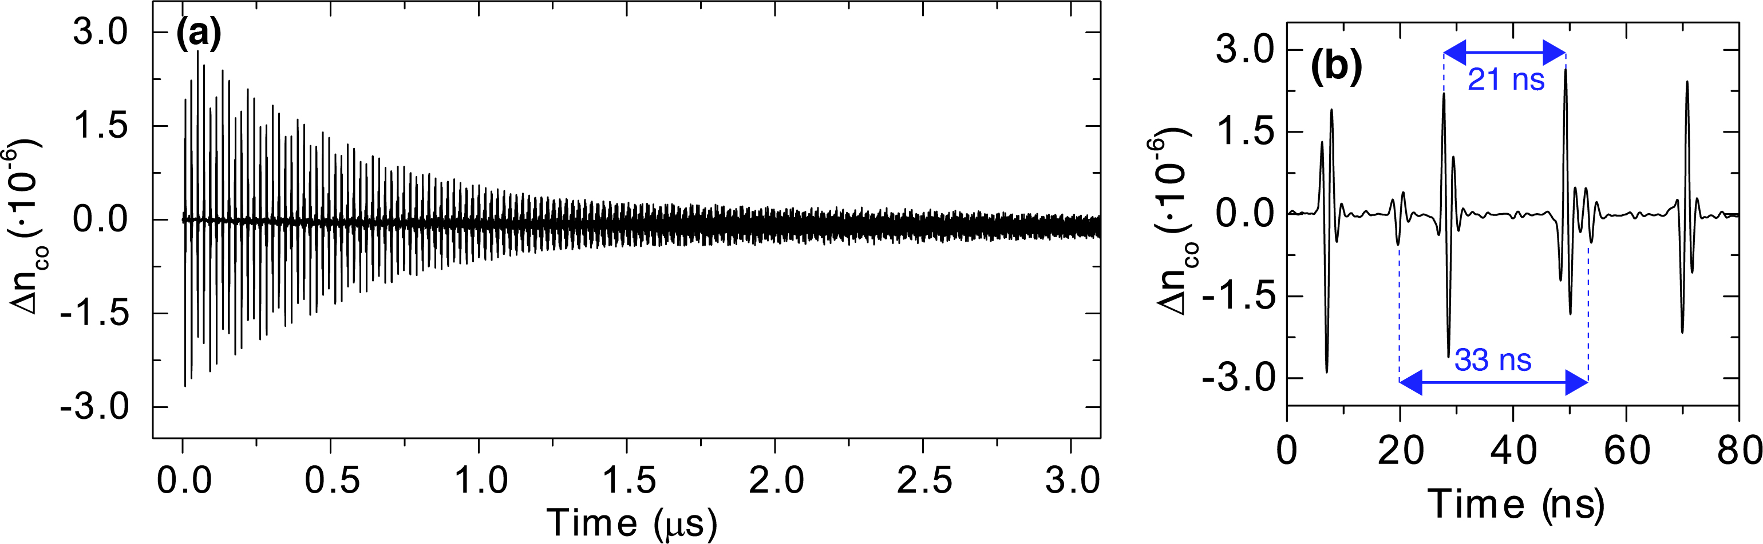
Figure 1: (a) Core effective index variation of the LPG for a pump peak power of 7.4 kW. (b) Detailed plot of the first 80 ns with visible excitation of R_{0m} and TR_{2m} modes.
[1] R. M. Shelby, M. D. Levenson, and P. W. Bayer, "Guided acoustic-wave Brillouin scattering," Phys. Rev. B 31(8), 5244–5252 (1985).
[2] J. Wang, Y. Zhu, R. Zhang, and D. J. Gauthier, "FSBS resonances observed in a standard highly nonlinear fiber," Opt. Express 19(6), 5339 (2011).

