Label free biosensors based on biogratings patterned on microfibers
A. Juste-Dolz¹, M. Delgado-Pinar^{*,2}, M. Avella-Oliver^{1,4}, E. Fernández¹, D. Pastor³, M. V. Andrés², Á. Maquieira^{1,4}
¹⁾ Instituto Interuniversitario de Investigación de Reconocimiento Molecular y Desarrollo Tecnológico (IDM), Universitat Politècnica de València, Universitat de València, 46022 Valencia, Spain.
²⁾ Laboratory of Fiber Optics - Institut de Ciència dels Materials (ICMUV), Universitat de València, Catedrático José Beltrán 2, 46980 Paterna, Valencia, Spain
³⁾ Photonics Research Labs, Universitat Politècnica de València, 46021 Valencia, Spain.
⁴⁾ Departament de Química, Universitat Politècnica de València, 46022 Valencia, Spain.
* martina.delgado@uv.es
The development of photonic biosensors is currently a research topic of high interest, with a significant, potential impact on industry and medicine. In particular, label-free biosensors based on optical fibers or microfibers can lead to miniaturized, inexpensive and low-loss devices. Here, we present the design, fabrication, and proof of concept of a novel biosensor based on a bio-Bragg-grating (BBG) that is imprinted on the surface of a microfiber.
Our approach combines the ability to pattern a periodic network of bioreceptors on the surface of a microfiber (3 μm in diameter), with the sensing capacity of microfibers due to its significant evanescent optical field. The bioreceptors (BSA, in our case) are placed in a periodic fashion onto the fiber surface by microcontact printing [1], with a period of 556 ±1 nm. The interaction between the fundamental optical mode of the microfiber and this incipient BBG leads to a weak reflection peak in the optical response of the device, which is spectrally located at its Bragg wavelength, see Fig. 1 (a). The biosensing transduction principle relies on the fact that, if the specific target (IgGs in this case) is present in the external medium, it will bind to the bioreceptors that conform the BBG, increasing its modulation depth. As a result, it will be possible to quantify the concentration of specific IgGs by measuring the reflectivity of the BBG, see inset in Fig. 1 (b). A dosis-response curve of an experimental immunoassay is shown in Fig. 1 (b), fitted to a sigmoidal (logistic 4 parameters) regression. From these results, experimental detection and quantification limits of 0.1 µg mL⁻¹ and 0.4 µg mL⁻¹, respectively, of unlabelled IgG in label-free conditions are obtained.
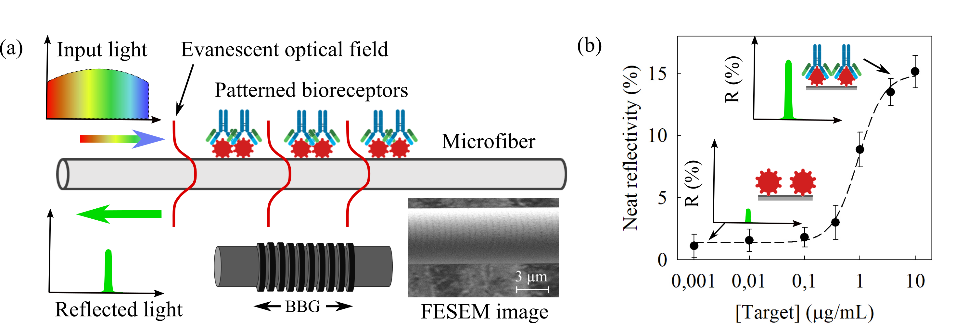
Figure 1 (a) Scheme of a BBG and FESEM image. (b) Experimental dose-response immunoassay curve.
[1] Avella-Oliver, M. et al., Anal. Chem. 2017, 89 (17), 9002–9008. doi.org/10.1021/acs.analchem.7b01649.

